**2022 Clean Watersheds   
Needs Survey (CWNS)**

**State Coordinator Manual**

***Draft***

The policies and procedures in this manual are draft as of October 2021 and subject to change. Screenshots of the data entry portal will be finalized when the portal is final.

**Submitted to:**

**U.S. Environmental Protection Agency**

**William Jefferson Clinton Building, 4204M**

**1200 Pennsylvania Avenue, NW**

**Washington, DC 20460**

**October 2021**

**Contents**

**Page**

List of Acronyms and Abbreviations xii

Glossary xiv

1. Background, History, and Purpose 1-1

1.1 Congressional Mandate 1-1

1.2 Tie to the CWSRF 1-1

1.3 Data Users 1-2

1.4 Updates from the 2012 CWNS 1-2

1.5 State Coordinating Committee and Subcommittees 1-3

1.5.1 Data Elements and Data Entry Portal Subcommittee 1-3

1.5.2 Documentation Subcommittee 1-3

1.5.3 Cost Modeling Subcommittee 1-3

1.6 Roles and Responsibilities 1-3

1.6.1 EPA Headquarters 1-3

1.6.2 EPA Regions 1-4

1.6.3 State Coordinators 1-4

1.6.4 Municipality Staff 1-4

1.6.5 Small Communities 1-4

1.6.6 EPA Contractor 1-5

2. 2022 CWNS Scope, Terminology, and Data Structure 2-1

2.1 Information Structure 2-1

2.2 CWNS ID 2-1

2.3 Need Category 2-1

2.4 Infrastructure Type 2-2

2.5 Facility Type 2-3

2.6 Change Type 2-3

3. CWNS Policies 3-1

3.1 Allowable Projects 3-1

3.2 American Indian and Alaska Native Village Needs 3-2

3.3 Unallowable Costs 3-2

3.4 Documentation Guidelines 3-3

3.4.1 Document Annotation 3-4

3.4.2 Clarification Statement for Potentially Unallowable Costs 3-4

3.5 Designated Documents List 3-4

3.5.1 Document Guidance 3-7

3.5.2 Older Documentation Guidelines 3-11

3.6 Cost of Previous Comparable Construction 3-11

3.7 Documentation Guidelines for Using the Small Community Form 3-12

3.7.1 Using the Small Community Form to Document Technical Data 3-12

3.7.2 Using the Small Community Form to Document Projects 3-13

3.7.3 Using the Small Community Form to Document Costs 3-13

3.8 Requirements for State-Specific Approaches 3-13

3.8.1 Document Types 3-14

3.8.2 Approach Submittal Requirements 3-14

3.8.3 Associating the Outputs of an Approved Methodology with Specific CWNS IDs 3-14

3.9 Requirements for CETs 3-15

4. Data Collection Processes and Procedures 4-1

4.1 2022 CWNS Schedule and Milestones 4-1

4.2 Data Prepopulated in DEP 4-2

4.3 Technical Data 4-2

4.3.1 Technical Data for Wastewater Facilities 4-2

4.3.2 Technical Data for Stormwater, NPS, and Decentralized Treatment Facilities 4-3

4.4 Needs Data 4-3

4.4.1 Checkbox of Compliance-Related Reasons for Need 4-3

4.4.2 Document Annotation 4-4

4.4.3 Documented Costs 4-4

4.4.4 CETs 4-5

4.5 Data Review 4-7

4.5.1 Automated Data Validation 4-8

4.5.2 Manual Review 4-8

5. Navigating the Data Entry Portal 5-1

5.1 Gaining Access 5-1

5.1.1 Registering for DEP Access 5-1

5.1.2 Entering the DEP 5-2

5.2 Roles 5-2

5.3 Welcome Page 5-2

5.3.1 State-Specific Approaches 5-3

5.3.2 DEP Help 5-3

5.3.3 CWNS DEP Table Filtering and Sorting 5-3

5.3.4 Contact Us 5-4

5.4 Icons 5-5

5.5 Document Management 5-5

5.5.1 Navigating the Document Management List 5-5

5.5.2 Delete a Document 5-6

5.5.3 Adding a New Document 5-6

5.6 Data Entry Statuses 5-9

5.7 CWNS IDs List 5-10

5.7.1 Searching for an Existing CWNS ID 5-10

5.7.2 Archiving an Existing CWNS ID 5-11

5.7.3 Adding a New CWNS ID 5-11

5.7.4 Updating CWNS ID List Data for an Existing CWNS ID 5-13

5.7.5 Entering the Survey for a CWNS ID 5-13

5.8 Data Entry Workflow 5-13

5.8.1 CWNS ID Top Menu and Data Entry Notes 5-15

5.8.2 Sidebar Navigation 5-16

5.9 Facility Types and Change Types 5-16

5.9.1 Facility Types List 5-16

5.9.2 Adding a New Facility Type and Associated Change Types 5-16

5.9.3 Confirming Selected Facility Types 5-18

5.10 Permits 5-18

5.10.1 Adding a NPDES Permit 5-19

5.10.2 Adding a Non-NPDES Permit 5-20

5.11 Point of Contact 5-20

5.11.1 Point of Contact List 5-20

5.11.2 Point of Contact Search 5-21

5.11.3 Add Point of Contact 5-21

5.12 Location 5-23

5.12.1 Adding a Physical Location 5-23

5.12.2 Areas Related to Needs 5-26

5.12.3 Adding Areas Related to Needs 5-27

5.13 Documents 5-28

5.13.1 Linking Documents to a CWNS ID 5-29

5.14 Capital Costs 5-32

5.14.1 Entering Capital Costs 5-33

5.15 CET Inputs 5-34

5.15.1 Wastewater: Treatment Plant CET 5-34

5.15.2 Wastewater: Collection CET 5-35

5.15.3 Decentralized CET 5-36

5.15.4 CSO CET 5-36

5.15.5 Stormwater CET 5-37

5.15.6 NPS: Agriculture CET 5-37

5.15.7 NPS: Silviculture CET 5-38

5.16 Population and Flow 5-39

5.16.1 Population 5-40

5.16.2 Flow 5-41

5.16.3 Flow to Population Ratio 5-43

5.17 Discharge 5-44

5.17.1 Discharges List 5-44

5.17.2 Adding a Type of Discharge 5-44

5.17.3 Building and Editing a Sewershed in Discharge 5-46

5.18 Sewersheds 5-46

5.18.1 Sewershed at a Glance 5-46

5.18.2 Sewershed Table 5-47

5.19 Effluent 5-48

5.20 Unit Process 5-50

5.20.1 Adding a Unit Process 5-50

5.21 Asset Management 5-51

5.21.1 Adding an Asset Management Practice 5-51

5.22 Small Community Form 5-52

5.22.1 Indicating a CWNS ID Is a Small Community 5-53

5.22.2 Managing Small Community Forms 5-54

5.22.3 Adding a CWNS ID to the Small Community Form List 5-55

5.22.4 Editing Small Community Data Before the Form is Sent 5-57

5.22.5 Small Community Form Workflow 5-57

5.22.6 Sending a New Small Community Form 5-58

5.22.7 Uploading a Returned Form 5-60

5.22.8 Making Corrections 5-61

5.22.9 Sending and Receiving PDF Versions of the SCF 5-61

5.23 Review Portlet 5-61

6. Post-Survey Data Availability 6-1

6.1 Data Dashboard 6-1

6.2 Data Reports and Facility Factsheets 6-1

6.3 Publicly Available Access Database 6-3

6.4 DEP Available for States 6-3

**List of Appendices**

Appendix A. Need Categories

Appendix B. Facility Types

Appendix C. Change Types

Appendix D. Facility Type and Change Type Associations

Appendix E. Facility Type Associations

Appendix F. Facility Types and Need Categories Associations

Appendix G. Designated Document Types

Appendix H. Small Community Form

Appendix I. Data Areas and Data Elements Tables

Appendix J. 301(h) Ocean Discharge Waivers

Appendix K. Unit Process Lists

**List of Tables**

**Page**

Table 3‑1. Examples of Funding Commitments 3-2

Table 3‑2. List of Designated Documents 3-5

Table 4‑1. CWNS Schedule and Milestones 4-1

Table 4‑2. Wastewater Treatment CETs by Practice Type and Change Type 4-6

Table 4‑3. Wastewater Conveyance CETs by Conveyance Category 4-6

Table 4‑4. CSO Storage CETa 4-6

Table 4‑5. Stormwater CETs by Practice Type 4-7

Table 4‑6. NPS Control CETs 4-7

Table 4‑7. Decentralized Treatment CETs 4-7

Table 4‑8. Finding and Corresponding Score Deductions 4-12

Table 4‑9. Average Score and Corresponding Audit Rate 4-12

Table 5‑1. User Permissions 5-2

Table 5‑2. CWNS Contact Information 5-5

Table 5‑3. Data Entry Statuses 5-9

Table 5‑4. Descriptions of Data Fields to Create a New CWNS ID 5-12

Table 5‑5. Data Area Dependencies 5-14

Table 5‑6. Descriptions of Data Fields to Create a New Facility Type 5-18

Table 5‑7. Descriptions of Data Fields to Add a New Non-NPDES Permit 5-20

Table 5‑8. Descriptions of Data Fields to Create a New Point of Contact 5-23

Table 5‑9. Location Options by Infrastructure Type 5-24

Table 5‑10. Descriptions of Discharge Data Fields 5-46

Table 5‑11. Effluent Treatment Level Definitions 5-49

Table 5‑12. Descriptions of Data Fields to Create an Asset Management Practice 5-52

**List of Figures**

**Page**

Figure 2‑1. 2022 CWNS data structure. 2-1

Figure 4‑1. CWNS schedule and milestones. 4-1

Figure 4‑2. Types of review based on total dollar value, document types submitted, and infrastructure type. 4-9

Figure 4‑3. Review workflow. 4-9

Figure 5‑1. DEP welcome page. 5-3

Figure 5‑2. Document management list. 5-6

Figure 5‑3. “Upload New Document/Edit Document” window. 5-7

Figure 5‑4. Older documentation certification statement. 5-8

Figure 5‑5. Cost of previous comparable construction certification statement. 5-8

Figure 5‑6. CWNS ID list. 5-10

Figure 5‑7. “Add/Edit CWNS ID” window. 5-12

Figure 5‑8. “Enter Survey” icon. 5-13

Figure 5‑9. CWNS ID data entry workflow diagram. 5-14

Figure 5‑10. CWNS ID top menu. 5-15

Figure 5‑11. “Data Entry Notes” screen. 5-15

Figure 5‑12. Facility types list. 5-16

Figure 5‑13. “Add/Edit Facility Type” window. 5-17

Figure 5‑14. Facility types and change types confirmation window. 5-18

Figure 5‑15. Permits associated with a facility. 5-19

Figure 5‑16. NPDES permit search window. 5-19

Figure 5‑17. “Add/Edit Non-NPDES Permit” window. 5-20

Figure 5‑18. Point of contact list. 5-21

Figure 5‑19. Point of contact search. 5-21

Figure 5‑20. “Add/Edit Point of Contact” window. 5-22

Figure 5‑21. Physical location data area. 5-23

Figure 5‑22. “Add/Edit Physical Location” window. 5-25

Figure 5‑23. Physical location mapping tool. 5-26

Figure 5‑24. Areas related to needs data area. 5-27

Figure 5‑25. Mapping feature for areas related to needs. 5-28

Figure 5‑26. Documents data area. 5-29

Figure 5‑27. “Document Search” window. 5-30

Figure 5‑28. “Upload New Document/Edit Document” window. 5-31

Figure 5‑29. Adding documents to the “Cost by Category” table. 5-32

Figure 5‑30. “Cost by Category” table. 5-33

Figure 5‑31. Adding costs by document and category. 5-34

Figure 5‑32. Cost estimation tools data area. 5-34

Figure 5‑33. Wastewater treatment plant CET window. 5-35

Figure 5‑34. Wastewater collection CET window. 5-35

Figure 5‑35. Decentralized CET window. 5-36

Figure 5‑36. CSO CET window. 5-37

Figure 5‑37. Stormwater CET window. 5-37

Figure 5‑38. Agriculture CET window. 5-38

Figure 5‑39. Silviculture CET window 5-39

Figure 5‑40. Population and flow data areas. 5-40

Figure 5‑41. Adding/editing population Information. 5-41

Figure 5‑42. “Add/Edit Flow Information” window for disaggregated flows. 5-42

Figure 5‑43. Total flow warning. 5-42

Figure 5‑44. “Add/Edit Flow Information” window for total flow. 5-43

Figure 5‑45. Population to flow ratio. 5-43

Figure 5‑46. Discharge data area. 5-44

Figure 5‑47. “Add/Edit Discharge Method” window. 5-45

Figure 5‑48. Facility CWNS ID search. 5-45

Figure 5‑49. Sewershed at a Glance example. 5-47

Figure 5‑50. Sewershed table. 5-48

Figure 5‑51. “Edit Effluent” window. 5-49

Figure 5‑52. Unit process list. 5-50

Figure 5‑53. “Add/Edit Unit Process” window. 5-51

Figure 5‑54. Asset management data area. 5-51

Figure 5‑55. “Add/Edit Asset Management” window. 5-52

Figure 5‑56. Indicating a CWNS ID serves a small community. 5-54

Figure 5‑57. “Manage Small Community Forms” in the CWNS top menu. 5-54

Figure 5‑58. Adding state information to the SCF. 5-55

Figure 5‑59. SCF list. 5-56

Figure 5‑60. Searching for a small community to add to the email list. 5-57

Figure 5‑61. SCF workflow. 5-58

Figure 5‑62: Default small community email. 5-59

Figure 5‑63. SCF email information. 5-60

Figure 6‑1. 2012 data dashboard. 6-1

Figure 6‑2. Example 2012 facility fact sheet (page 1 of 5). 6-2

List of Acronyms and Abbreviations

|  |  |
| --- | --- |
| **BMP** | best management practice |
| **BOD5** | biochemical oxygen demand |
| **CEAP-Cropland** | Conservation Effects Assessment Project National Assessment for Cropland Report |
| **CET** | cost estimation tool |
| **CFR** | Code of Federal Regulations |
| **CIP** | Capital Improvement Plan |
| **CSO** | combined sewer overflow |
| **CWA** | Clean Water Act |
| **CWNS** | Clean Watersheds Needs Survey |
| **CWSRF** | Clean Water State Revolving Fund |
| **DEP** | Data Entry Portal |
| **eFOTG** | Electronic Field Office Technical Guide |
| **EPA** | U.S. Environmental Protection Agency |
| **ft** | foot |
| **ICIS-NPDES** | Integrated Compliance Information System–National Pollutant Discharge Elimination System |
| **I/I** | infiltration and inflow |
| **IUP** | Intended Use Plan |
| **LTCP** | Long-Term Control Plan |
| **MGD** | million gallons per day |
| **mg/L** | milligrams per liter |
| **MS4** | municipal separate storm sewer system |
| **NEP** | National Estuary Program |
| **NPDES** | National Pollutant Discharge Elimination System |
| **NPS** | nonpoint source |
| **NRCS** | USDA’s Natural Resources Conservation Service |
| **O&M** | operations and maintenance |
| **OW** | EPA’s Office of Water |
| **OWM** | EPA’s Office of Wastewater Management |
| **OWTS** | onsite wastewater treatment system |
| **PE** | Professional Engineer |
| **POTW** | publicly owned treatment works |
| **SEMS** | Superfund Enterprise Management System |
| **SSES** | sewer system evaluation survey |
| **SSO** | sanitary sewer overflow |
| **TMDL** | total maximum daily load |
| **USDA** | U.S. Department of Agriculture |
| **WAM** | web application management |
| **WIFIA** | Water Infrastructure Finance and Innovation Act |

| Glossary | |
| --- | --- |
| **Adjustment factor** | Calculated based on cost-related errors found in CWNS IDs that undergo an audit review and applied to the state’s total official auditable needs. |
| **Allowable** | Refers to projects meeting the criteria of the CWNS needs definition. |
| **Alternate document** | A document that might not include all project and cost documentation guidelines. Alternate documents commonly have information to document the project only (requirement #3) and can be used in conjunction with other documents that include costs or EPA cost estimation tools to document requirements #4 and #5. See Appendix G for the full list of alternate documents and their descriptions. |
| **Auditable** | Refers to a CWNS ID with a cost of $40 million or less that uses at least one primary document and was partially reviewed. |
| **Audit rate** | The percentage of federally accepted auditable CWNS IDs that are selected for an audit review by EPA. The audit rate can vary and is based on the findings from full and audit reviews of a state’s CWNS IDs that were submitted during previous quarters of the data entry period. Audit rates can range from 2 to 20 percent. |
| **Authority** | Owner and/or operator of a facility and/or facilities linked to a CWNS ID. |
| **Capital costs** | Fixed, one-time expenses incurred on the purchase of land, buildings, construction, and equipment used in the production of goods or in the rendering of services. |
| **Change type** | Term and categorization to describe one or more planned projects to be accomplished at a CWNS ID within the survey period. |
| **Cost** | Estimated dollars needed to implement one or more projects. |
| **CWNS ID** | The unique 11-digit identification number assigned either by the DEP or edited by the state to identify each facility or group of related facilities. The first two digits of the code are required to be the state’s two-digit Federal Information Processing Standards (FIPS) code. This is the basic unit of organization and identifier for the survey and is used to refer to the facility or facilities with which it is associated. |
| **Decentralized wastewater treatment infrastructure** | A system relying on natural processes and/or mechanical components to collect, treat, and disperse or reclaim wastewater from a single dwelling or building *or* a wastewater collection and treatment system under some form of common ownership that collects wastewater from two or more dwellings or buildings and conveys it to a treatment and dispersal system on a suitable site near the dwellings or buildings. For the purposes of the CWNS, decentralized systems may be onsite (individual) or clustered. Clustered systems may include multifamily septic systems or package plants. |
| **Eligible** | Refers to projects meeting the criteria of one of the 12 Clean Water State Revolving Fund eligibilities that can receive a loan under the federal guidelines for State Revolving Fund programs. |
| **Facility** | An infrastructure asset or program that addresses a current or projected water quality or water-related public health problem. |
| **Facility type** | Describes the infrastructure purpose, stormwater regulatory category, and water-quality-related action of the infrastructure asset or program (e.g., treatment, collection, stormwater categorization, nonpoint source control measure, or decentralized treatment type). |
| **Infrastructure type** | Used to categorize groups of facility types based on pollution mitigation measures. Infrastructure types are wastewater, stormwater, nonpoint source, and decentralized treatment. |
| **Need** | Unfunded project(s) (or portions thereof) and associated capital costs that address a water quality or water-quality-related public health problem existing as of January 1, 2022, or expected to occur within the next 20 years. |
| **Need category** | Categorization of capital investment project types that can be funded through the Clean Water State Revolving Fund and included in the CWNS. CWNS categories generally follow the Clean Water State Revolving Fund funding categories. |
| **Needs data** | Data collected for each CWNS ID that pertain to needs. These data include needs by document, areas related to needs, and cost model inputs. |
| **Nonpoint source control infrastructure** | Infrastructure used to manage and/or treat nonpoint source pollution. |
| **Nonpoint source pollution** | Any source of water pollution that does not meet the legal definition of “point source” in Section 502(14) of the Clean Water Act. Nonpoint source pollution is caused when rainfall or snowmelt, moving over and through the ground, picks up and carries natural and human-made pollutants, depositing them into lakes, rivers, wetlands, coastal waters, and groundwaters. |
| **Official needs** | Projects and associated costs that meet the definition of “need” and are reported in the main body of the Report to Congress. |
| **Operations and maintenance (O&M)** | The functions, duties, and labor associated with daily operations and normal repairs, replacement of parts and structural components, and other activities needed to preserve an asset so that it continues to provide acceptable services and achieves its expected life. |
| **Other documented needs** | Needs that meet the definition of “need” but do not meet the definition of “official need.” Other documented needs are reported in an appendix of the Report to Congress. |
| **Primary document** | A document that is likely to contain all three need documentation guidelines (the description of the project that solves the water quality or public health problem, the cost for each project, and the source of the cost). See Appendix G for the full list of primary documents and their descriptions. |
| **Project** | A capital investment to an asset or program that addresses a water-quality or public health problem. |
| **Sewershed** | A group of facilities that ultimately discharge to a single point or multiple shared points. Sewersheds are automatically created by the Data Entry Portal when the state sets the discharge method to “Discharge to Another CWNS ID.” Sewersheds are only created for wastewater facility types. |
| **Stormwater infrastructure** | Infrastructure used to collect, convey, treat, or infiltrate stormwater. Stormwater is rainwater or melted snow that runs off streets, lawns, and other sites. See “Stormwater infrastructure (gray)” and “Stormwater infrastructure (green)” also. |
| **Stormwater infrastructure (gray)** | Infrastructure that collects and conveys stormwater from impervious surfaces, such as roadways, parking lots, and rooftops, into a series of pipes and ultimately discharges untreated stormwater into a local water body. |
| **Stormwater infrastructure (green)** | Infrastructure that uses plant or soil systems, permeable pavement or other permeable surfaces or substrates, stormwater harvesting and reuse, or landscaping to store, infiltrate, or evapotranspirate stormwater and reduce flows to sewer systems or to surface waters. |
| **Technical data** | Refers to data collected for each CWNS ID that provide information about the CWNS ID. These data include information such as wastewater or stormwater flow; population served; and descriptive data on the discharge, effluent, unit process, and utility management. They do not pertain to needs. |
| **Wastewater infrastructure** | A managed system consisting of collection sewers and a treatment plant used to collect and treat wastewater from a service area. When publicly owned, such a system has been called a publicly owned treatment works, as defined at 40 CFR 122.2. |

This document contains information for state coordinators to reference when providing the U.S. Environmental Protection Agency (EPA) with information about the capital investment needs and technical information of wastewater, stormwater, nonpoint source (NPS) control, and decentralized treatment facilities in their states. EPA will use this information to complete the 17th Clean Watersheds Needs Survey (CWNS) and report the findings to Congress. This document includes background on CWNS policies and procedures, as well as instructions for navigating the CWNS Data Entry Portal (DEP).

# Background, History, and Purpose

The 2022 CWNS is EPA’s 17th. This survey communicates to Congress current estimates for the Clean Water Act (CWA)–related needs of the nation and each state, including territories. EPA conducted the first survey in 1972 and continued biennially until 1992. From 1996 to 2012, EPA conducted the survey every four years. The last survey was conducted in 2012.

## Congressional Mandate

EPA, in partnership with the states, conducts the CWNS to identify and document the cost of each state’s capital needs to meet the water quality and water-quality-related public health goals of the CWA. The CWNS is required under Section 205(a) of the CWA and Section 516 of the Water Quality Act of 1987, which amended the CWA. The Act requires EPA to “make a detailed estimate…of the cost of construction of all needed publicly owned treatment works[1] in all of the states and of the cost of construction of all needed publicly owned treatment works in each of the states.” As part of the mandate, EPA is required to submit the detailed cost estimate in a Report to Congress. The Report to Congress is currently used to calculate the allotment formula for the Sewer Overflow and Stormwater Reuse Municipal Grants Program[2].

Section 516 of the Water Quality Act of 1987 also requires the Report to Congress to include a comprehensive analysis of the national requirements for treating wastewater to meet water quality objectives. Therefore, EPA collects information (regardless of existing need) on the type of treatment systems already in place or needed to support this analysis.

## Tie to the CWSRF

The Clean Water State Revolving Fund (CWSRF) program was established under Section 603(c) of the CWA to fund water quality protection efforts. The program was established in 1987 with three eligibilities: the construction of publicly owned treatment works (POTWs), implementation of an NPS management program, and the development and implementation of a National Estuary Program (NEP) Comprehensive Conservation and Management Plan. Since then, the CWSRF eligibilities have expanded, first through the Water Resources Reform and Development Act of 2014 and again with the passage of America’s Water Infrastructure Act of 2018.

Early on, the survey focused on providing an estimate of construction costs of POTWs and an inventory of existing and proposed wastewater conveyance and treatment facilities in the United States. As the CWSRF has broadened its funding eligibilities, EPA has also broadened the scope of the CWNS, reflecting the expansion of types of projects eligible for funding. In the 2012 CWNS, EPA reported technical and needs data for:

* POTWs (including information on combined sewer overflows [CSOs] and sanitary sewer overflows (SSOs))
* Municipal stormwater programs
* Decentralized wastewater treatment

The 2022 CWNS collects technical and needs data for the same projects, plus NPS best management practice (BMP) implementation and desalination, water efficiency, and renewable energy projects.

## Data Users

The CWNS data are collected and managed by EPA’s Office of Water/Office of Wastewater Management (OW/OWM). The main use of the CWNS data is by Congress and state legislatures in their budgeting efforts; however, the data are available to the public and are used to measure environmental progress, contribute to academic research, and help local and state governments implement water quality programs.

Prior to 2012, users had to request data from OW/OWM, but starting in 2012, OW/OWM made the CWNS data publicly available via download from the CWNS data dashboard. This allowed for greater transparency and access to the data for the general public, but it meant that EPA could no longer track who accessed the data or for what purpose.

EPA intends to continue to make the CWNS data publicly available through the CWNS data dashboard. The data will be available for viewing on the website and data downloads will be available for users who provide affiliation and intended use information so that EPA can better understand its importance to the public.

## Updates from the 2012 CWNS

In addition to the changes to the need categories and change types (see Sections 2.3 and 2.6), EPA made the following notable updates for the 2022 CWNS:

* Revised the statewide population audit to ensure the population is not double-counted
* Revised which data areas are optional for states to complete
* Modified the requirement for documenting water-quality-related need
* Clarified the definition of “funded”
* Updated the preapproved documents list
* Updated wastewater cost estimation tools (CETs) and inputs
* Developed new stormwater management, agricultural, and silvicultural CETs

## State Coordinating Committee and Subcommittees

In preparation for the 2022 CWNS, EPA and state coordinators worked together to review and improve the policies and procedures for conducting the CWNS, including data entry, the procedures to ensure data quality, and data accessibility. Three subcommittees were convened to support this process.

### Data Elements and Data Entry Portal Subcommittee

This subcommittee evaluated the need for and assessed the value of each data area and element collected through the CWNS and made recommendations for data element requirements. The subcommittee also provided input on the development of a new DEP to maximize usability for state coordinators. Topics addressed included data entry approach, population audit, and optional data areas.

### Documentation Subcommittee

This subcommittee evaluated the usefulness and accessibility of the types of documentation that could be used to support reported needs and recommended requirements for such documentation. It also explored related topics, including a preapproved documents list and the definition of “funded.”

### Cost Modeling Subcommittee

This subcommittee provided input to EPA on the development of CETs to be used for approximating CWNS costs when the documented costs of identified needs are not readily available. The subcommittee made recommendations on the size and type of facilities to be modeled, the size of facilities for which state-specific approaches will be considered, cost modeling approaches, and appropriate modeling parameters. Topics addressed included wastewater, stormwater, decentralized, and NPS models.

## Roles and Responsibilities

The CWNS is conducted through collaboration between federal, regional, state, municipality staff, and small community personnel. This section outlines the roles and responsibilities for all collaborators.

### EPA Headquarters

Overall CWNS implementation:

* Ensure national consistency by establishing sound policies and procedures.
* Approve development and ensure implementation of the Quality Assurance Project Plan.
* Manage contractors.
* Prepare the Report to Congress.
* Act as final arbitrator in disputes.
* Manage and control data security requirements.

Management of the CWNS DEP and database:

* Coordinate within EPA to ensure a proper environment for the DEP is maintained.
* Coordinate DEP training sessions.
* Ensure DEP concerns are prioritized and resolved as resources allow.
* Provide CWNS administrative and technical support.
* Provide user support to state coordinators (with assistance of EPA Regions) on issues related to the DEP.

### EPA Regions

Assist EPA headquarters in regional management of the CWNS and provide support to states:

* Ensure state coordinators have a thorough understanding of the CWNS and are documenting needs.
* Communicate with state coordinators on data submission status and milestones.
* Provide and/or coordinate mentoring for novice state coordinators.
* For some states, the EPA Region may serve as the state coordinator.

### State Coordinators

Update, review, and submit CWNS data:

* Collect and enter data for all need categories.
* Analyze current data and update cost, technical information, and documentation.
* Coordinate and submit any state specific methods for estimating projects and costs for EPA review.
* Collect and enter data on new facilities.
* Submit any documentation to the DEP.
* Adhere to schedule for updating technical data.
* Address questions about data anomalies.
* Provide other state staff and other applicable entities access to the DEP to submit their data electronically to the state.

### Municipality Staff

Respond to requests from state coordinators:

* Provide state coordinators with planning documents.
* Support technical data collection by providing requested data.

### Small Communities

Provide technical and needs data for their communities that might not be publicly available:

* Access the web-based small community form through the emailed link.
* Update technical and needs data.

Provide documentation, signatures, or CET inputs for needed projects.

### EPA Contractor

Analyze state-provided CWNS data:

* Develop the Quality Assurance Project Plan.
* Review data submitted to the DEP to ensure accuracy and compliance with CWNS policies.
* Ensure national consistency through established documentation procedures.
* Perform quality control checks on needs, population, and other technical data.
* Analyze needs estimates at the end of data collection.
* Update CETs using data reported through the survey.
* Provide data analysis for the CWNS Report to Congress.

Provide CWNS administrative and technical support:

* Help EPA maintain the DEP and correct programming errors.
* Provide advice to EPA headquarters and guidance to EPA Regions on technical issues involving the CWNS.
* Support CWNS meetings (briefings, startup, mid-survey, etc.).
* Follow all EPA policies and procedures.

# 2022 CWNS Scope, Terminology, and Data Structure

## Information Structure

The CWNS collects information about water pollution control facilities (technical data) as well as any projects and costs documented for those facilities (needs data). CWNS ID data are classified by infrastructure type, facility type, change type, and need category. State coordinators enter technical data for each CWNS ID and its associated infrastructure type, facility types, and change types. State coordinators also enter needs and assign them to need categories. Figure 2‑1 shows the structure of information entered in the DEP.

Figure 2‑1. 2022 CWNS data structure.

## CWNS ID

As the state enters a new facility into the DEP, it is assigned a unique CWNS ID. The CWNS ID is either auto-generated by the DEP or assigned by the state (see Section 5.7.3 for more details). Entries from previous surveys retain their CWNS IDs from survey to survey. Each CWNS ID can include only one infrastructure type. The state can determine how facilities are reported for a CWNS ID, but guidance for each infrastructure type is as follows:

* **Wastewater**: A CWNS ID can include multiple wastewater facility types. However, each treatment plant must be assigned a unique CWNS ID to track the technical information associated with the plant. For example, a CWNS ID can include one treatment plant and also one or more collection system. Alternately, plants and collection systems can be entered as separate CWNS IDs that are linked through a discharge method (see Section 5.17 for more discussion of discharge methods) to become part of the same sewershed.
* **Stormwater**: Since some stormwater facility types can potentially cover larger areas (i.e., whole counties), each CWNS ID should only include one facility type.
* **NPS**: EPA recommends that each CWNS ID associated with an NPS control infrastructure have only one facility type (e.g., “brownfield” or “groundwater”). However, a state can enter multiple facility types under a given CWNS ID if that accommodates the specific situation. EPA anticipates that states using the CETs for “agriculture (cropland)” or “silviculture” will do so under a single CWNS ID that represents either the whole state or multiple counties. If the state coordinator has documented needs, those should be entered under one or more separate CWNS ID(s) whose locations do not overlap with CWNS IDs used for CETs to ensure needs are not double counted.
* **Decentralized**: Individual decentralized systems can be reported as individual CWNS IDs, but it is more likely—and encouraged—that states would want to report the needs of a group of decentralized systems (such as all onsite systems within a county) as one CWNS ID. The state will still need to enter the total number of individual units within the system.

## Need Category

States will assign needs to categories that generally align with the CWSRF as shown below. Note that needs associated with categories VIII, IX, XI, and XIII (grayed out and marked with asterisks) had been collected in past surveys, but are no longer collected. Detailed descriptions of the need categories are included in Appendix A.

* I Secondary Wastewater Treatment
* II Advanced Wastewater Treatment
* III Conveyance System Repair
* III-A Infiltration/Inflow (I/I) Correction
* III-B Sewer Replacement/Rehabilitation
* IV New Conveyance Systems
* IV-A New Collector Sewers and Appurtenances
* IV-B New Interceptor Sewers and Appurtenances
* V Combined Sewer Overflow (CSO) Correction
* VI Stormwater Management
* VI-A Gray Infrastructure
* VI-B Green Infrastructure
* VI-C General Stormwater Management
* VII Nonpoint Source (NPS) Control
* VII-A NPS Control: Agriculture (Cropland)
* VII-B NPS Control: Agriculture (Animals)
* VII-C NPS Control: Silviculture
* VII-E NPS Control: Groundwater Protection (Unknown Source)
* VII-F NPS Control: Marinas
* VII-G NPS Control: Resource Extraction
* VII-H NPS Control: Brownfields/Superfund
* VII-I NPS Control: Storage Tanks
* VII-J NPS Control: Sanitary Landfills
* VII-K NPS Control: Hydromodification
* VII-M NPS Control: Other Estuary Management Activities
* VIII Confined Animals (Point Source)*
* IX Mining (Point Source)*

Note that the CWSRF categories “improve energy efficiency,” “climate change adaptation,” “renewable energy,” and “improve water efficiency” are applied in the CWNS as change types rather than need categories.

* X Water Reuse
* XI Estuary Management*
* XII Decentralized Wastewater Treatment Systems
* XIII Planning*
* XIV Desalination

The categories above were modified from the 2012 categories based on changes to CWSRF categorization:

* Categories V-A and V-B combined into V
* Categories VI-A and VI-B combined into VI-A
* Category VI-C changed to VI-B
* Category VI-D changed to VI-C
* Category X renamed (“Recycled Water Distribution” to “Water Reuse”)
* Category XIV added

## Infrastructure Type

Each CWNS ID must be classified as one of four types of infrastructure:

* **Wastewater infrastructure:** A managed system consisting of collection sewers and a single treatment plant used to collect and treat wastewater from a service area. When publicly owned, such systems have been called POTWs, as defined at 40 CFR 122.2.
* **Stormwater infrastructure:** Infrastructure used to collect, convey, treat, and infiltrate stormwater. Stormwater is rainwater or melted snow that runs off streets, lawns, and other sites. Includes gray and green infrastructure.
* **NPS control infrastructure:** Infrastructure used to manage and/or treat NPS pollution. NPS pollution is any source of water pollution that does not meet the legal definition of “point source,” per CWA Section 402(14). It generally results from land runoff, precipitation, atmospheric deposition, drainage, seepage, or hydrologic modification.
* **Decentralized treatment infrastructure:** A system relying on natural processes and/or mechanical components to collect, treat, and disperse or reclaim wastewater from a single dwelling or building *or* a wastewater collection and treatment system under some form of common ownership that collects wastewater from two or more dwellings or buildings and conveys it to a treatment and dispersal system located on a suitable site near the dwellings or buildings. For the purposes of the CWNS, decentralized systems may be onsite (individual) or clustered; clustered systems may include multifamily onsite systems or package plants.

## Facility Type

As shown in Figure 2‑1, each infrastructure type is divided into facility types that describe infrastructure assets or programs grouped by infrastructure purpose, stormwater regulatory category, and water-quality-related action. See Appendix B for a full list of facility types and definitions. Facility types are associated with needs through the need category.

## Change Type

States will assign one or more change types to each CWNS ID. Change types describe the planned capital investments to be achieved within the survey period and align with the categories of need (see Appendix C for the full list of change types).

The following change types are each mutually exclusive of any other change type:

* No change (no planned changes)
* Abandonment (full decommissioning of a facility)
* New (construction of a new facility)

The following change types can be reported in combination with each other:

* Increase capacity
* Increase level of treatment
* Rehabilitation
* Replacement
* Redevelopment
* Process improvement
* Expansion
* Instrumentation/electrical/laboratory
* Improve energy efficiency
* Climate change adaptation
* Renewable energy
* Improve water efficiency

See Appendix C for descriptions of each change type.

Appendix D shows which change types can be associated with each facility type, Appendix E shows which facility types can be associated with other facility types, and Appendix F shows which facility types can be associated with each need category.

# CWNS Policies

## Allowable Projects

For a project to be included in the 2022 CWNS, it must be:

Resource:

EPA’s [*Overview of Clean Water State Revolving Fund Eligibilities*](https://www.epa.gov/sites/production/files/2016-07/documents/overview_of_cwsrf_eligibilities_may_2016.pdf)(2016)

* **CWSRF eligible**. A CWSRF eligible project is a solution to a water quality problem that is eligible for funding according to national CWSRF eligibility criteria.
* Note that flood control structures or stormwater projects that do not have water quality benefits are not eligible, as defined in the CWSRF guidance.
* Note that planning activities that have a reasonable prospect of resulting in a capital project are eligible.

CWSRF eligibility for wastewater and stormwater facilities is generally limited to publicly owned facilities; however, NPS and decentralized facilities can be privately owned. Pilot projects for increased resilience of treatment works and energy or water conservation projects can also be privately owned.

* **Unfunded**. For the 2022 survey, a project is considered funded—and therefore not a need—if by January 1, 2022, construction has started or external funds (e.g., a grant or executed loan) are committed to the project, even if construction has not yet begun.
* Projects scheduled to begin construction prior to January 1, 2022, are considered “funded” and therefore may not be included in the CWNS, as they are no longer considered to be needs. If a project was scheduled to begin construction but did not start before 2022, EPA recommends the state include a clarification statement or annotation in the provided documentation (e.g., the intended use plan (IUP) or capital improvement plan (CIP) containing the project) explaining that it did not begin construction as scheduled. Similarly, if only a phase of the construction has started, the state may enter needs for the future phases and explain this in the clarification statement. If only part of the project is funded as of January 1, 2022, that portion is excluded, but the remaining unfunded costs or unfunded phases may be included. By entering a need into the CWNS, state coordinators are indicating that they have confirmed that the needs have not been funded and are therefore eligible for the CWNS.

* Table 3‑1 provides some examples of external funding commitment. Commitment to fund a project or CWNS ID is typically indicated by formal letter or award documents. These documents do not need to be submitted or annotated; they are listed here as examples.
* **Within the survey period.** The CWNS captures costs associated with capital investment projects that have not begun construction before January 1, 2022, and that are planned to be completed by December 31, 2041; it cannot include costs that fall outside this period.

Table 3‑1. Examples of Funding Commitments

|  |  |  |
| --- | --- | --- |
| Funding Type | Agency/Source | Commitment Indicator |
| Grants | * Department of Housing and Urban Development (HUD) Community Development Block Grant (CDBG) * Sewer Overflow and Stormwater Reuse Municipal Grant * State-specific grant programs | Award letter |
| Loans | * CWSRF loan * U.S. Department of Agriculture (USDA) Rural Development Loan * Water Infrastructure Finance and Innovation Act (WIFIA) loan | Signed commitment letter |

## American Indian and Alaska Native Village Needs

The Indian Health Service (IHS) conducts a survey and prepares a Report to Congress annually under Public Law 86-121 on the capital investment needs for wastewater infrastructure on tribal reservations and in Alaskan Native Villages. Those needs are based on the Sanitation Deficiency System (SDS) within the [IHS Sanitation Tracking and Reporting System (STARS)](http://wstars.ihs.gov/). For more information about the IHS data collection and the SDS, refer to the [IHS website](https://www.ihs.gov/sites/dsfc/themes/responsive2017/display_objects/documents/Final_SDS_Guide_v2.pdf).

So as not to duplicate this effort, the CWNS does not include wastewater treatment or decentralized treatment projects planned on American Indian or Alaska Native Village land. However, because IHS does not collect information about needs associated with stormwater and NPS control, those needs can be included in the CWNS.

## Unallowable Costs

The CWNS does not allow non-capital costs, including:

* Costs for ongoing operations and maintenance (O&M).
* Payroll or fringe benefits for typical facility operations.

In some cases, documentation of need for an eligible project may include costs that are not CWSRF eligible. These costs cannot be reported as needs in the CWNS and should be deducted from the total project cost. Examples include:

* Land acquisition that is *not* integral to an eligible project. An example of eligible acquisition is land purchased for the location of the project or for siting a treatment process as part of the eligible project. An example of ineligible acquisition would be land purchased to be used as a recreational area adjacent to the project.
* Road improvements that are *not* integral to an eligible project.
* Abandonment/demolition as a stand-alone project with no water quality benefit. However, demolition of infrastructure (such as a treatment plant) that is an integral part of an eligible project (such as a treatment plant replacement) is eligible. Similarly, replacement of gray infrastructure with green infrastructure including purchase and demolition costs is eligible.

## Documentation Guidelines

States are required to provide information supporting project and cost information for all needs reported in the CWNS. Documentation must have six specific elements, through either data entered into the DEP or documents submitted:

1. **A description of the current or potential water quality impairment or human health issue, or “problem” (problem).** Given that projects must be CWSRF eligible and fall within the need categories to be included in the survey, the existence of a current or potential water quality impairment or human health problem is implied by inclusion in the survey. States will enter this documentation element within the DEP by choosing one or more option(s) from the checklist to describe the problem (see Section 4.4.1 for a checklist options).
2. **The location of the CWNS ID (location).** The state must identify the physical location of the CWNS ID as a single latitude/longitude point, county, watershed, or town within the DEP. If the location is already noted in the CWNS database from previous surveys or other outside data, the state must verify/correct the location. A general location, such as a state or county, does not meet this criterion except for stormwater, decentralized, or NPS CWNS IDs. See Section 5.12 for options to include additional areas of need when a project spans multiple counties, watersheds, or congressional districts.
3. **A description of the project(s) that will solve the problem (project description).** The state must provide documents describing one or more specific project(s) that address the identified problem or threat. The project must be specific to the CWNS ID (i.e., the provided document must cover the geographic area indicated for the CWNS ID instead of a general area). There must be a reasonable expectation that construction of the project will be completed within 20 years.
4. **The cost of each project (project cost).** The state must provide the cost to implement each project. Costs should be reported as they are in the document and not adjusted for inflation. Generally, only site-specific cost data are acceptable, although the CWNS does allow for states to provide cost of previous comparable construction (document type 5). Costs from comparable construction projects must be based on at least three projects that were bid or completed within the last six years; are similar in size, scope, and geographic area; and have detailed construction cost data available. See Section 3.6 for further guidance.

If there are no documented costs, EPA-developed CETs for certain categories are provided within the DEP with certain constraints. *Modeling may only be used when no documented cost is available and still requires documentation for the project description.* See Section 3.9 for CET requirements.

1. **The source of the cost (source).** The state must identify the source of the cost (e.g., engineer’s estimates, costs from comparable practices, estimates from equipment suppliers) for each project.

**Current documentation (current).** For all needs, the document must be “current.” The document date must be January 1, 2016, or later (within six years of survey launch) unless approved by EPA. Guidelines for potential exceptions to this requirement can be found in Section 3.5.2.

Documentation of the first two elements is in the form of information entered in the DEP. The other elements must be provided in the form of the specific document types listed in Appendix G, such as the small community form (discussed below). See Sections 4.4.2 and 5.5.3 for more information on how to meet documentation guidelines.

In general, costs must be generated through a process independent of the CWNS. Allowable exceptions are the use of the EPA-developed CETs, cost estimation tools developed by states and approved by EPA (state-specific approaches), or costs submitted through the small community form that are certified by a Professional Engineer (PE) at the local or state level.

Some documents present several alternatives to address the identified water quality problem. If there is a recommended alternative, the state must use that alternative’s costs. If there is no recommended alternative, the state must use the average cost across all non-zero cost alternatives. All documented costs must be adjusted to reflect known funding that occurred between the document date and January 1, 2022. For details on requirements for specific documents, refer to Appendix G.

### Document Annotation

States must annotate all documents (i.e., highlight or otherwise identify relevant information such as cost, project title, year, etc., in them) associated with CWNS IDs with costs greater than $40 million, that are only supported by alternate documentation, or that are selected for audit, to facilitate EPA’s review. See Section 4.4.2 for detailed annotation procedures.

### Clarification Statement for Potentially Unallowable Costs

Some documents may have outdated information or may not provide complete information for EPA’s review, or EPA may be unable to determine if the state has correctly applied all CWNS policies. An example would be when a document indicates that a project was scheduled to begin construction prior to January 1, 2022, and is therefore considered “funded.” If no clarification statement is provided and EPA is unable to determine that no unallowable costs were included in the survey, EPA will request a state correction for CWNS IDs undergoing full review (see Section 4.5.2.1) or, in the case of audit reviews, assume the project is “funded” and apply audit deductions (for audit reviews, see Section 4.5.2.3).

To expedite review and prevent potential exclusion of eligible needs, the state coordinator is encouraged to provide statements or additional information to clarify why a cost that may appear to be unallowable has been included. State coordinators can provide this information to EPA either in annotation (with a comment bubble or text box in the PDF file, in the “Comments” field in the DEP annotation table, or in the comments column in the spreadsheet template) or by adding additional pages within the PDF file with the explanatory information. For the example above, a simple statement of “Project did to proceed as scheduled” would be adequate.

## Designated Documents List

The CWNS requires supporting documentation to confirm the projects and costs for each CWNS ID. The designated documents, including documents used in previous surveys and those new to the 2022 CWNS, are listed in Table 3‑2 and defined in Appendix G. EPA also identified which of the designated documents are primary or alternate.

* **Primary documents** are those that are likely to contain information satisfying all three need documentation guidelines (the project that solves the problem, the cost for each project, and the source of the cost).
* **Alternate documents** are those that might not include all project and cost documentation guidelines. Alternate documents commonly have information to document the project only (requirement #3) and can be used in conjunction with other documents that include costs or EPA CETs to document requirements #4 and #5.

States can use either a primary document *or* a combination of alternate documents to support the inclusion of a project and its costs for a given CWNS ID.

Other terms and concepts related to documentation and requirements include:

* **Independent:** Refers to documents that were generated for a purpose other than the survey and through a process independent of the survey.
* **Generated for the purposes of the survey:** Refers to data collection methods or forms that were developed specifically to support needs submitted to the CWNS.
* **Supplemental:** Refers to documents that provide additional information to explain or add to a designated document. These can be either independent or generated for the purposes of the survey. Specific guidance is discussed in Section 3.5.1 below.
* **Prior approved:** Refers to documents that EPA has determined are applicable to reporting needs for the CWNS.

**Requires EPA prior approval:** Refers to documents that require EPA’s input and approval before they may be submitted for the CWNS. In the prior approval process, EPA will review the document to determine if it meets project and/or cost documentation guidelines and designate it as primary or alternate. The document can then be associated with one or more CWNS ID. Prior approval does not include a complete review of CWNS policies; this will occur during full or audit review.

Table 3‑2. List of Designated Documents

| Document No. | Document Type | Designation |
| --- | --- | --- |
| Preapproved Documents | | |
| 1 | CWSRF IUP/Project Priority List | Primary |
| 2 | Non-CWSRF Governmental Loan and Grant Applications | Primary |
| 3 | CWSRF Loan Pre-applications/Final Applications | Primary |
| 4 | Non-governmental Grant Applications | Alternate |
| 5 | Cost of Previous Comparable Construction | Alternate |
| 6 | State-Approved Area-Wide or Regional Basin Plan | Alternate |
| 7 | State Approved Local Comprehensive Water and Sewer Plan | Alternate |
| 8 | Total Maximum Daily Load (TMDL) | Alternate |
| 9 | NEP Comprehensive Conservation and Management Plan | Alternate |
| 12a | Completed State Needs Surveys and other state forms (approved as primary) | Primary |
| 12b | Completed State Needs Surveys and other state forms (approved as alternate) | Alternate |
| 13 | Wastewater/Stormwater User Rate Studies | Alternate |
| 14 | Climate Resilience Evaluation and Awareness Tool Reports | Alternate |
| 15 | Regional Water Plans | Alternate |
| 16 | Hazard Mitigation Plans | Alternate |
| 17 | Integrated Stormwater and Wastewater Plan | Alternate |
| 20 | CIP or Master Plan | Primary |
| 21 | Facility Plan or Preliminary Engineering Report | Primary |
| 22 | Engineer’s Study | Alternate |
| 23 | Final Engineer’s Estimate/Lowest Bids | Primary |
| 24 | Sewer System Evaluation Documents | Alternate |
| 25 | Diagnostic Evaluation | Alternate |
| 26 | Sanitary Survey | Alternate |
| 27 | State-Approved Municipal Wasteload Allocation Plan | Alternate |
| 28 | Recently Promulgated Municipal, State, or Federal Regulation | Alternate |
| 30 | Administrative Orders, Court Orders, or Consent Decrees | Alternate |
| 31 | NPDES or State Permit Requirement (with Schedule) | Alternate |
| 32 | Draft CSO Long-Term Control Plan (LTCP) | Alternate |
| 33 | Approved CSO LTCP/Annual Report | Primary |
| 34 | Signed Draft LTCP from CSO LTCP-EZ Template | Alternate |
| 35 | State-Approved LTCP from CSO LTCP-EZ Template | Primary |
| 40 | Watershed-Based Plans | Alternate |
| 41 | Section 319 Funded or EPA Reviewed Watershed-Based Plans | Primary |
| 42 | Approved State Annual 319 Workplans | Alternate |
| 43 | Approved State 319 Project Implementation Plans | Primary |
| 44 | NPS Management Program/Assessment Report | Alternate |
| 45 | NPS Management Program/Groundwater Protection Strategy Report | Alternate |
| 46 | NPS Management Program/Wellhead Protection Program and Plan | Alternate |
| 47 | NPS Management Program/Delegated Underground Injection Control Program Plan | Alternate |
| 48 | Source Water Assessment/Source Water Protection Plan | Alternate |
| 49 | Natural Resources Conservation Service (NRCS) Conservation Plans and Farm Plans | Alternate |
| 50 | Electronic Field Office Technical Guide (eFOTG) | Alternate |
| 51 | State/Federal Agricultural Cost-Share Program Cost Tables | Alternate |
| 52 | Professional Appraisals | Alternate |
| 53 | Census of Agriculture | Alternate |
| 54 | Conservation Effects Assessment Project National Assessment for Cropland Report (CEAP-Cropland) | Alternate |
| 55 | U.S. Forest Service Forest Inventory and Analysis Database | Alternate |
| 56 | National Association of State Foresters BMP Survey | Alternate |
| 60 | Municipal Storm Water Management Plan | Alternate |
| 61 | Stormwater Utility Feasibility Study | Alternate |
| 71 | Small Community Form | Primary |
| 72 | Information from an Assistance Provider | Alternate |
| 73 | Asset Management Plan | Alternate |
| 96 | Excel Spreadsheet Annotations | n/a |
| 101c | CWNS ID–Specific Output to State-Specific Approach (approved as primary) | Primary |
| 101d | CWNS ID–Specific Output to State-Specific Approach (approved as alternate) | Alternate |
| Requires EPA Prior Approval | | |
| 99a | Undesignated (submitted as primary) | Primary |
| 99b | Undesignated (submitted as alternate) | Alternate |
| 100a | State Needs Surveys and other state forms (submitted as primary) | n/a |
| 100b | State Needs Surveys and other state forms (submitted as alternate) | n/a |
| 101a | State-Specific Approach (submitted as primary) | n/a |
| 101b | State-Specific Approach (submitted as alternate) | n/a |

### Document Guidance

General guidance covering all document types:

* For documents that require a local government official’s signature (2, 4, 12, 71), “local” means city, community, town, borough, village, township, parish, or county. A local government official does not mean just the elected representative (e.g., mayor); it can be any other qualified official (e.g., public works manager).
* For documents that are developed based on fiscal years, the expenditures for the fiscal year that includes the official data entry date (January 1, 2022) must be pro-rated. For example, if the fiscal year 2022 goes from July 2022 to June 2023, the needs under fiscal year 2022 must be divided by two.
* If more than one alternative is listed in a document, only costs for the recommended alternative may be used for the cost estimate.
* The state coordinator should check the funding status of all projects to make sure that the need has not already been satisfied.
* For alternate documentation that contains projects but not costs, projects with specific locations should be identified. For example, a watershed management plan with a proposal for a 2-acre constructed wetland next to a town’s municipal building would be acceptable. However, a plan that generally listed a constructed wetland as a potential solution to the city’s stormwater issues without any specifics (i.e., the size or location) would not. Documentation of cost is assessed on a case-by-case basis depending on the amount of detail reported and the source of the information. Related documents that can justify costs commonly used in conjunction with these document types include cost of previous comparable construction (5), CIPs (20), or engineer’s estimates (22 and 23).
* State coordinators can submit supplemental documents with information that explains or adds to a designated document (e.g., justifying that projects in an old IUP have not been funded). These should be combined with the main document and submitted as one document. Note that loan or grant applications have specific guidance for their supplemental documentation (outlined below).

The following designated documents have additional guidance:

Documents 71 and 72 are specific to small communities.

* **CWSRF IUP/Project Priority List (1):** If a state rolls unfunded projects from one IUP to the next, they need to submit only their current IUP. If a state does not roll projects into subsequent IUPs, then they may submit past IUPs if the projects are still considered active and remain unfunded. If the IUP is not current (i.e., not the most recent IUP), the state must submit supplemental documentation to indicate that the projects are still needed. This supplemental documentation may include relevant sections of documents submitted in support of the funding application, such as detailed project descriptions, engineer’s reports, or project applications. Alternatively, the state may provide supplemental internal documentation generated during the determination of the funding allocation that explains why a CWSRF-eligible project was not funded (e.g., a memo that lists all projects that have been reviewed and cleared for funding). If no supplemental documentation is available, the state may include a clarification statement (see Section 3.4.2) to indicate that the projects are still needed.
* **Loan or grant applications (2, 3, 4):** Loan or grant applications may be used to document projects and costs for the categories for which the grant or loan funding is requested. Applications should contain clearly written narrative that defines the project and its cost. All supporting documentation to the application must be submitted. If the grant or loan application supplemental information includes a Facility Plan or Preliminary Engineering Report (21), Engineer’s Study (22), or Final Engineer’s Estimate/Lowest Bids (23), or other of the designated documents, the documents should be uploaded separately under that document number and costs should be entered under that document and not as document type 2. Other supplemental documentation can be submitted with the application itself.
* **Cost of Previous Comparable Construction (5):** This document type may be used to justify costs, but documentation describing the project as a solution to the problem is still required. Section 3.6 presents guidance on how to use this document type, along with specific criteria for each need category.
* **CIP or Master Plan (20):** When using a CIP or Master Plan to document projects, the state coordinator should keep the following items in mind:
* Planning documents frequently include projects with little specific detail; therefore, state coordinators should be careful to select the correct category of need.
* CIPs typically include a capital budget for the first year and are updated annually, so projects scheduled after the first year may not have started as planned. If the state coordinator is using a CIP for a year prior to 2021, they should include a clarification statement (see Section 3.4.2) noting which projects did not begin construction as scheduled.
* **Sewer System Evaluation Documents (24):** Sewer system evaluations included within a Facility Plan or a CSO Report should be reported under the corresponding document type. An I/I analysis or a sewer system evaluation survey (SSES) not included in one of those documents should be listed as document type 24.
* **Diagnostic Evaluation (25):** This type of evaluation may be used to document a project if the results indicate that construction is necessary to achieve compliance.
* **Sanitary Survey (26):** The sanitary survey must document high, areawide decentralized system failure rates that are considered serious enough to be a health hazard (such as groundwater contamination caused by malfunctioning onsite wastewater treatment systems [OWTSs]). A community with a population of 10,000 or fewer may use a letter from a registered state or county sanitarian or PE with documentation or other evidence of a site visit as this document type.
* **State-Approved Municipal Wasteload Allocation Plan (27**): This plan may be used to document the project for a treatment plant expansion or upgrade as long as the study identifies a specific wastewater treatment point source and appropriate design flows and treatment levels. This plan may be used to document the project and may be used to document costs if the project descriptions identify specific costs.
* **Recently Promulgated Municipal, State, or Federal Regulation (28):** Recently promulgated regulations can document the project but not the cost. This documentation should include a copy of the regulation and a statement signed by a municipal operator or state permitting authority employee indicating which facilities are affected (electronic signatures are acceptable). State coordinators need only to reference federal regulations and do not need to submit them.
* **CSO LTCP (32,33):** These plans may be used to document projects and costs for Category V (CSO) needs only. LTCPs not yet approved by the state or EPA but that have been adopted/signed by the municipality should be entered as document type 32; state-approved or EPA-approved LTCPs should be entered as document type 33.
* **LTCP from CSO LTCP-EZ Template (34, 35):** This document type may only be used when a standard LTCP is not available. A draft LTCP must be accompanied by supplemental documentation in the form of a signed, written statement from a local official (34). These state- or EPA-approved LTCPs must be accompanied by supplemental documentation that demonstrates state or EPA approval (35).
* **Approved State 319 Annual Workplans (42) or Project Implementation Plans (43):** To make use of these document types, the state coordinator must also submit supplemental documentation to demonstrate the EPA Region’s approval of the State Annual 319(h) Workplan or each individual 319(h) Project Implementation Plan. The most recent Approved State Annual 319(h) Workplans for the state may be used as standard documentation. A 319(h) Project Implementation Plan or State Annual 319(h) Workplan not approved by the state’s EPA Region may still potentially be used as a document to justify projects and costs. “Unapproved” 319(h) Project Implementation Plans and State Annual 319(h) Workplans need to be reviewed on a case-by-case basis for inclusion in the CWNS and should be submitted as document type 99 instead of document type 42 or 43.
* **NRCS Conservation Plans and Farm Plans (49):** Only those practices recommended to address potential water quality problems should be included in the CWNS. Some plans might include cost information. When using Conservation Plans or Farm Plans, state coordinators must be aware that some of the estimates of areas needing treatment and conservation practices are to protect the agricultural capability of the soil, not water quality. Therefore, they should not be included in the CWNS.
* **eFOTG (50):** When using eFOTG information, state coordinators must be aware that some of the estimates of areas needing treatment and conservation practices are to protect the agricultural capability of the soil, not water quality related. Therefore, those should not be included in the CWNS.
* **State/Federal Agricultural Cost-Share Program Cost Tables (51):** Each program has cost tables of the predetermined average costs for BMPs and/or summaries of projects implemented by county. These unit costs can be used to estimate the total cost of a project.
* **Professional Appraisals (52):** State coordinators should be aware that these costs will be accepted only in those situations where the easement or land purchase is done with the primary purpose to solve a water quality of human health problem.
* **Small Community Form (71):** For use only by communities with populations of 10,000 or fewer. See Section 3.7 for guidance on use of the small community form.
* **Information from an Assistance Provider (72):** For use only by communities with populations of 10,000 or fewer. Information from an assistance provider (document type 72) is an additional alternative document type that can be used by small communities and submitted if other acceptable document types are not available.
* **Asset Management Plan (73):** This plan must be specific to a facility and must identify the timeframe within which projects are needed.
* **Excel Spreadsheet Annotations (96):** This document type is an EPA-developed or state-generated spreadsheet template designed to help expedite the annotation process and must be submitted with one or more of the other designated document types. Both templates (single CWNS ID and single document) and spreadsheets developed by the state to show cost calculations should be submitted under this document type. In situations where documents are used to support needs for more than one CWNS ID, such as the state’s IUP or CIPs for multiple facilities, the state coordinator should use the template for a single document.
* **State Needs Surveys and other state forms (12/100):** These documents may be used in situations in which states are surveying infrastructure needs separate from the CWNS, or when the state does not want to use the small community form. Before using a completed State Needs Survey form for a CWNS ID, the state must submit the form to EPA for prior approval as document type 100. Once the format is approved, each CWNS ID–specific completed form should be submitted as document type 12.

For communities with populations of 10,000 or fewer, State Needs Surveys may be acceptable for documenting costs if other pre-approved document types are not available. For use without a PE certification, EPA will review the surveys on a case-by-case basis to determine if the survey includes sufficient detail and to evaluate the state’s review rigor. For communities with populations over 10,000, State Needs Surveys may be used to collect documented projects and/or costs if they meet the documentation guidelines and EPA approves the form for use or if they provide the inputs for State-Specific Approaches (document type 101).

State forms are acceptable for documenting costs for small communities if they contain the following minimum elements:

* Costs, by need category
* Description of needs
* Time horizon of needs
* Contact information
* Population estimates

A local government official’s signature to certify that the community has the water quality needs described in the form

* **State-Specific Approaches (101):** This document type can be used to justify projects and/or costs. Detailed guidance on how to use this document type is presented in Section 3.8.

### Older Documentation Guidelines

The primary concern associated with accepting documentation more than six years old is that the conditions for which the facility/project was designed have changed and therefore the need for the infrastructure projects may have changed. If a state coordinator wishes to use older documentation to support needs, they will have to confirm via a checkbox in the DEP that:

* Construction has not started
* The project(s) are not funded
* The project(s) are still needed and the scope is the same

In addition, the state coordinator should confirm that no substantial changes to technology or conditions at the facility have occurred that would preclude the proposed project(s) as a reasonable solution to the problem presented. This confirmation could include that:

* The technology is still relevant and not outdated as the solution to the problem.
* Facility population has not changed substantially since development of the costs.
* There have been no substantive changes to environmental conditions since the original solution was developed.

The process for certifying older documentation is discussed in Section 5.5.3.1.

## Cost of Previous Comparable Construction

Document type 5 (Cost of Previous Comparable Construction) may be used to document costs, but not the need for the project itself. Any project that is supported by the cost of previous comparable construction must also be accompanied by an approved document that contains a description of the project that will solve the water quality/human health problem. The document date entered in the system should be the date when EPA headquarters approved the use of the document. The base date should be the date the state judges to be the best fit for the group of documents that are being used. Ideally, the base date should be the date of one of the documents used for the analysis.

The state coordinator must request prior approval for any document type 5 that will be used to estimate costs for more than one CWNS ID. For documents that will be used to estimate costs for only one CWNS ID, the state coordinator may request prior approval by EPA, or they may decline prior approval review and submit the document. The state will be asked to confirm that they understand that issues may be found with the document when the full CWNS ID is reviewed and there is a potential the needs will be rejected.

This estimate of cost must be based on at least three projects that:

* Were bid or completed within the last six years.
* Are similar in size, scope, and geographic area (e.g., county, watershed). The size of the project (e.g., population served, pipe lengths, flow treated) must be within 25 percent of the size of the comparable construction. Generally, projects should be in the same county or watershed. In some cases, it may be appropriate to use document type 5 to determine costs for larger geographic areas (e.g., region, state).
* Have detailed construction cost data available.

The specific rules for using document type 5 for each need category are:

* Any projects being used to estimate costs for categories I, II, V, VI, and X must have design parameters be within 25 percent of the project being estimated (i.e., flow treated, volume treated, surface area, or population served).
* Any projects being used to estimate costs for categories III and IV must have used the same pipe type/grade combination as the CWNS ID project(s).

## Documentation Guidelines for Using the Small Community Form

EPA has developed a web-based small community form (document type 71) that states can provide to communities with a population of 10,000 or fewer to document technical and needs data. The form link can be sent to small communities via email and includes instructions and data input sections similar to the data areas within the DEP. The form is intended to capture the needs of small communities that do not have other acceptable forms of documentation for needs.

In order to provide the form, the state needs to be able to confirm that the CWNS ID is owned by and serves a small community within the DEP. See Section 5.7.3 for information on the small community confirmation, Section 5.22 for instructions on the use of the form, and Appendix H for an example form.

### Using the Small Community Form to Document Technical Data

The small community form includes inputs for technical data. If available, the DEP will pre-populate the form with the most current technical data (see Section 4.2 for more details). The community can update any technical data that are not current.

### Using the Small Community Form to Document Projects

If the small community has acceptable documentation of projects, that documentation should be submitted, and the form should include the document type and title.

If no documentation of needed projects exists, small communities can enter free text to describe the needed projects for applicable categories. A local official can sign the form to certify that the project descriptions are accurate.

### Using the Small Community Form to Document Costs

If the small community has acceptable documentation of costs, that documentation should be submitted, and the form should include the document type, title, base date, and cost.

If no cost documentation exists, small communities have three options for estimating costs:

* A local PE develops a cost estimate and certifies the cost estimate by electronically signing the form and providing their PE number.
* A local official develops a cost estimate and signs the cost certification, and a state PE certifies the cost as reasonable after reviewing the estimate. This state PE will also electronically sign the form and provide their PE number.
* Cost modeling parameters are included in the small community form to generate estimated costs using EPA’s CETs. (To use these tools, the small community must complete the “Cost Estimation” tab on the form.)

The state coordinator can choose whether to offer the second option and name the state PE responsible for signing the form in the DEP**. If the state coordinator prefers not to offer this option for their state’s small community forms, it will not be included as an option in the template generated for their communities.**

## Requirements for State-Specific Approaches

A state coordinator may want to propose approaches to estimating needs that are specific to their state. State-specific approaches to estimating needed projects and costs are used where a state has data available to create a methodology to both determine projects as well as how to estimate costs associated with those projects.

Examples of past state-specific approaches to documenting projects are:

* Demonstrating projects for decentralized systems on a county basis by determining the number of systems per county and the average failure rate (and related replacement rate) by county.
* Demonstrating projects for an increased level of wastewater treatment due to a revised state water quality standard that affected certain wastewater treatment facilities statewide.

Examples of past state-specific approaches to documenting costs are:

* Providing the average costs for decentralized systems per county or region within the state based on collected survey data.
* Providing a state engineer’s cost analysis associated with installing wastewater treatment system components to address new statewide water quality standards.

Approved state-specific approaches will be documented and shared with other states. States have until May 31st, 2022 to submit a new approach/ method for review by EPA. See Section 5.3.1 for more details on how to navigate to the available state-specific approaches within the DEP.

### Document Types

State-specific approach project identification or cost estimation methodologies (document types 101a and 101b) must be preapproved by EPA before a state may use the approach to identify CWNS ID-specific needs. Once the methodology has been approved, the state will be allowed to upload a document (or documents) summarizing the outputs of the methodologies and associate the needs to specific CWNS IDs (document types 101c and 101d). See Table 3‑2 for a summary of the state-specific approach document types and their uses.

### Approach Submittal Requirements

The submittal requirements for document types 101a and 101b are the same. State coordinators must provide the following:

* The category(ies) of need that the approach will be documenting. Note each approach should only apply to one infrastructure type but may apply to multiple categories of need.
* A thorough description of the proposed approach that includes:
* The rationale for why the state believes the approach is necessary and/or the best method to estimate needs. This should be concise while still providing enough detail for a thorough review.
* The basis of the method, such as another approved state-specific approach or a similar accepted model or estimation method.
* Information on whether the state has used this approach for other planning purposes.
* A description of the data set(s) that will be used in the method.

Any supporting references such as tables, graphs, or values used, as applicable. If a state database is used, a description of the data available may be provided in lieu of a copy of the data. If a state coordinator submits accompanying Excel spreadsheet annotations (document type 96), formulae and references must be present. Hardwired/static values with no reference to external sources are not acceptable. Units and other modeling parameters should be clear and relevant.

If the approach is not based on an accepted method or one that the state has already used outside the CWNS, the submittal should also include hypothetical output examples with associated inputs for EPA to review. *See Section 4.1 for submittal deadlines.*

### Associating the Outputs of an Approved Methodology with Specific CWNS IDs

Once a state-specific approach is approved, the state will upload either a 101c or a 101d document that documents the outputs of the methods (e.g., cost estimates for CWNS IDs, numbers of projects and costs). This needs data can be associated with specific CWNS IDs and will be reviewed by EPA in the same manner as other documented needs.

## Requirements for CETs

EPA has developed tools to estimate costs for facilities with documented needs but no cost documentation. Each tool requires data inputs provided by the state coordinator to run. The tools also have limits in terms of practice types, size, or capacity for which they can be used. Specific information requirements and limits for each tool are provided in Section 5.

The following cost modeling tools will be provided in the DEP:

* Wastewater infrastructure
* Treatment plant (Categories I and II)
* Collection (Categories III and IV)
  + Pipe
  + Pump stations
* CSO correction (Category V)
  + Storage facility
  + Permeable pavement
  + Green roof
  + Bioretention
  + Buffer strip
  + Infiltration trench
  + Vegetated swale
  + Constructed wetland
  + Wet pond
  + Dry pond
* Stormwater (Category VI)
* Permeable pavement
* Green roof
* Bioretention
* Buffer strip
* Infiltration trench
* Vegetated swale
* Constructed wetland
* Wet pond
* Dry pond
* NPS control (Category VII)
* Cropland agriculture BMPs
* Silviculture BMPs
* Decentralized treatment (Category XII)

Onsite or clustered

In order to use the tools, states must provide a current document (requirement #6) that includes the inputs entered in the CET, such as the project size, and a description of the project (requirement #3). See Section 3.4 for further details on document requirements.

# Data Collection Processes and Procedures

The CWNS is a national effort, so data comparability is extremely important to the overall consistency and quality of the CWNS data set. To ensure data comparability, data collection procedures must follow a set of guidelines and criteria for gathering, documenting, and entering data.

The CWNS is a major data collection effort and states are encouraged to take a methodical approach to collecting information. To get started state coordinators might want to refer to in-house documents such as the state’s IUP Project Priority List (being careful to exclude any projects that are already funded). Other in-house or readily available documents may be grant and loan applications for the CWSRF or other state or national grant and loan programs. Once the in-house data sources are exhausted, states may want to reach out to their largest municipalities for planning documents such as CIPs or Master Plans. Planning documents for many cities and towns may also be publicly available online.

## 2022 CWNS Schedule and Milestones

Table 4‑1. CWNS Schedule and Milestones

|  |  |
| --- | --- |
| Month XX, 202X | OMB approval |
| December 1, 2021 | State-specific approach and state survey submittal period begins |
| March 1, 2022 | Official data entry begins |
| May 31, 2022 | State-specific approach and state survey submittal period ends |
| December 31, 2022 | Prior approval of document period ends |
| February 28, 2023 | Official data entry period ends |
| March 2022–June 2023 | EPA reviews state data (rolling basis) |
| Summer 2023 | EPA hosts CWNS 2022 end-of-survey meeting |
| Late 2023/early 2024 | EPA delivers CWNS 2022 Report to Congress |

Figure 4‑1. CWNS schedule and milestones.

## Data Prepopulated in DEP

To reduce data entry burden on states, EPA is prepopulating data within the DEP wherever possible. The two sources of data that will be used to prepopulate information are the 2012 CWNS and the Integrated Compliance Information System–National Pollutant Discharge Elimination System (ICIS-NPDES) database. The ICIS-NPDES database is maintained by EPA’s Office of Compliance and tracks permit compliance for facilities regulated by NPDES.

EPA will prepopulate the DEP with technical data from past surveys. For wastewater facilities, EPA will also update technical data with information from the ICIS-NPDES database including permit number, permit type, facility address, and county. State coordinators will need to approve the data before it can be included in the 2022 CWNS.

Due to the long period since the last CWNS, EPA will not prepopulate needs data from the last survey. For future surveys, needs data will likely be prepopulated for states to approve. For the current survey, EPA will make the document types and titles submitted for the 2012 CWNS available to states for reference.

## Technical Data

For the 2022 CWNS, “technical data” refers to permit, point of contact, location, population, flow, discharge, effluent, unit processes, and asset management data areas. See Appendix I for a table showing which data areas are required and which are optional for each infrastructure type and the full list of data elements.

### Technical Data for Wastewater Facilities

In addition to estimating the capital investment needed to meet the water quality goals of the CWA, an objective of the CWNS is to evaluate trends in the nation’s ability to provide wastewater treatment. The Report to Congress includes the following information:

* Data on the number of people served by the nation’s POTWs.
* Population served by level of treatment (raw, less than secondary, secondary, advanced, and no discharge) to demonstrate the trends in the nation’s ability to provide wastewater treatment.
* Population served by each level of treatment for past surveys, in the current survey, and in the future (projected) if all needs reported in the survey are met.

To track the trends in wastewater treatment, the CWNS collects technical data for all wastewater facilities, regardless of whether there are documented needs. States are asked to review and update technical data for all wastewater facilities, with an emphasis on population, flow, effluent, and discharge data areas, which are used to link facilities within a **sewershed**.

A **sewershed** is a group of facilities that ultimately discharge to a single point or multiple shared points. Sewersheds are automatically created by the DEP when the state sets the discharge method to “Discharge to Another CWNS ID.” Sewersheds are only created for wastewater facility types.

### Technical Data for Stormwater, NPS, and Decentralized Treatment Facilities

States will also be required to enter technical data for stormwater, NPS, and decentralized treatment facilities with needs, or to review and update any technical data prepopulated from the previous survey for facilities with current needs.

## Needs Data

States will collect information about needs from a variety of sources including in-house documents such as their CWSRF IUPs, grant and loan applications (CWSRF or others), or other state-generated documents and plans; from documents generated by the facility such as CIPs, Facilities Plans, or LTCPs; or from other independent documentation such as NPS Management Plans.

For the 2022 CWNS, needs data are entered in the DEP in the form of data from submitted documentation, CET inputs, and identifying additional areas related to needs where applicable.

* **Areas related to needs:** This data area follows location within the technical data, and is for noting other geographic data, including county(ies), congressional district(s), and watershed(s) with the facility and its reported needs.
* **Needs by document:** This data area is for submission of documents to support needs and to enter information about the documents.
* **Capital costs:** This data area is for inputting the capital costs associated with each category by document.
* **CET inputs:** This optional data area is for inputs to CETs for CWNS IDs that have identified projects, but no documented costs are available.

See Appendix I for a table listing all data areas and data elements, identifying which are required and which are optional for each infrastructure type. See Section 5 for instructions on entering these data into the DEP.

### Checkbox of Compliance-Related Reasons for Need

To document the water quality or human health problem/impairment that the project is addressing, the state is required to select one or more compliance-related needs from a list:

* The project(s) is required to maintain compliance with a NPDES permit.
* The project(s) is necessary to obtain compliance with a new permit requirement.
* The project(s) is to increase capacity or improve treatment in advance of anticipated new permit requirements.
* The project(s) is to achieve or maintain compliance with a TMDL.
* The project(s) will prevent unregulated water quality or human health impacts.
* The project(s) improves water efficiency, improves energy efficiency, improves water conservation, addresses climate change, or improves resiliency.

### Document Annotation

For CWNS IDs with costs greater than $40 million or not supported by primary documents, states are required to annotate the following information in the documentation to help the EPA reviewer identify where the information can be found:

* The document title, date, and author if the first page does not clearly identify these items.
* The recommended alternative (if more than one is presented).
* A description of the project(s) needed.
* Associated costs and category(ies) of costs (costs should be labeled with the same cost category(ies) entered into the DEP).
* The base date for the costs (i.e., the year in which the dollars are being reported) if different than the document publication date.

If a document is supporting multiple CWNS IDs, states should clearly indicate which CWNS ID each project and/or associated cost is for. If it appears that unallowable costs are included in a document (e.g., the project start date is outside of the survey period), the state coordinator is encouraged to clarify why the cost has been included to prevent back and forth during federal review. Clarification statements can be included within annotations or attached to the document (See Section 3.4.2 for more guidance on when and how to use clarification statements).

The state can annotate documentation in any of three ways:

Link to download Adobe Acrobat:  
[Adobe](http://www.adobe.com/)

* Within the PDF before uploading to the DEP. States are encouraged to provide supplemental documentation for documents with many projects to demonstrate how costs were summed by category (submitted as document type 96).
* Within the annotation table in the DEP for each document. See Section 5.14.1 for more details.
* Within one of the two spreadsheet templates developed by EPA (document type 96). The two EPA spreadsheet templates allow the state to provide required and optional inputs for either 1) a single CWNS ID supported by multiple documents or 2) a single document to support multiple CWNS IDs. See Appendix G for a description of the templates. Templates can be accessed through and downloaded from the home page of the DEP.

For CWNS IDs with costs of $40 million or less supported by at least one primary document, states are not required to annotate the supporting documents. If a CWNS ID is later selected for audit (detailed in Section 4.5.2.3), the state will be notified at that time, via email and within the DEP, that they must annotate the associated documents.

### Documented Costs

Once the state has found documentation containing costs for a CWNS ID to be entered in the DEP, they should review their documents to ensure costs meet all requirements listed in Section 3.1. Eligible costs should be summed by need category, with the need category annotated (within the document, the DEP, or the spreadsheet, depending on the chosen form of annotation) for EPA review. If the document includes costs for more than one CWNS ID, the state should annotate which CWNS ID the costs are for.

Once costs are summed, the state will enter the total costs into the DEP under “Capital Costs.” See Section 5.14 for detailed instructions on entering costs into the DEP and Appendix G for designated document types.

The most common documents used to support the following infrastructure types in the 2012 CWNS were:

* **Wastewater**: IUPs, CIPs, and facility plans. Although in-house documents such as IUPs are the most readily available to states, documents prepared by the facility such as CIPs are likely to provide a more comprehensive assessment of needs.
* **Stormwater:** State-specific approaches (approved by EPA), CIPs, and IUPs.
* **NPS:** NPS management program/assessment report, State-Specific Approaches (approved by EPA), and IUPs.
* **Decentralized:** State Needs Surveys and other state forms, Sanitary Surveys, and State-Specific Approaches (approved by EPA).

### CETs

EPA provides several CETs through the DEP, which states can use if they have identified needs that *do not* have documented costs and that match one of the CET types. For each tool, acceptable inputs have been defined based either on the data used to develop the tools or on input from EPA and the Cost Modeling Subcommittee. The tables below present the tools available by infrastructure type, inputs, and allowable capacities.

When using CETs for facility types that may involve larger areas (e.g., decentralized and NPS CWNS IDs that cover entire counties or watersheds), states should take care to ensure that needs are not double counted by entering overlapping needs under separate CWNS IDs. For example, a state may submit “NPS Control: Agriculture (Cropland)” needs documented with a watershed management plan for certain counties and use the CET tool to estimate the needs in the state’s remaining counties. These needs should be entered under separate CWNS IDs; one for the areas covered by the CET and one (or more) covering the documented needs. EPA will pay particular attention to these CWNS IDs during federal review to ensure that needs are not double counted.

Table 4‑2. Wastewater Treatment CETs by Practice Type and Change Type

| Inputs in MGD,a Maximum Acceptable Inputs Listed | | | | | |
| --- | --- | --- | --- | --- | --- |
| Practice Type | Construction Type | | | | |
| New or Replace | Rehabilitation | Treatment Upgrade | Expansion | Add  Disinfection |
| Lagoon | 5 | 2 | 2 | 2 | 30 |
| Aerated lagoon | 5 | 2 | 2 | 2 |
| Secondary mechanical | 5 | 8 | 3 | 3 |
| Advanced | 5 | 11 | 12 | 12 |
| aMillion gallons per day | | | | | |

Table 4‑3. Wastewater Conveyance CETs by Conveyance Category

|  | Inputs in ft or MGD,a Maximum Acceptable Inputs Listed | | | |
| --- | --- | --- | --- | --- |
| Conveyance Category | | Construction Type | Total Project Length (ft)b | Pump Station  (MGD)a |
| III-A: I/I Correction | | Rehabilitation | 195,000 | n/a |
| III-B: Sewer Replacement/Rehabilitation | | Replace/  Rehabilitation | 195,000 | n/a |
| IV-A: New Collector System | | New | 450,000 | 10 |
| IV-B: New Interceptor System | | New | 450,000 | 10 |
| aMillion gallons per day; bFeet | | | | |

Table 4‑4. CSO Storage CETa

| Inputs in MG,2 Maximum Acceptable Inputs Listed | | |
| --- | --- | --- |
| Practice Type | Construction Type | Total Storage Volume (MG)b |
| Combined Sewage Storage Facility | New/Replace | 38 |
| aTools for practices listed in Table 4‑5 will also be made available for estimation of project-specific Category V (CSO) needs;  bMillion gallons | | |

Table 4‑5. Stormwater CETs by Practice Type

| Inputs Can Be Either Area, Volume, or Acreage—Maximum Acceptable Inputs Listed | | | | | |
| --- | --- | --- | --- | --- | --- |
| Practice Type | **Construction Type** | Practice Area  (ft2)a | Practice Volume  (ft3) b | Drainage Area  (Acres) | Quantityc |
| Permeable pavement | New Development/  Redevelopment | 10,000 | 10,000 | NA | Unlimited |
| Green roof | 43,560 | 10,000 | NA | Unlimited |
| Bioretention | 15,000 | 26,000 | 5 | Unlimited |
| Buffer strip | 440,000 | 260,000 | NA | Unlimited |
| Infiltration trench | 11,000 | 26,000 | 5 | Unlimited |
| Vegetated swale | 29,000 | 26,000 | 5 | Unlimited |
| Constructed wetland | 100,000 | 140,000 | 50 | Unlimited |
| Wet pond | 50,000 | 250,000 | 50 | Unlimited |
| Dry pond | 50,000 | 250,000 | 50 | Unlimited |
| Underground detention or retention | n/a | 250,000 | 50 | Unlimited |
| aSquare feet; bCubic feet; cThe DEP will not allow an entry greater than 99, but the state can enter more than one given practice if necessary. | | | | | |

Table 4‑6. NPS Control CETs

| No Size Criteria or Limitations | | |
| --- | --- | --- |
| Practice | Acres of Need Limitation | Notes |
| Agriculture | < state total harvested acres | EPA to provide CET and Acres Estimation Tool to estimate acres of need |
| Silviculture | < state total harvested acres | EPA to provide CET and guidance on how to estimate acres of need |

Table 4‑7. Decentralized Treatment CETs

| Parameters Are Population or Dwelling Unit—No Model Range Limits | | | |
| --- | --- | --- | --- |
| Practice | New | Rehabilitate/Repair/Replace | Notes |
| Onsite and clustered | $ per dwelling unit | $ per dwelling unit | Costs adjusted to location based on construction cost index |

## Data Review

EPA will review states’ data through two processes. First, a series of automated data checks in the DEP will let the state know if there is a problem with data entry, such as an incomplete required field, entered data that do not fall within certain ranges, or entries that do not align with other entered data as expected. Second, EPA will manually review data entered into the DEP as well as documents submitted to support needs.

This section briefly summarizes the data checks performed both automatically within the DEP and manually by reviewers. It also touches on the different types of review and the audit process. Section 5 provides more detail about the automated checks that states will encounter during data entry. The *2022 Review Manual* will provide a thorough explanation of all manual checks that will be conducted by reviewers.

### Automated Data Validation

A series of data validation checks in the DEP will automatically ensure all required fields have been completed and flag values outside expected ranges. The state may be required to provide an explanation in these cases (see Section 5).

For wastewater CWNS IDs and associated populations, the DEP will perform population checks by comparing the “2022 population receiving treatment” to the “2012 population receiving treatment.” This check will be performed at the CWNS ID level in real time during the data collection period. The 2012 population data will be shown in the “Sewershed at a Glance” feature for states to compare. If the population receiving treatment is within 5 percent of the 2012 population receiving treatment after accounting for population change (by comparing 2010 Census data with the most recent available Census data), data validation would require states to select an explanation for the discrepancy using the dropdown in the DEP. After the data collection period ends, EPA will revisit the population receiving treatment by treatment type at the state level.

### Manual Review

Due to resource limitations, EPA will be unable to review every document submitted for the CWNS. Instead, review will be prioritized based on the total dollar value of the CWNS ID and the type of supporting documentation submitted. For CWNS IDs with no needs that are infrastructure types other than wastewater, review will be limited to automated data checks. For all other CWNS IDs, each CWNS ID receives either a partial or full review, as shown in Figure 4‑2. See Table 3‑2 and Appendix G for definitions and descriptions of primary and alternate documents.

Figure 4‑2. Types of review based on total dollar value, document types submitted, and infrastructure type.

#### Full Review

For CWNS IDs with costs greater than $40 million or those with costs $40 million or less but are supported by only alternate documentation, EPA will conduct a full review of the CWNS ID. When EPA conducts a full review, they will review required technical data for completeness and associated needs data for appropriateness and consistency across states and sewersheds. They will also examine the project and costs documentation to ensure that:

* Each cost entered into the DEP matches the documentation.
* Costs are acceptable (eligible for the CWSRF).
* Costs are appropriate (no inflation, O&M, or other non-capital costs are included).
* Costs are entered under the correct need category.

If EPA finds errors in data entry, or incorrect application of CWNS policies, they will request that the state correct the errors and resubmit the CWNS ID for federal review. EPA requests that the state coordinator respond in a timely manner, ideally within two weeks of a state correction request. If the state does not respond in a timely manner, limited EPA resources at the end of the survey period may not allow for a re-review of the updated information. See Figure 4‑3 for the review workflow between the states and EPA.

Figure 4‑3. Review workflow.

During review, CWNS IDs will receive a score based on the accuracy of data entry. The scores for federally accepted CWNS IDs will impact the state’s audit rate but *not* their needs (see Section 4.5.2.3 for details).

For wastewater facilities, EPA will review technical data for all facilities in the sewershed together. If there is an error in the technical data for any CWNS ID, all CWNS IDs within the sewershed will be returned to the state for correction. EPA will review the needs data for CWNS IDs in the sewershed individually. If there is an error in the needs data for a CWNS ID, EPA will return only that CWNS ID to the state for correction.

#### Partial Review

EPA does not have the resources to conduct a full review of all CWNS IDs. For CWNS IDs that do not receive a full review (those with costs $40 million or less and that are supported by at least one primary document), EPA will conduct a partial review of each CWNS ID and an audit review of a subset of these CWNS IDs and supporting documentation. Partial reviews include examination of all technical and needs data entered into the DEP, but do not include review of documentation submitted. For more details on the partial review process, see the *2022 Review Manual*, which can be accessed through the home page of the DEP.

#### Audit Review

To ensure data collected are of high quality, EPA will perform an audit of federally accepted, partially reviewed CWNS IDs. These are referred to as “*auditable* CWNS IDs.” Each state’s audit rate starts at 5 percent but can increase or decrease quarterly during the data entry period, as discussed below. The DEP will inform states which CWNS IDs have been selected for audit. If documents associated with the selected CWNS IDs have not already been annotated, the state will be notified through the DEP and an email alert that they must annotate the documentation within one week. If documents have already been annotated, states have that week as an opportunity to review and revise the annotation if necessary.

**Auditable:**

A CWNS ID is auditable if its cost is $40 million or less, it uses at least one primary document, and it has been federally accepted after a partial review.

If EPA makes changes to data during the audit, such as correcting non-cost errors (e.g., missing document title or wrong date), the state will be notified through the review portlet that changes have been made. However, the state will not need to take any action.

There are two main components to the CWNS audit process:

* **Scoring CWNS IDs to determine the audit rate:** Each CWNS ID that undergoes a full review (detailed in Section 4.5.2.1) or an audit review will receive a score based on the accuracy of the state’s data entry with respect to the submitted documentation. The purpose is to determine the level of confidence in the state’s understanding of CWNS policies and to adjust the percentage of CWNS IDs pulled for audit review accordingly.
* **Cost adjustment:** Cost-related errors found during an audit review are used to calculate a cost ratio that will be applied to the state’s total official needs for auditable CWNS IDs only. EPA assumes that cost-related errors found during an audit review reflect consistent errors across all auditable CWNS IDs submitted for the state. CWNS IDs that underwent a full review will *not* be impacted.

###### Determining the Audit Rate

All states will be audited at a 5 percent rate in the first quarter of data collection. For subsequent quarters, full review and audit review scores from the previous quarter will be used to revise this **audit rate** percentage. EPA reserves the right to change the audit rate for the fourth quarter based on available resources and other potential outside factors.

**Audit rate**:

The percentage of auditable CWNS IDs selected for an audit review. The quarterly audit rate percentage is based on the state’s full and audit review performance during previous quarters and ranges from 2 to 20 percent of CWNS IDs entered by the state coordinator.

For the second, third, and fourth quarters, EPA will assign a state’s audit rate by averaging full review and audit scores for a state. A CWNS ID’s audit score starts at 100 and is reduced based on three types of errors found during review: unreviewable documentation errors, cost errors, and non-cost errors. As previously stated, the audit rate has no impact on the reported needs.

* **Unreviewable documentation errors** occur when a document submitted cannot be reviewed by EPA. This error could result from issues with the document itself (i.e., it does not match its description in the DEP) or if a document is not annotated. These documents cannot be reviewed as submitted, so the CWNS ID’s survey status will be changed to “State Review Required” and a description of the error(s) will be provided to the state. States are required to correct the error within one week so that EPA can review the document. If the error is corrected, it does not affect the state’s audit score; however, if it is not addressed within one week, the CWNS ID will receive a score of 50, which is likely to increase the state’s audit rate. The costs for that CWNS ID will be adjusted to $0.
* **Cost errors** include cost data entered into the DEP incorrectly. This can be due to an error in data entry (e.g., value does not match what is in the documentation or costs are not annotated) or a misunderstanding of CWNS policies (e.g., ineligible or duplicative costs were entered). Each cost error will decrease the audit score by 10.
* **Non-cost errors** include minor errors such as a missing signature, an error in a document title, or an error in a document date. Each non-cost error will decrease the audit score by 5.

Table 4‑8 provides the list of documentation checks and corresponding deductions associated with each of the findings. Deductions are based on the relative importance of the finding.

As a reminder, the audit score does not affect needs—it is only used to determine the number of CWNS IDs that are selected for review.

For CWNS IDs supported by multiple documents, EPA will review each document and score the CWNS ID based on documentation checks completed in series. Deductions will be made to the single score for the CWNS ID; however, no CWNS ID will receive a score less than 0.

The score assigned to CWNS IDs during the full or audit review will be used to calculate an average score for the state, which will determine the audit rate for subsequent quarters. See Table 4‑9 for the average audit score and corresponding audit rate. EPA reserves the right to change the score ranges corresponding to each audit rate based on available resources.

To maintain data integrity, EPA will correct non-cost errors identified through the audit review within the DEP. The CWNS ID’s score does not change after errors are corrected. As previously mentioned, the state will be notified through the DEP communication area that changes were made to the data based on the audit and will receive a summary of all findings.

Table 4‑8. Finding and Corresponding Score Deductions

|  |  |
| --- | --- |
| **Finding** | **Deduction** |
| Document not annotated or annotations are unreviewable. *Any documents not annotated will not be reviewed.* | 100 |
| Document unreviewable (e.g., undesignated, not associated with correct CWNS ID, etc.). | 100 |
| Document title, author or date not annotated if not on first page. | 5 |
| Project description(s) and/or selected alternative not clearly annotated. | 5 |
| Base date not clearly annotated (if different than document date). | 5 |
| Document includes more than one designated document type. | 5 |
| Document type does not accurately describe the document. | 5 |
| Annotated project description does not indicate that the project is site-specific. | 5 |
| Costs in DEP incorrect due to typographical or data entry error. | 5 |
| Annotations do not clearly indicate costs and associated categories. | 10 |
| One or more submitted costs were allocated to incorrect categories within the DEP. | 10 |
| Overlapping costs (either in multiple documents or between CETs and documented costs) entered into DEP. | 10 |
| Projects that are unallowable (e.g., not SRF eligible, outside the survey period, funded) entered into DEP. | 10 |
| Unallowable costs (e.g., O&M) entered into DEP. | 10 |

Table 4‑9. Average Score and Corresponding Audit Rate

| Average Score | Audit Rate |
| --- | --- |
| > 90 | 2 percent |
| 89–70 | 5 percent1 |
| < 69 | 10–20 percent |
| 1Standard rate | |

###### Adjusting the State’s Needs Related to Auditable CWNS IDs

**Adjustment factor** is calculated based on cost-related errors found during an audit review and applied to the state’s total official needs associated with auditable CWNS IDs not audited.

During the full review process, EPA works with states to identify and correct errors in submitted costs on a CWNS ID basis to ensure an accurate estimation of needs. CWNS IDs that are only partially reviewed will not receive this level of review scrutiny; therefore, EPA will use the results of the audit to adjust a state’s total auditable needs by reviewing needs documentation for a representative sample.

To do this fairly and consistently, EPA will compare the total correct needs based on the provided supporting documentation to the needs entered in the DEP by the state coordinator for each CWNS ID. The ratio of these two values will be used to develop the adjustment factor for each audited CWNS ID. EPA will update incorrect costs for audited CWNS IDs within the DEP and calculate the weighted average of all adjustment factors for a given state. The weighted adjustment factor will be used to calculate the portion of that state’s total auditable needs that will be included in the Report to Congress as official needs for all CWNS IDs that did not receive a full or audit review. EPA will apply the weighted average as an adjustment factor to *only*the state’s total needs for auditable CWNS IDs not audited but will not apply any adjustment factor greater than 100 percent or less than 50 percent. This means the needs of CWNS IDs that received a full or audit review will not be affected.

**Example:**

CWNS ID #1:

Entered needs: $9,000,000

Correct needs: $8,000,000

Adjustment factor: (8,000,000 ÷ 9,000,000) = 0.89

CWNS ID #2:

Entered needs: $10,000,000

Correct needs: $1,000,000

Adjustment factor: (1,000,000 ÷ 10,000,000) = 0.10

CWNS ID #3:

Entered needs: $11,000,000

Correct needs: $12,000,000

Adjustment factor: (12,000,000 ÷ 11,000,000) = 1.09

Weighted Average

= $\frac{\left(0.89 × 8,00,000\right) + \left(0.1 × 1,000,000\right) + \left(1.09 × 12,000,000\right)}{8,000,000 + 1,000,000 + 12,000,000}$

= 0.97

#### Special Requests

Outside the traditional review process, states will be able to make special requests for help from EPA through the “Contact Us” button in the DEP. Examples of special requests include:

* **Early training reviews:** In order to help ensure states have a solid understanding of the CWNS policies and procedures and DEP functionality, and to help states avoid confusion in collecting and entering data, EPA plans to provide one early training review to each state in the first month of data collection, pending time and resources. This early training review will be a full review of one CWNS ID, to be selected by the state. Any errors or issues found during this review will not affect the state’s audit rate. EPA will determine if the review should be followed by a summary email or conference call with the state coordinator(s).
* **Ad hoc document reviews:** States are encouraged to make specific requests for reviews if they have a certain type of document that they want feedback on prior to entering successive facilities. They are also encouraged to provide advanced communication when submitting documents for complicated or previously problematic facilities. EPA will try to accommodate all ad hoc document review requests but will prioritize requests made in the first six months of data collection (i.e., through August 2022). After that time, requests that require extensive review might not be honored due to resource and time constraints.
* **Audit detailed findings requests:** If the state wants more information about an audit than what is shown in the review portlet, they can request more detailed audit findings.
* **Re-opening a CWNS ID:** If a state wishes to reopen a CWNS ID after it has been federally accepted, they can request this from EPA on a case-by-case basis. Requests should include the reason addition to or modification of the CWNS ID data is required. The state will be required to resubmit the ID for federal review.

# Navigating the Data Entry Portal

The screenshots in this section are draft as of October 2021 and subject to change.

After gaining access to the DEP, a state will be able to view the CWNS ID list from the previous survey. It will also be able to upload documents, view state-specific approaches, and access useful resources.

This section provides detailed information about each section of the DEP, including screen shots, and demonstrates actions required for data entry. Its subsections generally follow the order of sections in the DEP. Although the state is not required to follow this order (except in certain cases where there is data dependency), it is recommended to complete the sections sequentially to avoid errors or a possible need to restart data entry. For instance, the state would have to restart data entry if a change to the infrastructure type or facility type resulted in different data entry requirements.

## Gaining Access

### Registering for DEP Access

State and EPA DEP users will first register to request access to the CWNS DEP through EPA’s web application management (WAM) system. If the user already has an EPA WAM account, they can follow the second set of instructions below to request access to the CWNS DEP community.

###### For State and External Users Without EPA Accounts

1. Create a new account at Login.gov by following the on-screen instructions.
2. Go to <https://waa.epa.gov/> using the Login.gov username and password.
3. Request access to the "Clean Watersheds Needs Survey DEP” Community. Go to “Community Access” → “Request Web Community Access” → “Clean Watersheds Needs Survey DEP”.
4. Click “Submit.”
5. Wait to receive EPA approval of the request (this is not instantaneous).

After this approval, the user will receive an email informing them that they have been given access.

###### For EPA Users or External Users Who Already Have EPA Accounts

1. Log in to <https://waa.epa.gov> using Login.gov username and password or PIV card.
2. Go to “Community Access” → “Request Web Community Access” → “Clean Watersheds Needs Survey DEP”.
3. Click “Submit.”
4. Wait to receive EPA approval of your request (this is not instantaneous).

After this approval, the user will receive an email informing them that they have been given access.

### Entering the DEP

After gaining access to the community, the user can navigate to the DEP by going to <https://cwnsdep.epa.gov/>.

Log in to the DEP using the same information used to access WAM. The recommended web browser is Google Chrome or Microsoft Edge.

## Roles

Once the user is registered in WAM, the CWNS administrator can specify which permissions the user will have (Table 5‑1) and which state(s) the user will have access to. In general, state coordinators and their contractors will have access to view and edit all the CWNS IDs within their state; if a state coordinator needs access to multiple states, they should contact CWNS Support to request additional permissions.

Other state staff and contractors can also be given access to their relevant states. State coordinators should provide EPA with contractor’s contact information so they can be assigned to the correct state. Contractors should set up access using the steps in Section 5.1. If a state user is to be assigned a “view only” role, the state should contact CWNS Support describing the need for the role.

EPA Regional staff can also request access and will be assigned a view-only role for each of the states in their region.

Table 5‑1. User Permissions

| User Role | Permission |
| --- | --- |
| State coordinators and their contractors | Default permission: edit within state (or other states if given permission by a CWNS administrator) |
| By request: view only |
| EPA regional staff | Default permission: view only within multiple states |
| By request: edit |

## Welcome Page

Once inside the DEP, states will be greeted with a welcome page that contains links to various resources (Figure 5‑1), including DEP help, training recordings, and reference documents. Important announcements and dates will appear in the “Announcements” area.

Figure 5‑1. DEP welcome page.

### State-Specific Approaches

Approved state-specific approaches are highlighted on the welcome page so states can view the approaches. This section will discuss how the state-specific approaches area functions once developed.

### DEP Help

States will be able to access resources related to the CWNS within the “DEP Help” area, including:

* EPA CWNS website
* Annotation templates
* Review guide and checklists
* Data dictionary
* Recorded trainings
* CET resource library
* NPS Coordinators list

### CWNS DEP Table Filtering and Sorting

For every table within the DEP, states can use various actions to filter and sort visible rows. Table functions include:

* **Search:** The text typed into a search bar, including numbers and letters, will be searched across all columns. The search does not look for each typed element separately.
* For example, if “federal 01000” is typed in, the search function will look for that phrase, rather than “federal” and “01000” as two separate terms.
* The search is not case sensitive.
* **Reports:** In the CWNS ID list, two reports have already been generated: the “Primary Report” that shows all facilities that have not been archived and the “Archived Facilities” report that shows all archived facilities.
* **Choose number of rows to view:** The value shown in this dropdown is the number of rows visible on the page and can be adjusted.
* **Filters:** Any filter applied to the table will appear at the top of the table next to a green funnel icon. By unchecking the box next to the funnel, the filter will be unapplied to the table. The state can re-check it to reapply the filter. In the “Primary Report,” the “Review Status not in ‘Archived’” filter is already applied.
* **Download:** Some data can be downloaded in comma-separated value (CSV) files. If download is available, a “Download Data Table (CSV)” button will appear. This will download the data shown on the page (all rows, not just the first 100) as they are filtered and sorted.
* **Column header filter and sort:** In many of the tables in the DEP, states can select a column header. This contains a filter option that will only filter based on values in that column. The sort value will allow the state to sort based on that column. Sort is alphabetical for letters.
* **Reset:** Thisbutton will remove all filters. In the case of the CWNS ID list, it will show the primary report.

### Contact Us

For questions before the beginning of the survey, states should send questions to [cwns@epa.gov](mailto:cwns@epa.gov). Once the survey has started, states should request assistance from EPA through the “Contact Us” button in the top right corner of the application.

Contact information for EPA staff and contractors supporting the CWNS is listed in Table 5‑2.

Table 5‑2. CWNS Contact Information

| Role | Headquarters Staff | Phone | Email |
| --- | --- | --- | --- |
| Team Leader | Joshua Klein |  | klein.joshua@epa.gov |
| Assistant Team Leader | Elisabeth Schlaudt |  | schlaudt.elisabeth@epa.gov |
| **EPA Region** | **Regional Coordinator** | **Phone** | **Email** |
| 1 | Katie Marrese | 617-918-1658 | marrese.katie@epa.gov |
| 2 | Mike Shaw | 212-637-3785 | shaw.michael@epa.gov |
| 3 | Ken Pantuck | 215-814-5769 | pantuck.kenneth@epa.gov |
| 4 | Sheryl Parsons | 404-562-9337 | parsons.sheryl@epa.gov |
| 5 | Steffanie Crossland | 312-353-4779 | cossa.laura@epa.gov |
| 6 | Miranda Penn | 214-665-7417 | penn.miranda@epa.gov |
| 7 | Kelly Beard-Tittone | 913-551-7217 | beard-tittone.kelly@epa.gov |
| 8 | Jenn Berig | 303-312-6262 | berig.jennifer@epa.gov |
| 9 | D. Isaiah Larsen | 415-972-3182 | larsen.david@epa.gov |
| 10 | David Carcia | 206-553-1566 | carcia.david@epa.gov |
| **Role** | **Contractor Name** | **Phone** | **Email** |
| Reviewer (Eastern Research Group, Inc.) | Linda Hills | 781-674-7366 | linda.hills@erg.com |

## Icons

Icons for the DEP are still under development. This section will identify all icons used in the DEP (approximately 20).

## Document Management

### Navigating the Document Management List

The “Documents” area allows states to see all documents that have been uploaded for any CWNS IDs within their state. Using the document list, states can download documents, upload new documents, archive documents, and update information (Figure 5‑2) before entering the main survey. The DEP is not prepopulated with documents from the previous survey, but a download of the metadata from previous documents is available in this area.

Note that uploading a new document in the document area will not link it to a CWNS ID. This must be done after selecting the “Enter Survey”  icon next to the CWNS ID in the CWNS ID list (see Section 5.7.5) and linking it to a CWNS ID (see Section 5.13.1).

!

Figure 5‑2. Document management list.

### Delete a Document

Clicking the trashcan icon will allow the state to delete an outdated or duplicated document. A document cannot be deleted if it is linked to a CWNS ID. To unlink a document and remove all associated costs, see Section 5.13.1.3. If a document is linked to a CWNS ID that has been submitted for Federal Review, it cannot be deleted.

### Adding a New Document

Clicking the “Add New Document” button will open the “Upload New Document/Edit Document” window (Figure 5‑3). *Note that the state coordinator can add a new document during needs data entry for a specific CWNS ID in the “Documents” section.*

To upload a new document:

1. Indicate how the document will be annotated.
2. If unknown, states can select “Not Annotated.” Annotation is required for CWNS IDs with costs over $40 million or that use only alternate documents. The state coordinator will have the chance to edit the document metadata or annotation method when linking it to a CWNS ID in the survey.
3. If annotating in the DEP, page number fields will appear next to document metadata that must be filled in. Select the checkbox next to “Title, author, and published date on first page” if the metadata is on the first page of the document.
4. If annotating in Excel, select the appropriate radio button and be sure to also upload the Excel spreadsheet annotations (document type 96) separately.
5. Select the document type. Some document types require certifications (see Section 5.5.3.2).
6. Enter document metadata. For Excel spreadsheet annotations (document type 96), enter the document date and base month/year as the date the document was created. Indicate in the document title which documents or CWNS IDs are annotated within the spreadsheet (e.g., “Annotation for IUP”) and list the state coordinator who created the spreadsheet as the author. If not indicated in the document title, note which documents are annotated within the spreadsheet in the “Notes” field.
7. (Optional) Include any notes about the document that might be helpful to the state or to the CWNS review team.
8. Select “Upload document.” Navigate the computer’s file system to select the correct document.

Select “Save” to upload the document to the DEP. Once saved, the document will show up in the Document List and in the document search for any CWNS ID.

Figure 5‑3. “Upload New Document/Edit Document” window.

#### Older Documentation

If the state selects a document date before January 1, 2016, they will have to certify via a checkbox that the document meets the eligibility criteria listed in Section 3.5.2. The certification statement is shown in Figure 5‑4.

**Certification Statement**

This document is older than six years and must be accompanied by a certification statement that indicates the document meets eligibility criteria. Please certify that this document meets the eligibility criteria below and provide an explanation in the Notes. Please contact CWNS Support if you have questions.

Eligibility Criteria (see State Coordinator Manual for more information):

* Construction has not started.
* The project(s) are not funded.
* The project(s) are still needed and the scope is the same.
* Technology is still relevant and not outdated as the solution to the problem.
* Facility population has not changed substantially since development of the costs.
* There have been no substantive changes to environmental conditions since the original solution was developed.

*I certify that this document meets the eligibility criteria and understand that this document must be approved before the costs associated with it are accepted.*

Figure 5‑4. Older documentation certification statement.

#### Cost of Previous Comparable Construction

States will have to certify that Cost of Previous Comparable Construction documents meet all eligibility criteria (see Section 3.6) via a checkbox. The certification statement is shown in Figure 5‑5.

**Certification Statement**

Costs of Previous Comparable Construction (Document Type 5) submittals must be accompanied by a certification statement that indicates the document meets eligibility criteria. Please certify that this document meets the eligibility criteria below. Please contact CWNS Support if you have questions.

Eligibility Criteria (see State Coordinator Manual for more detailed requirements for each Category):

* At least three comparable projects are included in the documentation.
* The comparable projects were bid or completed after January 1, 2017.
* The comparable projects are similar in size, scope, and geographic area to the submitted CWNS facility.
* The documentation has detailed construction cost data for all the projects.

Please provide an explanation of why this document meets eligibility criteria in the Notes section.

* Example of confirmation statement likely to receive approval: "The comparable construction projects are in the same county as the CWNS facility and have flows in the range of -0.5% to +12% of the CWNS facility. The costs for xyz equipment from project X will not be included since that is not in the scope of this project, but all other equipment matches."

*I certify that this document meets the eligibility criteria and understand that this document must be approved before the costs associated with it are accepted.*

Figure 5‑5. Cost of previous comparable construction certification statement.

#### Mailing Documents

If the state needs to mail a document to EPA, follow steps 1–3 above, then for step 4 select “Mail hard copy to EPA (Contingency)—follow instructions.” Then select “Save.” This will allow the state to save the metadata without uploading a document. To fulfill the requirements for a mailed hard copy, follow these instructions:

1. Instructions here…

## Data Entry Statuses

All states will begin with a prepopulated list of CWNS IDs in the DEP based on previous surveys. The status of these facilities will all begin with either “State Assigned” or “Archived.” Archived CWNS IDs were marked as “DE” or deleted in 2012. “State Assigned” CWNS IDs were federally accepted or unsubmitted in the 2012 survey.

Each CWNS ID will go through several statuses before becoming federally accepted and included in the Report to Congress. These statuses will help states track the progress of each CWNS ID. The survey status for each CWNS ID will be shown in the CWNS ID list (see Section 5.7) and at the top menu of the survey page (see Section 5.8.1).

Table 5‑3. Data Entry Statuses

|  |  |
| --- | --- |
| **Data Entry Status** | **Description** |
| Archived | The CWNS ID is saved but cannot be changed or submitted for federal review. |
| State Assigned | CWNS IDs migrated from the 2012 CWNS database start with this status. The CWNS ID is available to the state for updating for the 2022 survey. |
| State In Progress | The state is actively updating the CWNS ID. |
| Federal Review Requested | The state has completed all updates to the CWNS ID and submitted it associated data for federal review. |
| Federal Assigned | EPA has assigned the CWNS ID to a reviewer. |
| Federal In Progress | The federal reviewer is actively reviewing the CWNS ID. |
| State Correction Requested | EPA has reviewed the data and found errors, and the CWNS ID has been sent back to the state for corrections. The state can view errors and edit the CWNS ID data. |
| Federal Accepted | EPA has accepted the CWNS ID for inclusion into the Report to Congress. |
| Federal Audit Requested | EPA has selected the CWNS ID for audit. |
| Federal Audit Assigned | EPA has assigned the CWNS ID to an audit reviewer. |
| State Annotation Requested | The CWNS ID reviewer has requested that documents for the CWNS ID be annotated. |
| Federal Audit In Progress | The CWNS ID is actively being reviewed by an audit reviewer. |

## CWNS IDs List

The bulk of the data entry will begin in the “Enter Survey Data” section. Selecting this link in the header will navigate the state to their CWNS ID list. This list will initially contain CWNS IDs from previous surveys that were not purged (marked for permanent deletion). States are encouraged to archive (see Section 5.7.2) any CWNS IDs that are no longer relevant because the entity either is duplicated in another CWNS ID or has been decommissioned.

Not all CWNS IDs from previous surveys in a state’s CWNS ID list were federally accepted in 2012. Refer to <https://www.epa.gov/cwns/clean-watersheds-needs-survey-cwns-2012-report-and-data> for information on federally accepted 2012 facilities and data. It is imperative that all CWNS IDs be reviewed for accuracy and completeness before being submitted for federal review.

!

The CWNS ID list will be automatically filtered to remove archived CWNS IDs from view. All active CWNS IDs are listed in the primary report. States can select “X” next to the filter to view all CWNS IDs, including archived ones. Alternatively, states can select the dropdown  icon next to the primary report and select the “Archived CWNS IDs” report to only view archived CWNS IDs.

Before data can be entered, an existing CWNS ID must be selected or a new one created. States can search for all the CWNS IDs within their state, add new CWNS IDs, archive outdated CWNS IDs, or update basic CWNS ID information through the CWNS ID list before entering the main survey (Figure 5‑6).

Figure 5‑6. CWNS ID list.

### Searching for an Existing CWNS ID

States can search for a CWNS ID that is already in the CWNS ID list using multiple tools, as described in Section 5.3.2. Some suggested search functions are:

* Using the search bar to search for the CWNS ID name or CWNS ID.
* Selecting the table headers (e.g., infrastructure type) and filtering the table.
* Selecting the table headers and sorting the information alphabetically or numerically.

To remove the search filters, click the “Reset” button at the top right corner of the table. This will display the primary report.

Some states may find it useful to organize CWNS ID information in an Excel table. The “Download Data Table (CSV)” button at the top right corner of the table allows the state to download a CSV file with a list of all the CWNS IDs with the same columns presented in the CWNS ID list. CSV files can be opened with Excel.

### Archiving an Existing CWNS ID

Selecting the “Archive CWNS ID” trashcan icon will allow the state to change the status of an outdated or duplicated CWNS ID to Archived. The DEP will archive the information so it can be retrieved during the data entry period if the removal was in error. To unarchive a CWNS ID, select the unarchive icon and the CWNS ID survey status will be changed to “State Assigned.”

### Adding a New CWNS ID

Selecting “Add New CWNS ID” will open the window shown in Figure 5‑7. Information about data fields can be found in Table 5‑4. To add a new CWNS ID:

1. Enter the CWNS ID name.
2. The CWNS ID will be auto-generated by the DEP, but is not saved until the “Save” button is selected. Select the  icon to edit the CWNS ID if desired. Note that the DEP will check to see if the CWNS ID is unique. If another facility has the same CWNS ID (including archived CWNS IDs), it will not save.

Once a CWNS ID has been saved, the ID cannot be edited again. This is to ensure consistency of IDs between surveys. Contact CWNS Support if you need to alter an existing CWNS ID.

!

1. Fill in remaining required fields.

The CWNS ID's infrastructure type is an important piece of information that determines the flow of data entry and which data elements are required. Changing infrastructure types for older CWNS IDs or for new CWNS IDs after beginning data entry is *not* recommended.

!

1. (Optional) Enter a description of the CWNS ID and projects. This can be helpful when coming back to a CWNS ID entry many months later.
2. (Optional) Select if the project is for a Superfund site. If selected, the DEP will open an optional field for entering the Superfund Enterprise Management System (SEMS) ID. See <https://www.epa.gov/enviro/sems-search> for more information on SEMS IDs.
3. If the CWNS ID is for a small community, toggle on “Owned by and serves a small community (10,000 persons or fewer).” This will allow the state to send this CWNS ID a small community form (see Section 5.22).

Save.

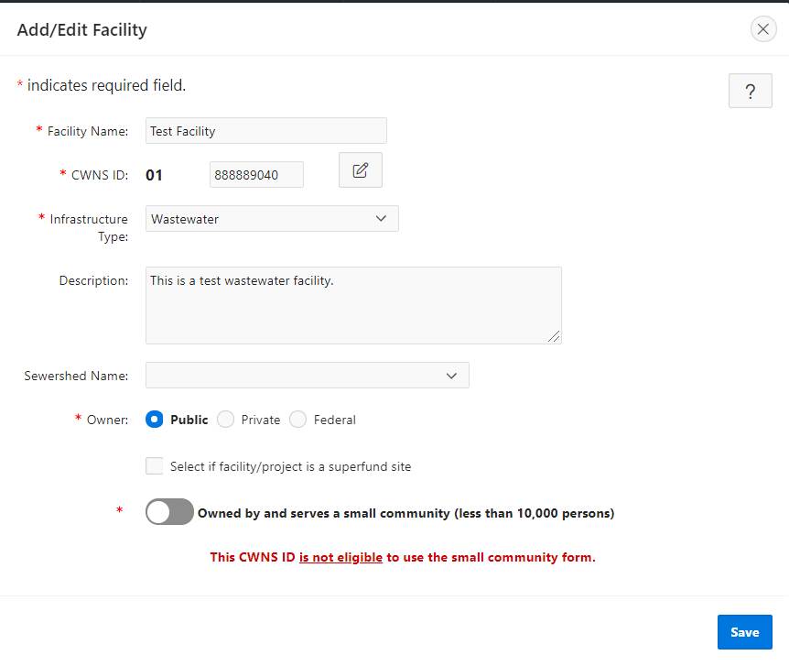

Figure 5‑7. “Add/Edit CWNS ID” window.

Table 5‑4. Descriptions of Data Fields to Create a New CWNS ID

| Field | Description | Required/Optional |
| --- | --- | --- |
| CWNS ID Name | Name of the CWNS ID. | R |
| CWNS ID | The unique 11-digit identification number assigned by the state to each facility or group of related facilities. The first two digits are required to be the state’s two-digit Federal Information Processing Standards (FIPS) code. For a new CWNS ID, the DEP will automatically generate one that is random and unique.  Clicking the icon makes the CWNS ID editable. | R |
| Infrastructure Type | For the CWNS, infrastructure types are used to categorize groups of facility types based on pollution mitigation measures. Infrastructure types are wastewater, stormwater, NPS, and decentralized treatment. | R |
| Description | Description of the CWNS ID. | O |
| Owner | Select “Public,” “Private,” or “Federal.” | R |
| Superfund checkbox | If the CWNS ID is for a Superfund site, you can indicate this by selecting this box. | O |
| SEMS ID | If you have selected the Superfund checkbox, an input box will appear where a SEMS ID can be entered. See <https://www.epa.gov/enviro/sems-search> to search for a SEMS ID. | O |
| Small community toggle | Select if the population serviced by the CWNS ID is 10,000 or fewer. | R |

### Updating CWNS ID List Data for an Existing CWNS ID

To edit the CWNS ID metadata, click the  icon next to the CWNS ID name in the CWNS ID list. This will open the same screen shown in Figure 5‑7, with all the data populated. Edit the desired information and select “Save.”

### Entering the Survey for a CWNS ID

After selecting a CWNS ID, the state can enter the survey and begin data entry. Each CWNS ID has a unique link to the survey data entry area. To navigate to this area, select the “Enter Survey”  icon in the CWNS ID list (Figure 5‑8).

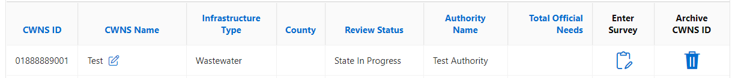

Figure 5‑8. “Enter Survey” icon.

## Data Entry Workflow

All data fields for a single CWNS ID survey are available on a scrollable page. Some sections of the survey contain popup windows to facilitate data entry. The data are saved in each section so that users do not have to complete the survey in one session.

EPA recommends that states complete data entry for a CWNS ID in the order the sections appear on the page, from top to bottom, as shown in Figure 5‑9. This is because later data fields can be dependent on earlier fields. Completing sections out of order may require the state to revisit a section that was previously completed, though the flexibility exists to work on most sections independently.

To help states understand where dependencies occur, Table 5‑5 lists out the major data area dependencies by section.

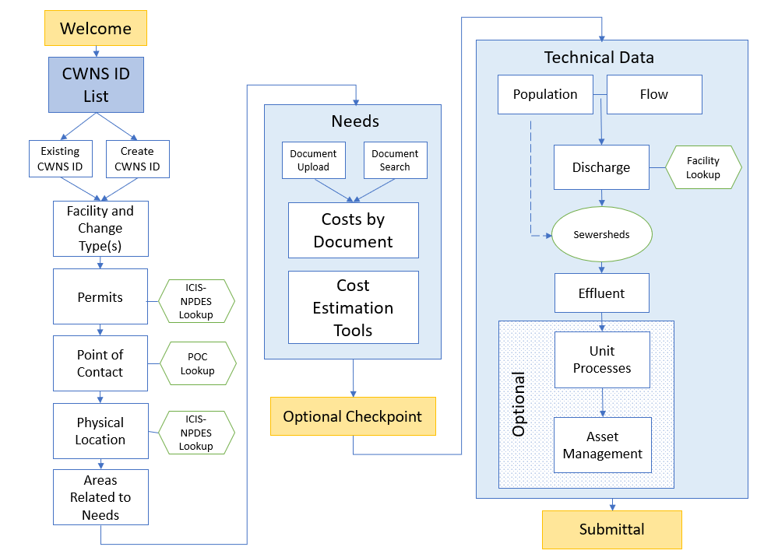

Figure 5‑9. CWNS ID data entry workflow diagram.

Table 5‑5. Data Area Dependencies

| Data Area | Dependency | Helpful For |
| --- | --- | --- |
| Facility and change types | None | All sections |
| Permits | None | Physical location |
| Point of contact | None |  |
| Physical location | Facility types | Areas related to needs |
| Areas related to needs | None | CETs |
| Documents | Change types |  |
| Costs by document | Change types |  |
| CETs | Change types, areas related to needs |  |
| Population | Facility types |  |
| Flow | Facility types |  |
| Flow to population ratio | Population, flow |  |
| Discharge | Facility types |  |
| Sewersheds | Facility types, population, discharge |  |
| Effluent | Facility types |  |
| Unit processes | Facility types |  |
| Asset management | None |  |

### CWNS ID Top Menu and Data Entry Notes

After the state coordinator clicks on the “Enter Survey” button for a CWNS ID, a top menu will appear to help the state easily identify which CWNS ID they are currently working on (Figure 5‑10). There are also two useful links:

* The link on the top left side of the bar will return the state to their CWNS ID list.
* The top right side contains a link to “Data Entry Notes” (Figure 5‑11), which opens a window where a state can enter useful notes about the CWNS ID. Notes must be saved using the “Save” button when finished.



Figure 5‑10. CWNS ID top menu.

Figure 5‑11. “Data Entry Notes” screen.

### Text Description automatically generated with medium confidenceSidebar Navigation

The state can use the navigation pane on the left of the screen to move between sections of the survey page. This pane is automatically open when a state enters a survey.

* Click the close  icon in the top left corner of the screen to close the pane.
* Click the hamburger  icon to reopen the navigation pane.

## Facility Types and Change Types

### Facility Types List

The state must select facility types and change types for each CWNS ID to indicate the types of facilities and planned changes for the CWNS ID (see Appendix B for the full list of facility types with definitions and Appendix C for the full list of change types with definitions). Clicking the “Edit” pencil icon will allow the state to modify facility types and change types (Figure 5‑12). The “Delete” button will remove the selected row.

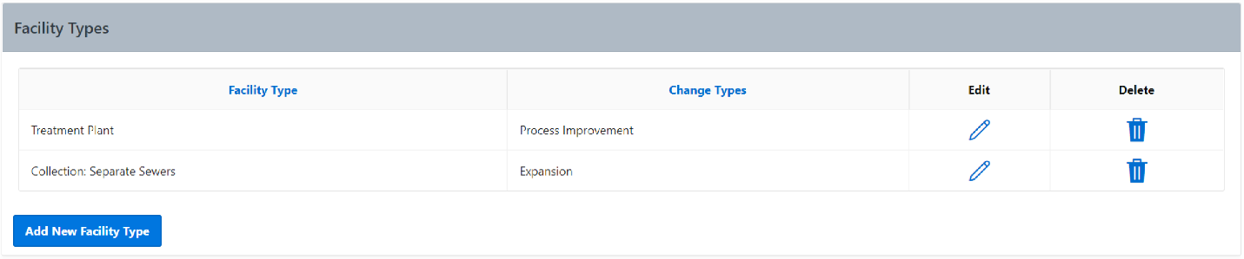

Figure 5‑12. Facility types list.

### Adding a New Facility Type and Associated Change Types

Selecting “Add New Facility Type” will open a window where the state can add facility types and associated change types (Figure 5‑13). The options for the facility types will be filtered based on the infrastructure type indicated in the “Add/Edit Facility” window shown in Section 5.7.3. Facility types must be unique, but each facility type can have multiple change types if applicable. Selecting a change type other than “no change” is an indication that one or more capital investments are needed for that facility and suggests that the state will be entering needs data later in the portal. If “no change” is selected for all facility types within the CWNS ID, needs data will not be required later in the survey.

If the facility does not currently exist but will be constructed during the survey period, select “new.” If the facility is to be completely abandoned and not replaced, select “abandonment.” Those two change types cannot be used in conjunction with any other change types. Existing facilities can have multiple change types.

To add a new facility and change type(s):

1. Click the “Add New Facility Type” button under the facility types table.
2. Select the desired facility type from the available options in the dropdown (already filtered based on indicated infrastructure type).
3. Select change type(s). If the facility already exists and has planned changes, select “Existing” and choose one or more options from the list of change types.
4. Save.

Repeat steps 1–4 to add another facility/change type combination if desired. Available options will be filtered based on previous choices.

Figure 5‑13. “Add/Edit Facility Type” window.

Table 5‑6. Descriptions of Data Fields to Create a New Facility Type

| Field | Description | Required/Optional |
| --- | --- | --- |
| Facility type | For the full list and definitions of facility types, see Appendix B. | R |
| Change type | For the full list and definitions of change types, see Appendix C. | R |
| If “existing” is chosen as a change type, one or more of the checkboxes that appear must be selected. | R |

### Confirming Selected Facility Types

After modifying the facility types and change types, the state is prompted to confirm their selections and continue with the survey (Figure 5‑14). Clicking “Confirm Facility Types and Continue Survey” will allow the state to continue data entry.

Facility types and change types are important pieces of information that determine the flow of data entry. Changing the facility and change types after editing later sections of the survey for a CWNS ID is *not* recommended. As much as possible, finalize all facility types and change types before continuing to the next sections of the survey.

!

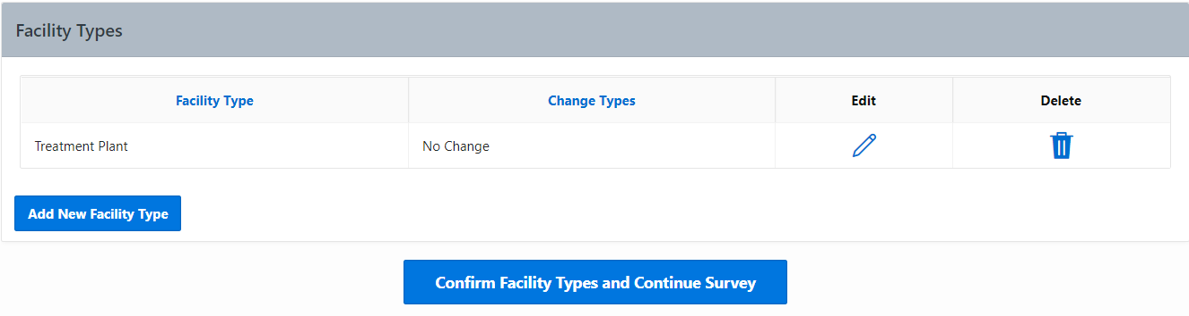

Figure 5‑14. Facility types and change types confirmation window.

## Permits

Both NPDES and non-NPDES permits associated with the CWNS ID can be entered into the DEP. NPDES permits typically have the form of state abbreviation, followed by up to seven numbers and letters (e.g., OH1234567). If the state knows the permit number, they can look up information reported by the facility (such as flow or location) to fill in other survey fields using data from the NPDES program database. The DEP uses a web service developed by the Enforcement Compliance History Online website (<https://echo.epa.gov/>) to retrieve NPDES program data.

States can view all the permits currently associated with the CWNS ID in the permits list. They are also able to add NPDES and non-NPDES permits, delete permit associations, and update permit information.

The DEP will be prepopulated with data from the previous survey; however, some information may be out of date. States should review and remove any permits that are no longer relevant.

Figure 5‑15. Permits associated with a facility.

### Adding a NPDES Permit

Clicking “Add NPDES Permit” will open the window shown in Figure 5‑16 with data fields listed in Table 5‑7. To add a NPDES permit:

1. Search for the permit number or facility name and select it from the search results.
2. The default search results only include active permits within ICIS-NPDES. Unchecking “Active Permits” will allow the state to view terminated permits.
3. Multiple permits can be associated at once using the check boxes and saved by clicking “Add Selected Permit(s).”

Select “Add Selected Permit(s)” to associate the permit with the current CWNS ID.

If a permit is not in ICIS-NPDES, the state can still add it as a non-NPDES permit (see Section 5.10.2).

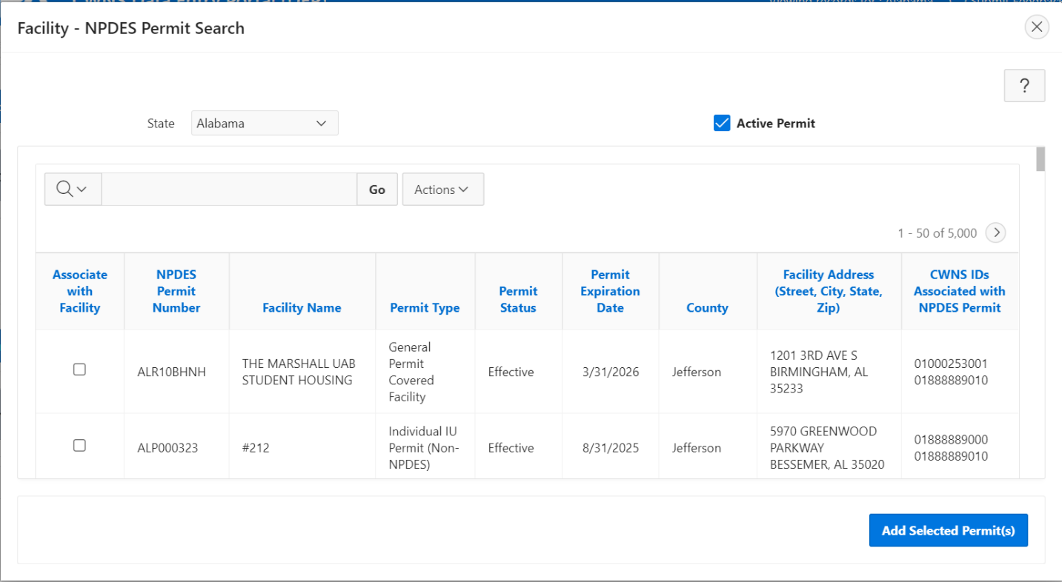

Figure 5‑16. NPDES permit search window.

### Adding a Non-NPDES Permit

To add a non-NPDES permit, select “Add Non-NPDES Permit.” In the window that opens (Figure 5‑17):

1. Enter the permit number.
2. Select the permit type from the dropdown (choose the most appropriate option).

Save.

This is also where NPDES permits that are no longer in ICIS should be added. This can be indicated using the permit type dropdown.

Figure 5‑17. “Add/Edit Non-NPDES Permit” window.

Table 5‑7. Descriptions of Data Fields to Add a New Non-NPDES Permit

| Field | Description | Required/Optional |
| --- | --- | --- |
| Permit number | A unique number for the permit | R |
| Permit type | Select from the dropdown list: NPDES permit no longer in ICIS, other, state—groundwater, state—land application, state—other | R |

## Point of Contact

States can view associated facility points of contacts and add, edit, delete, or search for new or previously entered points of contact. The DEP is prepopulated with data from the 2012 survey; however, some information may be out of date. States should review and remove any point of contacts that are no longer relevant.

### Point of Contact List

The point of contact list (Figure 5‑18) will display relevant information for each point of contact associated with the CWNS ID, including when it was last updated.

!

Note that while most point of contact information is optional, the state must select one responsible entity (and associated authority name) for each CWNS ID.

Figure 5‑18. Point of contact list.

### Point of Contact Search

Selecting “Point of Contact Search” will open the window shown in Figure 5‑19. This feature allows states to search across all previously entered point of contacts to quickly add to the CWNS IDs list. States can search the list by state or keyword to associate points of contact.

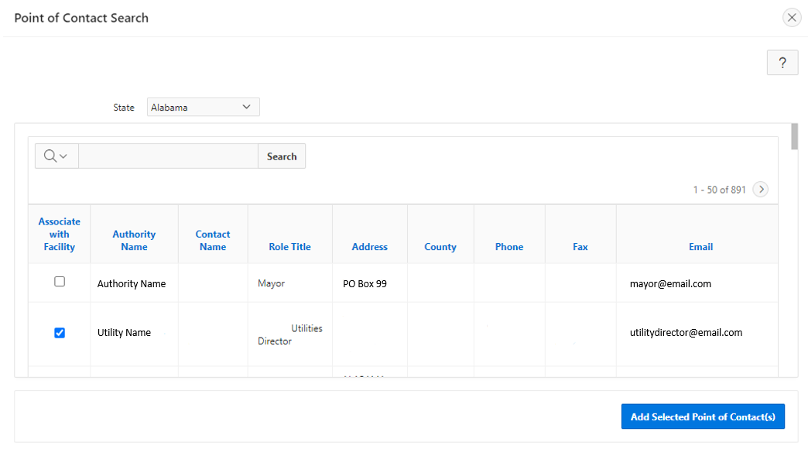

Utilities Director

Figure 5‑19. Point of contact search.

### Add Point of Contact

Selecting “Add Point of Contact” will open the window shown in Figure 5‑20 with the data fields listed in Table 5‑8. To add a point of contact:

1. Fill in the authority name.
2. If the authority is the responsible entity for the CWNS ID, indicate this by clicking the checkbox next to “Responsible Entity.” One point of contact entry must be specified as the responsible entity.
3. (Optional) Fill in the remaining fields.

Save.

The point of contact will be added to the DEP after the data are saved and will be available in the point of contact search for other CWNS IDs.

This contact information may be published as part of facility fact sheets, so only provide publicly available numbers or contact information that can be shared with the public.

!

Figure 5‑20. “Add/Edit Point of Contact” window.

Table 5‑8. Descriptions of Data Fields to Create a New Point of Contact

| Field | Description | Required/Optional |
| --- | --- | --- |
| Authority name | Name of the authority for this CWNS ID | R |
| Contact name | Name of the point of contact | O |
| Role/title | Role or title of the listed point of contact | O |
| Phone number | 10-digit phone number for the listed point of contact | O |
| Ext | Extension for the phone number | O |
| Fax number | 10-digit fax number for the listed point of contact | O |
| Email | Email address for the listed point of contact | O |
| Address | Street address for the listed point of contact | O |
| Address 2 | Additional street address information for the listed point of contact | O |
| City | City for the listed point of contact | O |
| State | State for the listed point of contact | O |
| County | County for the listed point of contact | O |
| Zip | 5-digit ZIP code or ZIP+4 digit code for the listed point of contact | O |
| Responsible entity | Check this box to indicate that this point of contact is the primary authority responsible for the CWNS ID (one responsible entity must be selected per CWNS ID) | O |

## Location

The location data area allows the state to view, add, edit, or delete the physical location of the CWNS ID (Figure 5‑21). The physical location should represent either the point location of the facility (e.g., treatment plant) or the area covered by the CWNS ID (e.g., OWTS). Latitude and longitude information must be provided for all CWNS IDs (either point location or approximate centroid). States can also identify additional/multiple areas related to needs within the location data area.

Figure 5‑21. Physical location data area.

### Adding a Physical Location

The state must update the physical location type based on infrastructure type. Wastewater CWNS IDs require coordinates and an address, while other infrastructure types can have locations that cover larger areas, such as cities and towns, countries, or an entire watershed or state. Refer to Table 5‑9 for the location options available for each infrastructure type.

Table 5‑9. Location Options by Infrastructure Type

| Infrastructure Type | Single Latitude/Longitude | City(ies)/Towns | Indicate Entire County | Indicate Entire Watershed | Indicate Entire State |
| --- | --- | --- | --- | --- | --- |
| Wastewater | Available | n/a | n/a | n/a | n/a |
| Stormwater | Available | Available | Available | n/a | n/a |
| NPS | Available | n/a | Available | Available | Available |
| Decentralized | Available | Available | Available | n/a | n/a |

Selecting “Add/Edit Physical Location” will open the window shown in Figure 5‑22. To add a physical location:

1. Select the type of physical location to be entered (list is filtered based on infrastructure type).
2. Update the coordinates by either:
3. Selecting “Confirm or Update Coordinates on Map.” This button will open a map where the state can search for an address or select a point on the map (Figure 5‑23).
4. Selecting “Use location from associated NPDES Permit” (only available if the state has already associated a NPDES permit with the CWNS ID). If multiple permits have been associated, the dropdown will list all of them. Selecting a permit number will autofill location information, including the address.

Note that not all NPDES permits have location information. If this is the case for the selected permit, this information will not populate.

!

1. Enter the required location fields (i.e., city[ies] or towns, zip code, county, watershed, or state).

Save.

Using the map tool will autofill information in areas related to needs shown in the next window (see Section 5.12.1).

Figure 5‑22. “Add/Edit Physical Location” window.

Figure 5‑23. Physical location mapping tool.

### Areas Related to Needs

The areas related to needs data area allows states to associate additional locations, including county(ies), congressional district(s), and watershed(s) (Figure 5‑24) with the need, if beyond the primary location identified in the previous “Locations” window. As previously mentioned, this window will be autofilled based on the location selected in the physical location window. States must indicate the primary county, congressional district, and watershed where the majority of needs occur, and can select additional counties/watersheds if necessary. If the state does not indicate any other locations in the table, it will include the locations based on the map selection by default. Any auto-generated areas related to needs can be removed if the information is not accurate.

EPA recognizes that the congressional districts may change during the data entry period. If this is the case, the primary congressional district will be updated based on the coordinates provided in the physical location. EPA may reach out to states to clarify location requirements if needed.

!

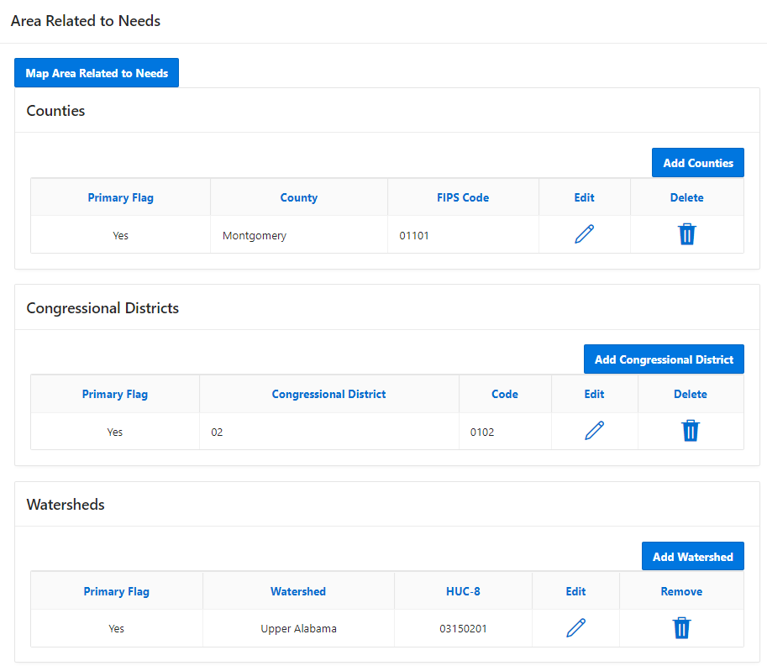

Figure 5‑24. Areas related to needs data area.

### Adding Areas Related to Needs

There are two ways to add an area related to needs: using a map or manually. To use the map feature:

1. Select “Map Areas Related to Needs.” This will open the map shown in Figure 5‑25.
2. The map will open to the coordinates provided in the physical location section.
3. States can change the map layers by selecting the appropriate radio button in the top right corner of the map. The available layers are congressional districts, HUC (watersheds at the HUC 8 level), and counties.
4. Review the information provided in the pop-up leaflet. If the location is incorrect or is not provided, click the correct area on the map. If needed, used the search  feature on the map to search for a location.
5. Once the location information is correct, click “Submit.” All three “Area Related to Needs” tables will update (though duplicate entries will not be added).
6. If no other areas are indicated in the “Areas Related to Needs” tables, the first selection using the map will automatically assign these areas as “primary.” This will not happen if the map is used again.
7. The state can edit the primary locations by clicking the pencil  icon next to the desired primary location and selecting the primary checkbox. This will remove the primary indicator from another area if it was previously selected.

Figure 5‑25. Mapping feature for areas related to needs.

To manually add an area related to needs, click the “Add” button for counties, congressional districts, and watersheds. Select the desired location from the dropdown and indicate if it is the primary location by selecting the primary checkbox.

## Documents

The documents data area (Figure 5‑26) allows the state to use one or more documents to support the needs data entered into the DEP for each CWNS ID. To do this, the state must link all relevant documents to the CWNS ID, then assign costs by category to the linked documents, either directly or by using CETs.

Figure 5‑26. Documents data area.

### Linking Documents to a CWNS ID

The state can link a document to a CWNS ID by searching for a document that was previously uploaded for another CWNS ID or within the main document management area (see Section 5.5) or by uploading a new document. The following sections will describe both processes.

The document metadata (data entered during document upload) will be the same for all CWNS IDs linked to the document. If the state edits the document metadata for one CWNS ID, it will change for all CWNS IDs. If the state needs to indicate different metadata for a single document (such as different annotation methods), they must upload the document again as a separate document. It is recommended that states include information about this in the “Notes” section in the document upload area.

!

#### Searching for an Already-Uploaded Document

Clicking “Documents Search” will open the window shown in Figure 5‑27. The document search allows the state to search for all previously uploaded documents (described in Section 5.5). To associate a previously uploaded document:

1. Search for documents by name or other metadata using the search bar or by filtering and sorting using the table column headers.
2. Select one or more document(s).
3. Click “Add selected document(s) to this CWNS ID.”

Figure 5‑27. “Document Search” window.

#### Adding a New Document

Clicking “Add Document” will open the window shown in Figure 5‑28. To upload a new document and automatically associate it with the current CWNS ID:

1. Indicate how this document will be annotated. Annotation is required for total CWNS ID costs over 40 million dollars, or if all document types selected are “alternate.”
2. If the annotation method is unknown, states can select “Not Annotated” until the CWNS ID that is linked to the document has costs over 40 million or none of the linked documents are “primary”; then the document will need to be annotated. Note that if this document is linked to other CWNS IDs, its annotation must include information for those CWNS IDs if they also meet the above criteria.
3. If annotating in the DEP, page number fields will appear next to document metadata that must be filled in. Select the checkbox next to “Title, author, and published date on the first page” if the metadata is on the first page of the document.
4. If annotating in Excel, indicate this for the PDF and for the Excel annotation document that will be uploaded as a separate document (Document type 96).
5. Select the document type. This may open additional fields (see Section 5.5.3 for more information). This is the same module described in Section 5.5.
6. Enter all required fields for the document metadata. If the base month/year of the costs presented in the document is unknown, it should be the same as the document’s published date. For Excel spreadsheet annotations (document type 96), enter the document date (and base month/year) as the date the document was created. Indicate in the document title which documents or CWNS IDs are annotated within the spreadsheet (e.g., “Annotation for IUP”) and list the state coordinator who created the spreadsheet as the author. If not indicated in the document title, note which documents are annotated within the spreadsheet in the “Notes” field.
7. (Optional) Include any notes about the document that might be helpful to the state or to the CWNS review team such as whether the uploaded document is supporting another or if it is a duplicate of a previously uploaded document.
8. Select “Upload document (Preferred) – PDF and XLSX files only.” Navigate the computer’s file system to select the correct document.
9. If the state needs to send a physical copy of the document, use the instructions in Section 5.5.3.3.

Save to upload the document to the DEP. Once saved, the document will show up in the document list and any document search.

Figure 5‑28. “Upload New Document/Edit Document” window.

#### Unlinking a Document from a CWNS ID

To unlink a document from a CWNS ID, the state should click the  icon under “Remove” as shown in Figure 5‑26. This will remove the document and any associated costs from the CWNS ID, but it will not delete the document from the system.

## Capital Costs

To add costs, the state must first select a document that was previously linked to a CWNS ID and then assign it to categories. To add a document to the costs by category table, select “Add Documented Cost.” This will open the window shown in Figure 5‑29. Then:

1. Select the document from the dropdown. This list is filtered based on documents linked to the CWNS ID.
2. Select the need category(ies) that are relevant to the costs in the document.

Save.

Figure 5‑29. Adding documents to the “Cost by Category” table.

Do not add Excel spreadsheet annotations (document type 96) to the costs by category table. It is important to add costs to the document that has the correct base month/year for the cost being entered.

!

When that is done, the “Cost by Category” table will update to include the document and each selected category (see Figure 5‑30). Now costs can be added to the document and category.

Figure 5‑30. “Cost by Category” table.

### Entering Capital Costs

The state can add costs by clicking “Add Documented Cost” in the “Cost by Category” table. This will open the window shown in Figure 5‑31. Then:

1. If treatment plant is indicated as a facility type, the form will ask for the type of treatment plant. Select the appropriate option from the dropdown.
2. If the costs are not for the treatment plant, indicate this by selecting “Not Applicable.”
3. If the state would like to use the annotation table to sum costs, they can select the “Use Table to Sum Costs?” toggle to open the table.
4. If the state has indicated that they are annotating in the DEP for the selected document, the table will be automatically set to open and must be used to annotate costs. Enter project cost information line by line. Click “Add Project” to add a new line. When a line is highlighted, clicking “Remove Project” will remove it.
5. If the table is open, states will not be able to enter an amount directly in the “Base Amount” field. This will automatically be summed from the cost column in the table.
6. The adjusted amount for inflation is a view-only field automatically calculated using the base month/year indicated in the document metadata.
7. (Optional) Enter project start and end years.
8. Indicate if the cost addresses an SSO. This field may not display based on previous selections.
9. (Optional) Enter notes about the added costs that may not be clear in either the annotation or the document itself.
10. Save.

Figure 5‑31. Adding costs by document and category.

## CET Inputs

CETs (Figure 5‑32) are available for states to use based on earlier DEP inputs and if a facility does not have any existing documents that include costs. State coordinators can provide inputs for estimated costs by clicking “Add Estimated Cost” in the “Cost by Category” table. This will open the window shown in Figure 5-32. The dropdown list will include the CETs available based on the infrastructure and facility types selected at the beginning of data entry. States will be prompted to select the document used to justify projects and the Needs Category associated with the cost. The document must contain the values used to calculate the cost estimate, such as the future design flow for the treatment plant CET.

Figure 5‑32. Cost estimation tools data area.

### Wastewater: Treatment Plant CET

As discussed in Section 4.4.4 and shown in Figure 5‑33 below, the treatment plant CET required inputs are zip code, practice type (lagoon, aerated lagoon, secondary mechanical, disinfection only), construction type (new/replace, rehabilitation, treatment upgrade, expansion, add disinfection), and future design flow in MGD. Limits on acceptable flows are practice and construction type dependent and are also covered in Section 4.4.4.

Figure 5‑33. Wastewater treatment plant CET window.

### Wastewater: Collection CET

As discussed in Section 4.4.4 and shown in Figure 5‑34 below, the collection CET required inputs are need category and construction type (new, replace, or rehabilitation). For pipe projects, inputs also include total length of pipe. For pump station projects, inputs also include capacity in MGD and number of pump stations. Limits on acceptable parameters are practice and construction type dependent and are also covered in Section 4.4.4.

Figure 5‑34. Wastewater collection CET window.

### Decentralized CET

As discussed in Section 4.4.4 and shown in Figure 5‑35, the decentralized CET required inputs are zip code, construction type (new or rehabilitation/repair/replace), and sizing method (either population or number of homes served). When using the population, states will be asked to estimate the population per household. Graphical user interface, application

Figure 5‑35. Decentralized CET window.

### CSO CET

As discussed in Section 4.4.4 and shown in Figure 5‑36, the CSO CET allows states to estimate costs to control CSOs using a storage facility or stormwater practices. The required input(s) for storage facility is volume in MG, and for stormwater are zip code, practice type, construction type (new development or redevelopment), and quantity. Stormwater inputs must also include one of the following sizing methods: practice area, practice volume, or drainage area and drainage area impervious surface. Limits on acceptable parameters are practice and construction type dependent and are also covered in Section 4.4.4.

Figure 5‑36. CSO CET window.

### Stormwater CET

As discussed in Section 4.4.4 and shown in Figure 5‑37, the stormwater CET required inputs are zip code, practice type, construction type (new development or redevelopment), and quantity. Inputs must also include one of the following sizing methods: practice area, practice volume, or drainage area and drainage area impervious surface. Limits on acceptable parameters are practice type dependent and are also covered in Section 4.4.4. Graphical user interface, application

Figure 5‑37. Stormwater CET window.

### NPS: Agriculture CET

As discussed in Section 4.4.4 and shown in Figure 5‑38, the NPS agriculture CET required inputs are total harvested acres and percent acres of need. This tool is designed to estimate needs for the entire state (for states for which that data exists) or multiple counties. If the state coordinator has documented needs in addition to those estimated by the Agriculture CET, those needs should be entered under one or more separate CWNS ID(s) and the locations associated with the respective IDs should not overlap to ensure needs are not double counted.

States have the option to use EPA’s Cropland Acres Tool to estimate acres of need on a state or county basis. They can do this by entering the total number of cropland acres in the state, and the tool will populate the “Acres of Need” field. The total number of cropland acres in a state or county can be found using USDA’s Census of Agriculture at <https://www.nass.usda.gov/AgCensus/>. The Acres Tool calculates the proportion of acres requiring conservation practices using NRCS’s Conservation Effects Assessment Project (CEAP) data, which can be found at <https://www.nrcs.usda.gov/wps/portal/nrcs/main/national/technical/nra/ceap/>. For more information see section 6.2 in *2022 Cost Estimation Tool Methods*.

If states have their own estimates of needed acres, they can indicate that they would not like to use EPA’s Acres Tool and enter their estimate in the “Acres of Need” field. However, if using this approach, states must ensure that their estimate of “Acres of Need” matches the assumptions in the agriculture cropland CET. For more information see section 6.2 in *2022 Cost Estimation Tool Methods*.

Figure 5‑38. Agriculture CET window.

### NPS: Silviculture CET

As discussed in Section 4.4.4 and shown in Figure 5‑39, the NPS silviculture CET required inputs are total harvested acres and percent BMP implementation rate. This tool is designed to estimate needs for the entire state for states for which that data exists. To estimate a state’s total harvested acres, visit <https://www.fia.fs.fed.us/tools-data/index.php>; to estimate a state’s percent BMP implementation rate, visit <https://www.stateforesters.org/bmps/>. For more information see section 7.2 in *2022 Cost Estimation Tool Methods*.

If the state coordinator has documented needs in addition to those estimated by the Silviculture CET, those needs should be entered under one or more separate CWNS ID(s) and the locations associated with the respective IDs should not overlap to ensure needs are not double counted.

Figure 5‑39. Silviculture CET window

## Population and Flow

The population and flow data areas allow the state to view, edit, and update the population and flow for the CWNS ID (Figure 5‑40) and review the corresponding flow to population ratio.

Figure 5‑40. Population and flow data areas.

### Population

Population is required for:

* Collection: separate sewers
* Collection: combined sewers
* OWTS
* Clustered system

Selecting “Edit Population” (Figure 5‑41) allows the state to update the population information for the CWNS ID.

For this data area:

* “Residential Population” applies to people who live within the service area of the selected facility.
* “Non-residential Population” applies to people who do not live within the service area of the facility but still use or are served by the associated sewers, treatment plants, or decentralized treatment systems. This population includes transient, seasonal, or commuting workers and tourists.
* Upstream population—that is, the population sent downstream from a linked upstream facility in a sewershed—is automatically calculated by the DEP. This information can be seen by clicking “View Upstream Details.”
* “Projected Design Population” refers to the estimated population in 2042, when planned changes are complete. This is particularly important where reported needs are to increase the population served by the CWNS ID. If the state does not have future population data for a CWNS ID, they should default to the 2022 population value.

The DEP will not allow states to enter population for CWNS IDs with treatment plant as the only facility type. Each treatment plant must receive its population from an associated collection system to prevent double counting population from collection systems and treatment plants.

!

Selecting “Add/Edit Population” will open the window shown in Figure 5‑41 and allow the state to update the population information for the CWNS ID. To edit the population:

1. Enter the current and projected residential design population for the receiving collection: that is, the population received (or collected) directly by the CWNS ID.
2. If available, enter the current and projected non-residential design population for the receiving collection.

Save.

Figure 5‑41. Adding/editing population Information.

### Flow

After clicking “Edit Flow Information,” states have two options for inputting flow based on the information they have available, either by entering individual flows by category or by entering total flow:

1. If information on individual flow types (e.g., municipal contribution) is available, use the “Disaggregated Flow Options” radio button and enter values for municipal, industrial, and/or infiltration flow (Figure 5‑42). The DEP will automatically sum the values in each row to calculate a total flow.
2. If disaggregated flow information is not available, change the input type to “Total Flow Only” and only enter information in this row.
3. When the state toggles between the two options, a warning will appear (Figure 5‑43), requiring approval to delete previously entered information. Clicking “Yes” will refresh the previous window and allow the state to only enter total flow information (Figure 5‑44).

Figure 5‑42. “Add/Edit Flow Information” window for disaggregated flows.

Figure 5‑43. Total flow warning.

Figure 5‑44. “Add/Edit Flow Information” window for total flow.

### Flow to Population Ratio

The DEP calculates the flow to population ratio based on the population and flow previously entered by the state.

$$Flow to Population Ratio \left(GPCD\right)= \frac{(Total Flow×1,000,000)}{\begin{aligned}Resident Receiving Collection \\ Population+(0.6 × \\ Non‐resident Receiving \\ Collection Population)\end{aligned}}$$

If the ratio is outside 25–300 gallons per capita per day (GPCD) for current design flow or future design flow, the DEP will prompt the state to explain by selecting a reason from a dropdown menu (Figure 5‑45). If more than one flow value is outside the range, only one reason is needed.

Figure 5‑45. Population to flow ratio.

## Discharge

Discharge is required for:

* Treatment plant
* Collection: combined sewer
* Collection: separate sewer

Discharge is optional for:

* Decentralized
* Stormwater
* Other facility types under wastewater

The discharge data area allows the state to add, delete, or update the different types of discharge for the CWNS ID. The DEP will be prepopulated with data from the previous survey; however, some information may be out of date. States should review and remove any data that are no longer relevant.

### Discharges List

In the discharge area (Figure 5‑46), the state can review the type(s) of discharge, percent of discharge (2022 or 2042 estimated), and receiving facility associated with the CWNS ID. The state can also edit, add, or delete types of discharge as needed. The percent discharge must sum to 100 percent or 0; a total percent discharge of 0 indicates that the type of discharge does not exist either in 2022 (this facility is closing) or is not estimated to exist in 2042 (the facility will close).

Figure 5‑46. Discharge data area.

### Adding a Type of Discharge

Clicking “Add Discharge Method” will open the window shown in Figure 5‑47 with fields listed in Table 5‑10. To add a type of discharge:

1. Select the type of discharge from the dropdown menu.
2. If “Discharge to Another Facility” is selected, a data entry field will appear with a “Look up Facility CWNS Number” button that will send the state to a lookup window where they can search for a CWNS ID (Figure 5‑48).
3. Enter the current percent discharge.
4. Enter future estimated percent discharge.
5. Save.
6. Repeat steps 1–4 to add as many types of discharges as needed.

If the sum of the discharge methods is not 100% (or 0%), the DEP will display a warning in red text. Use the edit pencil  icon to edit the values in the discharge methods as needed.

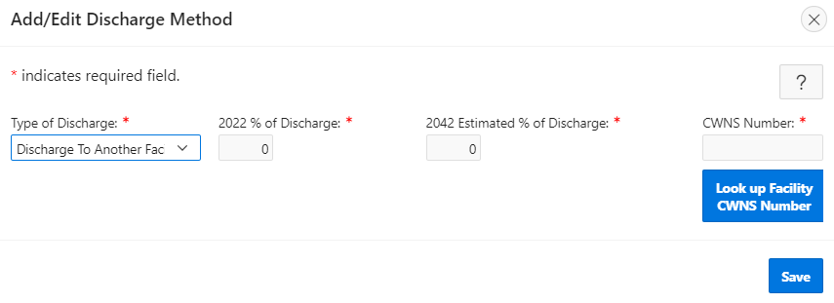

Figure 5‑47. “Add/Edit Discharge Method” window.

Figure 5‑48. Facility CWNS ID search.

Table 5‑10. Descriptions of Discharge Data Fields

| Field | Description | Required/Optional |
| --- | --- | --- |
| Type of discharge | Select one of the discharge types from the dropdown list. Only methods that are valid for the facility type are listed. Only the discharge method “Discharge to Another Facility” may be selected multiple times. | R |
| 2022 % of discharge | Input the % of discharge that is being sent to the selected type of discharge. | R |
| 2042 estimated % of discharge | Input the estimated % of discharge for 2042 to the selected type of discharge. | R |
| CWNS ID | The CWNS ID of the facility receiving the discharge. | R* (when discharge to another CWNS ID is selected as the type of discharge) |

### Building and Editing a Sewershed in Discharge

The discharge data area is the only section where sewershed linkages can be built. The amount of wastewater sent on, and to where, is determined when a state enters a percent discharge for a discharge type of “Discharge to Another Facility.” That percent discharge is applied to the total population.

Note that only the links downstream from the current CWNS ID can be added. To add upstream linkages, go to the upstream facility and create downstream links.

!

## Sewersheds

As indicated above, a sewershed is a network of linked facilities that indicates the number of people being treated by a particular facility. Especially important is the total number of people being treated by wastewater treatment plants. Wastewater treatment plants are generally the “end facility” in the network of the sewershed (where the flow ends up). To calculate the total population served by a plant, the DEP sums the upstream population values based on the indicated discharge linkages.

### Sewershed at a Glance

The DEP includes a “Sewershed at a Glance” feature that maps the sewershed network so the state can quickly visualize if the linkages are correct. The feature displays the current CWNS ID with a bright blue highlight and indicates the direction of flow using arrows from facility to facility with the percent of discharge being sent onwards. Figure 5‑49 shows a network of six example CWNS IDs.

Double clicking on a facility in the sewershed visualization will send the state to that CWNS ID survey. This is a quick way to move around the sewershed.

Sewershed linkages can only be completed in the discharge data area (Section 5.17). Population must be edited in the population data area (Section 5.16.1).

!

Figure 5‑49. Sewershed at a Glance example.

### Sewershed Table

The sewershed table displays population and discharge percentage for each facility in the sewershed. The selected CWNS ID is indicated in bold. States can click the “Enter Survey”  icon for discharge or population to be redirected to that survey section for the CWNS ID they selected to quickly edit sewershed details.

Editing information for a CWNS ID that is far upstream in the sewershed may have cascading effects on the population values for all downstream facilities. It is easiest to build and update sewersheds by moving from upstream to downstream facilities, editing the final “End Facility(ies)” last.

!

Note that the total population is not the population value treated by the facility. The total population is *all* population (wastewater) that moves through the facility. The population that is treated by the facility is the percent of discharge not discharged to another facility multiplied by the total population.

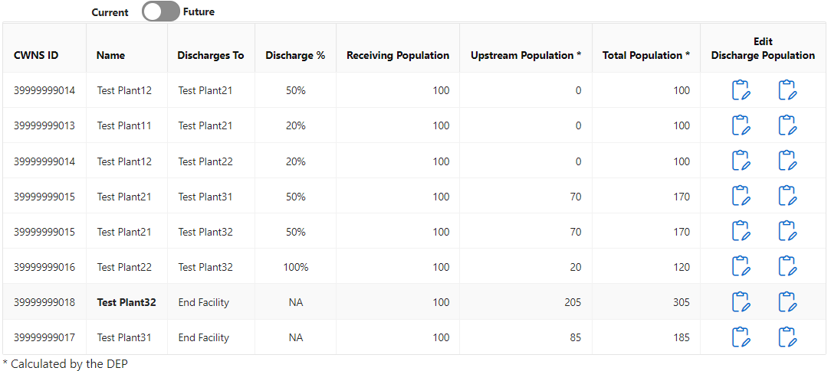

Figure 5‑50. Sewershed table.

## Effluent

The effluent data area allows the state to indicate the effluent treatment level for the CWNS ID (Figure 5‑51). For CWNS IDs with a change type of abandoned, only current treatment level data can be entered; for CWNS IDs with a change type of new, only future treatment level data can be entered. Change types are set at the beginning of the survey with facility types. It is important to set the change types before beginning this section—or, at the very least, to know if the facility is new or being abandoned.

Effluent is required for:

* Treatment plant

Effluent is optional for:

* Honey bucket lagoon
* Storage facility

Effluent treatment levels are defined in Table 5‑11. To edit the effluent data, click “Edit Effluent” to open the window shown in Figure 5‑51, then:

1. Enter the current effluent treatment level.
2. Indicate if there is currently disinfection in place.
3. Enter the future effluent treatment level.
4. Indicate if there will be disinfection in place.
5. If current disinfection is marked “Yes” and future disinfection is marked “No,” the DEP will display a warning indicating that it seems like disinfection is being removed. Make sure this is correct before continuing.

Save.

Table 5‑11. Effluent Treatment Level Definitions

| Effluent Treatment Level | Definition |
| --- | --- |
| Raw | No treatment. |
| Primary | Typically, less than 45 mg/L 30-day average concentration of biochemical oxygen demand (BOD5), achieved by removing floating debris and solids by screening, sedimentation, and skimming. The primary treatment must remove at least 30 percent of BOD5 and total suspended solids from the influent wastewater. |
| Secondary | Typically, 30 mg/L 30-day average concentration of both BOD5 and total suspended solids and pH 6–9 (secondary treatment levels required for some waste stabilization ponds and trickling filter systems may be less stringent). In addition, the secondary treatment must remove at least 85 percent of BOD5 and total suspended solids from the influent wastewater.  Secondary treatment is the minimum treatment required for discharges from all municipal wastewater treatment facilities by the CWA; facilities granted ocean discharge waivers under Section 301(h) are exempt from this requirement (listed in Appendix J). |
| Advanced | A level of treatment that is more stringent than secondary treatment or produces a significant reduction in nonconventional or toxic pollutants present in the facility’s effluent. Examples of advanced treatment indicators are nitrogen removal, phosphorus removal, ammonia removal, metal removal, and synthetic organic removal. |

Figure 5‑51. “Edit Effluent” window.

## Unit Process

Unit process is optional for:

* Treatment plant
* Phase I municipal separate storm sewer systems (MS4)
* Phase II MS4
* Non-traditional MS4
* Unregulated community stormwater
* NPS

The unit process data area allows the state to view, edit, and add new unit processes to the CWNS ID (Figure 5‑52). The DEP will be prepopulated with data from the previous survey; however, some information may be out of date. This section is optional and not required to submit the CWNS ID for federal review.

Figure 5‑52. Unit process list.

### Adding a Unit Process

Clicking “Add Unit Process” will open a new row of the unit process table for the state to edit (Figure 5‑53). To add a unit process:

1. Indicate the treatment type. Treatment type and unit process data elements are dropdowns. For the full list of unit processes for each infrastructure type, see Appendix K.
2. Select the unit process. This list is filtered based on the treatment type selection.
3. Indicate if the process currently exists or is planned to be installed.
4. (Optional) Add any notes about the process that may be useful to the state or to the CWNS team in understanding the facility.

Save.

Figure 5‑53. “Add/Edit Unit Process” window.

## Asset Management

The asset management data area allows the state to view, edit, and update the asset management practices for the CWNS ID (Figure 5‑54). This section is optional and not required to submit CWNS IDs for federal review. The costs entered should not be added as a part of the CWNS ID need but inform EPA about the state of asset management plans for the country’s utilities.

Asset management is optional for:

* All wastewater CWNS IDs
* All stormwater management CWNS IDs
* All decentralized CWNS IDs

Figure 5‑54. Asset management data area.

### Adding an Asset Management Practice

Clicking “Edit Asset Management” will open the window shown in Figure 5‑55. To add asset management information:

1. Select the level of implementation from the dropdown. See Table 5‑12 for a description of these choices.
2. Input the dollar values for the fields that appear below the implementation choice. The “Remaining Cost to Develop Program ($)” and “Annual Cost to Develop Program ($)” inputs are updated based on which implementation is selected from the dropdown.

Save.

Figure 5‑55. “Add/Edit Asset Management” window.

Table 5‑12. Descriptions of Data Fields to Create an Asset Management Practice

| Field | Description | Required/Optional |
| --- | --- | --- |
| Implementation | Select one of the implementation statuses from the dropdown list. | R |
| Remaining costs to develop program | Input the remaining costs. This is only available for “In Processes of Developing” or “Considering Implementation” selections. | R |
| Annual costs to develop program | Input annual costs for the program. This is only available for “Fully Implemented,” “In process of Developing,” or “Considering Implementation” selections. | R |

## Small Community Form

EPA has developed a web-based small community form, or SCF (document type 71) that states can provide to communities with populations of 10,000 or fewer to capture the needs of small communities that do not have other acceptable forms of documentation for needs.

In order to provide the form, the state needs to be able to confirm that the CWNS ID is owned by and serves a small community within the DEP. A state should not use the SCF if a community is not considered “small.” A CWNS facility is considered small if it meets all of the following criteria:

* It is not one of several facilities serving a community of more than 10,000 persons.
* It and its wastewater system are not within an urbanized area, so it is not a component of (and virtually indistinguishable from) surrounding adjacent entities that are not small.
* Its wastewater system is not physically connected to a regional treatment authority serving more than 10,000 persons.

If a returned SCF indicates that the community does not meet one of these criteria (e.g., the facility now serves more than 10,000 persons), the state should instruct the community to submit other documentation, as the SCF will no longer be accepted as documentation for that community.

Communities do not need access to the DEP to update the SCF. A small community will receive a unique URL that contains a copy of the data in the DEP to review and update. This copy is separate from the DEP data, so any data edited in it will not be reflected in the DEP. Once the form is returned, the state can upload the data into the DEP after reviewing them.

?

If the small community requests a paper copy of the SCF, see Section 5.5.3.3 for how to download and send the paper copy, then manually review, scan, and upload a PDF version of the completed form.

The 2022 SCF can be uploaded into the DEP and populate the CWNS ID with data completed by the small community. This can only be done if the small community completes and submits the form online. Data from hardcopy or PDF forms must be entered manually like all other document types.

### Indicating a CWNS ID Is a Small Community

Before they may send a community an SCF, the state must indicate that the CWNS ID is a small community in the CWNS ID list’s “Add/Edit CWNS ID” menu (Figure 5‑56).

1. Click on the  icon next to the facility name.
2. Select the toggle for “Owned by and serves a small community (10,000 persons or fewer).” *This must be selected to send and receive the SCF using the DEP.*

Save.

All CWNS IDs that were indicated as small communities in the 2012 survey will be indicated as small communities in the 2022 survey. The state should verify their status and, if necessary, change it by unselecting the small community toggle in the “Add/Edit Facility” menu in the CWNS ID list. See the steps above.

!

Once a state has indicated a community is small, that CWNS ID will be available to select in the next steps.

Figure 5‑56. Indicating a CWNS ID serves a small community.

### Managing Small Community Forms

States can manage SCFs in the “Manage Small Community Forms” area. This can be found in the top menu of the DEP (Figure 5‑57). This area will allow states to manage forms that are sent out to and returned by small communities.

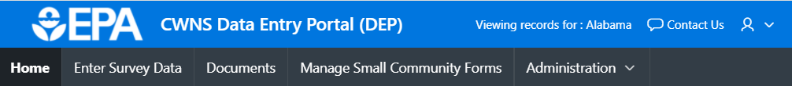

Figure 5‑57. “Manage Small Community Forms” in the CWNS top menu.

A state can add their state logo and state agency name to personalize the form and let small communities know the request is coming from the state. This logo will appear at the top of the page on the electronic version of the SCF.

The state also has the option to indicate if they have a state PE who is willing to certify costs if the small community does not have one. If so, the state can enter the PE’s contact information so they will be notified and sent the SCF after a community has completed it for certification. If the small community does not have a PE and the state has not provided an alternative PE, the form cannot be used to document costs.

In the “Manage Small Community Forms” area:

1. Click on the  icon to expand the “Small Community State Info” section (see Figure 5‑58).
2. Enter the name of the state environmental agency and agency contact information. This is the information that will be presented to the communities on their SCFs.
3. Select the “Choose file” option and upload the state logo.
4. If desired, select “Yes” for the PE question. This will open fields for the state PE’s contact information.
5. Enter the state PE’s name, email, and phone number. This information will not be available to the small communities but will allow the DEP to automatically send the form to the state PE via an online form if the community does not have a local PE to certify costs.

Click “Update” to save this information.

!

The logo should be square (or round) and of good quality. Its dimensions should be __ by ___ px for best results. Otherwise, it may be blurry, too small, or too large.

Figure 5‑58. Adding state information to the SCF.

### Adding a CWNS ID to the Small Community Form List

The small community form list is where the state can send and receive electronic SCFs. The list indicates if a form has been sent and received, as well as the total amount indicated in the form by the small community.

Small communities do not have to use the electronic version of the SCF. The paper version can be sent to states and, once returned, scanned and uploaded as all other document types (see Section 5.22.9). It is still helpful to indicate if the CWNS ID is a small community in the CWNS ID list, but the following process does not need to be used if a small community can only use paper documents.

!

Figure 5‑59. SCF list.

To add a CWNS ID to this list:

1. Click “Add Small Community Form” (see Figure 5‑59).
2. Use the search features to find the CWNS ID. Only CWNS IDs that have be indicated as small communities will show in the search feature (see Figure 5‑60).
3. Select the check box next to the CWNS ID.

Click “Add Selected Facility” to add the selected facility(ies) to the SCF list.

Figure 5‑60. Searching for a small community to add to the email list.

To delete an SCF, select the delete icon next to the CWNS ID in the SCF list. Note that this will not delete the CWNS ID, just the SCF associated with the ID. If a SCF is deleted from the list while the community has access to the link (i.e., after it is sent and before it is returned), the link will become “broken” and they will not be able to edit the data from the deleted SCF.

### Editing Small Community Data Before the Form is Sent

The state may want to edit the data in the SCF before sending the form to the small community to update. To do this, return to the main CWNS ID list and select “Enter Survey” as if updating any other CWNS ID. It is best that data be updated in the DEP this way before the form is sent. *Data cannot be edited in the Manage Small Community Forms area.*

### Small Community Form Workflow

The workflow presented in Figure 5‑61 below can help states facilitate the process of sending and receiving SCFs. As the form is updated, the state can track its status will change in the SCF list (shown in purple), which can help states determine where a particular form is in the workflow.

Figure 5‑61. SCF workflow.

### Sending a New Small Community Form

Once a CWNS ID has been added to the SCF list, the state can send the form to the small community via email. Each form will need to have a small community contact added to it before it can be sent. States can also add a personalized message to each email as desired. The default email is shown in Figure 5‑62.

statecoordinator@state.gov

Figure 5‑62: Default small community email.

To add a small community contact, go to “Manage Small Community Forms” and click the email  icon (Figure 5‑59), then:

1. Enter the contact information of the small community (Figure 5‑63**).**
2. (Optional) Add other recipient email addresses of the email.
3. (Optional) Add a personalized message.

Save.

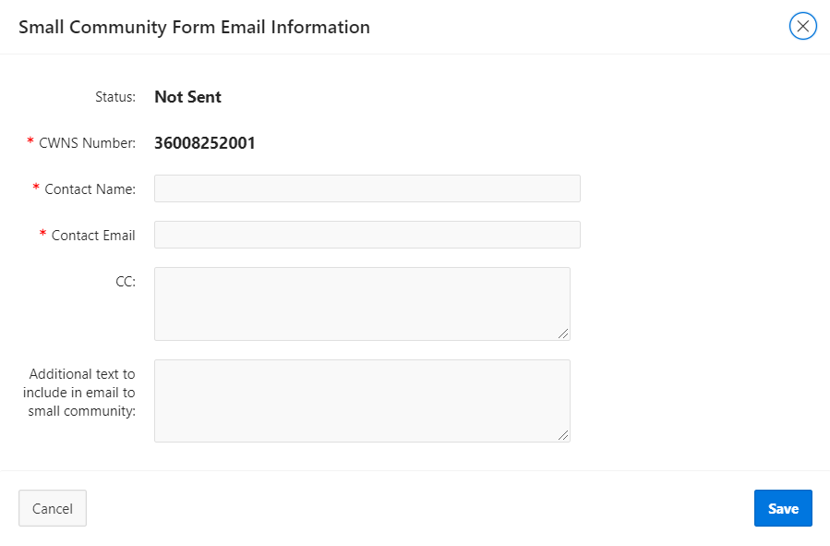

Figure 5‑63. SCF email information.

After entering this information, the state can send the email with a unique URL the small community can follow to view and update its form. Once the small community has completed the form and it is returned via one of the routes in the workflow, the state can view and upload the data into the DEP.

### Uploading a Returned Form

NOT DEVELOPED – The following sections are based on current requirements

Once a small community (or state PE) returns an SCF, the state will need to review the returned data. If the entered data is acceptable to the state, they can upload the form into the DEP.

To review and upload an SCF:

1. In “Manage Small Community Forms,” click the view icon. This will open the SCF in the browser.
2. Review the data, noting any errors. (Section 5.22.8 describes how to address errors.)
3. Once the data has been reviewed, click “Upload Data to DEP.”
4. Read the warning message that indicates all data in the form will overwrite what is currently in the DEP.

Click “I understand, upload.” if you would like the continue.

### Making Corrections

If the state finds errors in the SCF data, there are two ways to address the issue:

1. Ask the small community to fix the errors. For this method, the form would have to be deleted and a new form generated that would go back through the entire workflow (including gaining a new signature from the local or state PE).

Upload the data with the errors and fix them in the DEP.

If the form will not upload due to validation errors, the state can download the form as is and update the data manually, noting corrections in annotations or note fields.

### Sending and Receiving PDF Versions of the SCF

If a small community cannot access the online SCF, the state can download a PDF version of the form to send to the community to fill out manually.

To view, send, and upload a PDF version:

1. In “Manage Small Community Forms,” click the view icon. The SCF should open in the browser.
2. Review the data. If any changes are needed, close out of the form and return to the CWNS ID list. Click “Enter Survey” and edit the data. Return to the SCF form (step 1 above) and check the data again.
3. Click “Download” to download a PDF version of the form.
4. Send the form to the small community (either via email or by mail as a hardcopy). The community can make edits using a pen or Adobe edit functions.

When the form is returned (either by email or mail), upload the form as a PDF like any other document in the DEP.

Note: All new data received in the form will need to be entered manually by the state.

## Review Portlet

Description of the review portlet.

# Post-Survey Data Availability

Once findings are reported to Congress, EPA will make data publicly available at the CWNS website (<https://www.epa.gov/cwns>). EPA will develop online data visualization tools that allow users to view and download specific data. Users will be asked to identify their affiliation and the intended use of the data before being able to download any databases. This information will be used to help identify the usefulness of data areas and elements. States will also have access to a database file with their complete survey submission.

## Data Dashboard

The data dashboard will be an interactive display that allows users to select CWNS data for chosen geographic areas in bar graphs and pie charts. Users will be able to filter by state and see the total documented needs by category; official needs by category; number of facilities by size, flow, or treatment; small versus large communities; total needs over time; and the number of facilities with needs. See Figure 6‑1 for the 2012 data dashboard.

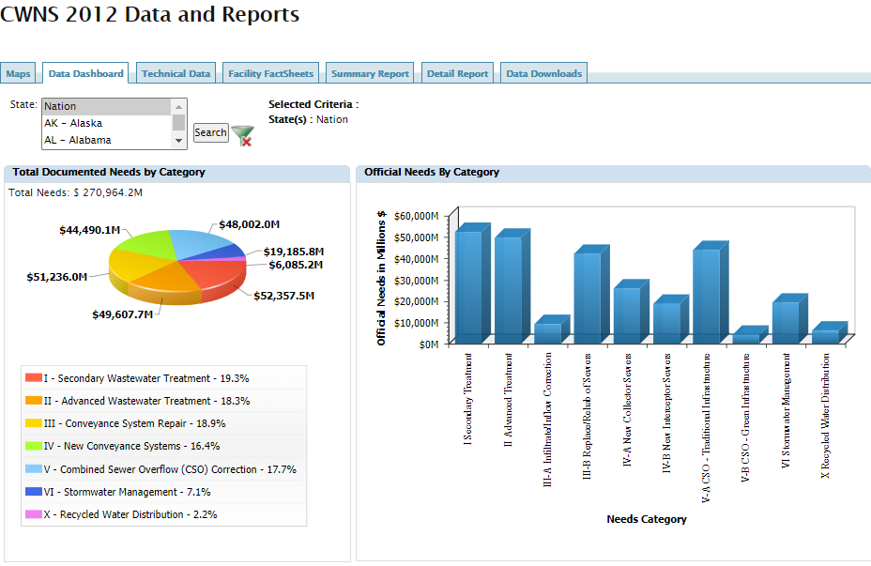

Figure 6‑1. 2012 data dashboard.

## Data Reports and Facility Factsheets

Users will be able to view interactive summary reports of needs data by geographic area (state, region, watershed, county, or congressional district). Examples of summary reports include official needs by category, total documented needs, total official needs by state, and number of facilities with needs by state.

In addition to summary reports, users will be able to download detailed reports that provide needs, wastewater treatment plant flows, centralized and decentralized population, discharge methods, and unit process data at the CWNS ID level. The detailed reports include CWNS ID information such as CWNS ID, CWNS ID name, permit number and type, and location data.

EPA intends to create the same facility fact sheets that show CWNS data available for an individual wastewater treatment plant, collection system, stormwater management facility, decentralized wastewater management project, or NPS pollution prevention project. See Figure 6‑2 for an example of a facility fact sheet from 2012.

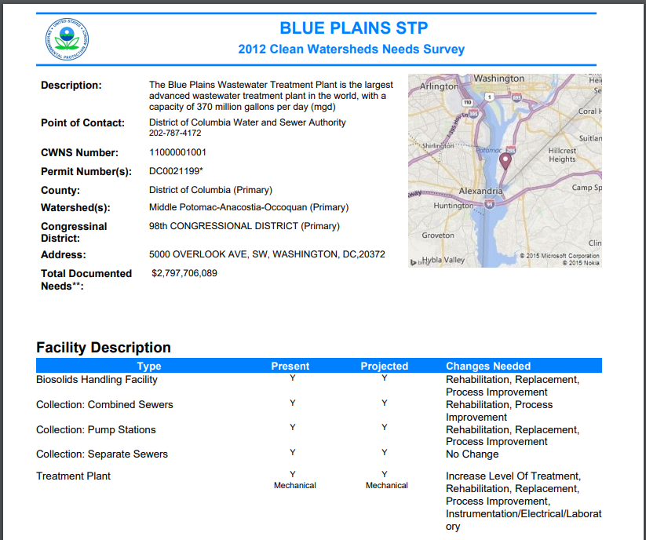

Figure 6‑2. Example 2012 facility fact sheet (page 1 of 5).

## Publicly Available Access Database

EPA will develop a clean version of the database (scrubbed of personal identifying information) and make it available for download, similar to the 2012 publicly available database. This database will include summary data for each data area and allow users to query data for their specific purposes.

## DEP Available for States

Information input to the DEP will be kept as “read only” and states will continue to have access between surveys. Each state will be able to download an Access database version of their entire survey submission that they can work in locally. Any changes to this version will not be reflected in EPA’s version.

**Appendices**

Need Categories

Table A-1 provides the full list of need categories and definitions.[3] Categories were updated to generally align with CWSRF categories. Four CWSRF categories are reported as change types in the CWNS: “improve energy efficiency,” “climate change adaptation,” “renewable energy,” and “improve water efficiency.”

Table A-1. Need Categories and Definitions

| 2022 Category Number | Category Name | Description |
| --- | --- | --- |
| I | Secondary Wastewater Treatment | This category includes needs necessary to meet secondary treatment criteria. Secondary treatment typically requires a treatment level that produces an effluent quality of 30 mg/L of both BOD5 and total suspended solids (secondary treatment levels required for some lagoon systems may be less stringent). In addition, the secondary treatment must remove 85 percent of BOD5 and total suspended solids from the influent wastewater.  Although they do not provide secondary treatment, facilities granted waivers of secondary treatment for marine discharges under Section 301(h) of the CWA and “honey bucket lagoons” are also included in this category. |
| II | Advanced Wastewater Treatment | This category includes needs necessary to attain or maintain a level of treatment that is more stringent than secondary treatment or produce a significant reduction in nonconventional or toxic pollutants present in the wastewater treated by a facility. A facility is considered to have advanced wastewater treatment if it achieves one or more of the following: BOD5 less than 20 mg/L, nitrogen removal, phosphorus removal, ammonia removal, metal removal, or synthetic organic removal. |
| III-A | Infiltration/Inflow (I/I) Correction | This category includes needs for correction of sewer system I/I problems. For infiltration, this includes controlling the penetration of water into a sanitary or combined sewer system from the ground through defective pipes or manholes. For inflow, it includes controlling the penetration of water into the system from drains, storm sewers, and other improper entries. It also includes costs for preliminary sewer system analysis and detailed SSESs. |
| III-B | Sewer Replacement/ Rehabilitation | This category includes needs for the maintenance (above and beyond ongoing O&M), reinforcement, or reconstruction of structurally deteriorating sanitary or combined sewers. The corrective actions must be necessary to maintain the structural integrity of the system. |
| IV-A | New Collector Sewers and Appurtenances | This category includes needs for new pipes used to collect and carry wastewater from a sanitary or industrial wastewater source to an interceptor sewer that will convey the wastewater to a treatment facility. |
| IV-B | New Interceptor Sewers and Appurtenances | This category includes needs for constructing new interceptor sewers and pumping stations to convey wastewater from collection sewer systems to a treatment facility or to another interceptor sewer. Needs for relief sewers are included in this category. |
| V | Combined Sewer Overflow (CSO) Correction | This category includes needs to prevent or control the periodic discharges of mixed stormwater and untreated wastewater (CSOs) that occur when the capacity of a sewer system is exceeded during a wet weather event. This category does not include needs for overflow control allocated to flood control, drainage improvement, or the treatment or control of stormwater in separate storm systems. |
| VI-A | Gray Infrastructure | This category includes needs for stormwater management program activities associated with the planning, design, and construction of conveying stormwater via pipes, inlets, roadside ditches, and other similar mechanisms. This category also includes needs associated with the planning, design, and construction of treating stormwater with wet ponds, dry ponds, manufactured devices, and other similar means. |
| VI-B | Green Infrastructure | This category includes needs for stormwater management program activities associated with the planning, design, and construction of low impact development and green infrastructure, such as bioretention, constructed wetlands, permeable pavement, rain gardens, green roofs, cisterns, rain barrels, vegetated swales, restoration of riparian buffers and flood plains, etc. Projects in this category can be either publicly or privately owned. |
| VI-C | General Stormwater Management | This category includes needs for stormwater management program activities associated with implementing a stormwater management program, such as geographic information systems (GIS) and tracking systems, equipment (e.g., street sweepers, vacuum trucks), stormwater education program startup costs (e.g., setting up a stormwater public education center, building a traveling stormwater education display), and stormwater management plan development. |
| VII-A | NPS Control: Agriculture (Cropland) | This category includes costs to address NPS pollution control needs associated with agricultural activities related to croplands, such as plowing, pesticide spraying, irrigation, fertilizing, planting, and harvesting. Some examples of BMPs used to address these needs are conservation tillage, nutrient management, and irrigation water management. |
| VII-B | NPS Control: Agriculture (Animals) | This category includes all costs that address NPS pollution control needs associated with agricultural activities related to animal production, such as confined animal facilities and grazing. Some typical BMPs used to address agriculture (animal) needs are animal waste storage facilities, animal waste nutrient management, composting facilities, and planned grazing. Any costs associated with facilities or measures that address point source pollution discharges are not reported in this category. |
| VII-C | NPS Control: Silviculture | This category includes all costs that address NPS pollution control needs associated with forestry activities, such as removal of streamside vegetation, road construction and use, timber harvesting, and mechanical preparation for the planting of trees. Some typical BMPs used to address silviculture needs are pre-harvest planning, streamside buffers, road management, revegetation of disturbed areas and structural practices, and equipment (e.g., sediment control structures, timber harvesting equipment). |
| VII-E | NPS Control: Groundwater Protection (Unknown Source) | This category includes all costs that address groundwater protection NPS pollution control needs, such as wellhead and recharge area protection activities. Any need that can be attributed to a specific cause of groundwater pollution, such as leaking storage tanks, soil contamination in a brownfield, or leachate from a sanitary landfill, is reported in that more specific category. |
| VII-F | NPS Control: Marinas | This category includes all costs that address NPS pollution control needs associated with boating and marinas, such as poorly flushed waterways, boat maintenance activities, discharge of sewage from boats, and the physical alteration of shoreline, wetlands, and aquatic habitat during the construction and operation of marinas. Some typical BMPs used to address needs at marinas are bulk heading, pump-out systems, and oil containment booms. |
| VII-G | NPS Control: Resource Extraction | This category includes all costs that address NPS pollution control needs associated with mining and quarrying activities. Some typical BMPs used to address resource extraction needs are detention berms, adit (mine entrance) closures, and seeding or revegetation. Any costs associated with facilities or measures that address point source discharges are not reported in this category. |
| VII-H | NPS Control: Brownfields/Superfund | This category includes all costs that address NPS pollution control needs associated with abandoned industrial sites that might have residual contamination (brownfields) and hazardous waste sites covered under the Comprehensive Environmental Response, Compensation, and Liability Act (Superfund sites). All costs for work at brownfield or Superfund sites, regardless of the activity, should be included in this category. Some typical BMPs used to address needs at brownfield or Superfund sites are excavation, removal, and disposal of contaminated sediment/soil; cleanup of contaminated groundwater or surface water; and capping of wells to prevent stormwater infiltration. |
| VII-I | NPS Control: Storage Tanks | This category includes all costs that address NPS pollution control needs associated with tanks designed to hold gasoline, other petroleum products, or chemicals. The tanks may be above or below ground level. Some typical BMPs used to address storage tank needs are spill containment systems; in situ treatment of contaminated soils and groundwater; and upgrade, rehabilitation, or removal of petroleum/chemical storage tanks. If these facilities or measures are part of addressing NPS needs at brownfields, the costs go in Category VII-H, "NPS Control: Brownfields/Superfund.” |
| VII-J | NPS Control: Sanitary Landfills | This category includes all costs that address NPS pollution control needs associated with sanitary landfills. Some typical BMPs used to address needs at landfills are leachate collection, onsite treatment, gas collection and control, capping, and closure. |
| VII-K | NPS Control: Hydromodification | This category includes needs to address the degradation of water resources as a result of altering the hydrological characteristics of coastal and non-coastal waters. For a stream channel, hydromodification is the process of the stream bank being eroded by flowing water, typically resulting in the suspension of sediments in the watercourse. Examples of such hydromodification activities include channelization and channel modification, dams, and stream bank and shoreline erosion. Some typical BMPs used to address hydromodification needs are conservation easements, swales, filter strips, shore erosion control, wetland development or restoration, and bank or channel (grade) stabilization. Any work involving wetland or riparian area protection or restoration is included under this category. |
| VII-M | NPS Control: Other Estuary Management Activities | This category is only used for management activities in the study areas of the 28 NEPs designated under Section 320 of the CWA. It includes costs associated with a limited number of estuary management activities that may not be appropriately included in other need categories. Some typical estuary BMPs are habitat protection for aquatic species; fisheries, oyster bed, and shellfish restocking and restoration; fish ladders; rejuvenation of submerged aquatic vegetation; artificial reef establishment; control of invasive vegetative and aquatic species; and water control structures for flow regime and salinity. Point source technologies included in the NEP’s Comprehensive Conservation and Management Plans should not be included in this category. |
| X | Water Reuse | This category includes needs associated with conveyance of treated wastewater that is being reused, including associated rehabilitation/replacement needs. Examples are pipes to convey treated water from the wastewater facility to the drinking water distribution system or the drinking water treatment facility and equipment for application of effluent on publicly owned land.  The needs associated with additional unit processes to increase the level of treatment to potable or less than potable but greater than that normally associated with surface discharge needs are reported in Category II. |
| XII | Decentralized Wastewater Treatment Systems | This category includes needs associated with the rehabilitation, replacement, or new installation of OWTSs or clustered (community) systems. It also includes the treatment portion of other decentralized sewage disposal technologies. Costs related to the development and implementation of onsite management districts are included (but not the costs of ongoing operations of such districts). Costs could also include the limited collection systems associated with the decentralized system. Public ownership is not required for decentralized systems.  This category does not include the needs to change a service area from decentralized wastewater treatment to a publicly owned centralized treatment system. Needs to construct a publicly owned centralized collection and treatment system should be reported in Category I, “Secondary Wastewater Treatment,” and/or Category II, “Advanced Wastewater Treatment.” Needs to install sewers to connect the service area to an existing collection system are reported in Category IV-A, “New Collector Sewers and Appurtenances,” and Category IV-B, “New Interceptor Sewers and Appurtenances.” |
| XIV | Desalination | This category includes needs for treatment and disposal of brine, desalination of brackish water to augment water supply, aquifer recharge using desalinated sea water, and treatment/‌reinjection of brackish groundwater. |

Facility Types

Table B-1 provides the full list of facility types and definitions.

Table B-1. Definitions of Facility Types

| Facility Type | Definition |
| --- | --- |
| Treatment plant | A combination of unit processes designed to receive and treat wastewater and then discharge the treated wastewater (effluent) into the environment. This type includes both mechanical plants and lagoons or ponds (other than honey bucket lagoons). It also includes unit processes intended to remove pollutants from CSOs prior to the discharge of the overflow to the environment. It can also include package plants, although it is up to the state if these are reported as treatment plants (wastewater) or clustered systems (decentralized). This type does not include unit processes intended to thicken, stabilize, dewater, or store biosolids; they should be designated as biosolids handling facilities. |
| Collection: combined sewers | Infrastructure designed to collect and transport a combination of wastewater and stormwater. This type does not include sewers that were designed to carry only wastewater and infiltration/inflow, which should be designated as collection: separate sewers. |
| Collection: separate sewers | Infrastructure designed to collect and transport wastewater. Although this type includes sewer systems that collect and transport infiltration and inflow, it does not include sewers designed to carry both stormwater and wastewater; they should be designated as collection: combined sewers. |
| Collection: interceptor sewers | Large sewer lines that collect the flows from smaller main and trunk sewers and carry them to the treatment plant. |
| Collection: pump stations | Mechanical devices designed to move waste and other fluid from underground pipelines and storage areas to higher elevations to reach the treatment plant. |
| Honey bucket lagoon | A shallow artificial lagoon where human waste from homes is transported to for disposal. |
| Storage facility | A facility that temporarily holds wastewater until it is transported and treated elsewhere. |
| Biosolids handling facility | A combination of unit processes designed to thicken, stabilize, dewater, or store biosolids prior to disposal. |
| Water reuse | The combination of unit processes used to convey treated wastewater that will be reused. |
| OWTS | A combination of natural and mechanical processes designed to collect, treat, and disperse or reclaim wastewater from a single dwelling or building. Septic tanks and drainfields or holding tanks are examples. |
| Clustered system | A combination of unit processes under some form of common ownership designed to collect wastewater from two or more dwellings or buildings and convey it to a treatment and dispersal system on a suitable site near the dwellings or buildings. Clustered systems include multifamily septic systems as well as package treatment plants. |
| Phase I MS4 | A combination of unit processes or BMPs designed to collect, treat, and transport stormwater for entities regulated under the NPDES Phase I permit process. Phase I permits are required for medium (population 100,000–249,999) and large (population 250,000 or more) MS4s in incorporated places or counties with populations of 100,000 or more. Capital projects to address primarily water-quality-related needs are allowable for CWNS 2022. Projects with integrated water quality and water quantity benefits are also permitted if the primary purpose is water quality. Only processes or practices that address water quality or public health problems are included in the CWNS. |
| Phase II MS4 | A combination of unit processes or BMPs designed to collect, treat, and transport stormwater for entities regulated under the NPDES Phase II permit process. Phase II permits were required for small MS4s (population 99,999 or less) located in "urbanized areas" as defined by the Bureau of the Census, as well as small MS4s outside urbanized areas that are designated by NPDES permitting authorities. Capital projects to address primarily water-quality-related needs are allowable for CWNS 2022. Projects with integrated water quality and water quantity benefits are also permitted, if the primary purpose is water quality. Only processes or practices that address water quality or public health problems are included in the CWNS. |
| Non-traditional MS4 | A combination of unit processes or BMPs designed to collect, treat, and transport stormwater for regulated MS4s owned by non-municipal, public entities (e.g., universities, Departments of Transportation, prisons, school districts). Capital projects to address primarily water-quality-related needs are allowable for CWNS 2022. Projects with integrated water quality and water quantity benefits are also permitted, if the primary purpose is water quality. Only processes or practices that address water quality or public health problems are included in the CWNS. |
| Unregulated community stormwater | In areas not regulated by NPDES permits, a combination of unit processes or BMPs designed to address stormwater pollution control needs associated with new or existing development in urban or rural settings, such as erosion, sedimentation, and discharge of pollutants (e.g., inadequately treated wastewater, oil, grease, road salts and toxic chemicals) into water resources from construction sites, roads, bridges, parking lots, and buildings. |
| Agriculture—cropland | A combination of BMPs designed to address water quality or public health problems caused by agricultural activities such as plowing, pesticide spraying, irrigation, fertilizing, planting, and harvesting. The primary agricultural NPS pollutants are nutrients, sediment, animal wastes, salts, and pesticides. Agricultural activities also have the potential to directly affect the habitat of aquatic species through physical disturbances of adjacent land caused by equipment or water management activities (e.g., dams, irrigation). |
| Agriculture—animals | A combination of BMPs designed to address water quality or public health problems caused by agricultural activities related to grazing and animal production such as animal feeding operations that are not subject to the concentrated animal feeding operation regulations. Animal waste includes the fecal and urinary wastes of livestock and poultry; process water (such as that from a milking parlor); and the feed, bedding, litter, and soil with which they become intermixed. Pollutants such as organic solids, salts, bacteria, viruses, and other microorganisms, and sediments might be contained in animal waste transported by runoff water and process wastewater. |
| Silviculture | A combination of BMPs designed to address water quality or public health problems caused by forestry activities such as removal of streamside vegetation, road construction and use, timber harvesting, and site preparation for the planting of trees. Silvicultural activities can cause degradation of water quality and habitat quality if care is not taken to prevent adverse effects. Sediment from erosion due to tree harvesting activities and access road construction, temperature increases due to riparian shade removal, and pesticides and fertilizer used during timber operations are some of the major pollutants from timber harvesting sites. Silviculture BMPs include measures that control erosion from access roads, maintain the stability of stream banks, ensure the revegetation of harvested areas, and control the introduction of pesticides and fertilizers into waterways. |
| Marinas | A combination of BMPs designed to address water quality or public health problems associated with boating and marinas, such as poorly flushed waterways; boat maintenance activities; discharge of sewage from boats; stormwater runoff from marina parking lots; and the physical alteration of shoreline, wetlands, and aquatic habitat during the construction and operation of marinas. |
| Resource extraction | A combination of BMPs designed to address water quality or public health problems caused by mining, quarrying, hydraulic fracking, and oil/gas operations. Eligible water quality projects that remediate or prevent contamination from these sites, whether active or abandoned, include projects to treat drainage (e.g., acid mine drainage) and wastewater (e.g., fracking wastewater), prevent aquifer contamination, excavate and remediate contaminated soil at the site, remove contamination from water or soil that is not part of the site (e.g., removal of mine tailings from stream beds), or prevent runoff. |
| Brownfields/Superfund | A combination of BMPs designed to address water quality or public health problems at abandoned, idle, or underused industrial and commercial sites. Brownfields or Superfund sites can be in urban, suburban, or rural areas. |
| Storage tanks | A combination of BMPs designed to address water quality or public health problems caused by tanks designed to hold gasoline or other petroleum products or chemicals. The tanks may be above or below ground level. |
| Sanitary landfills | A combination of BMPs designed to address water quality or public health problems at sanitary landfills. Sanitary landfills are landfills designed as disposal sites for nonhazardous solid wastes rather than hazardous solid waste or biosolids. |
| Groundwater—unknown source | A combination of BMPs designed to address groundwater protection needs from an unknown or otherwise undefined source. Any need that can be attributed to a specific cause of groundwater pollution should be indicated with a more specific type, such as storage tanks, brownfields, or sanitary landfills. |
| Hydromodification | A combination of BMPs designed to address water quality or public health problems associated with channelization and channel modification, dams, and stream bank and shoreline erosion. |
| Estuary management | A combination of BMPs designed to protect the estuarine ecosystem. Examples include habitat for aquatic species, fisheries, oyster bed, and shellfish restocking and restoration; fish ladders; rejuvenation of submerged aquatic vegetation; artificial reef establishment; control of invasive vegetative and aquatic species; and water control structures for flow regime and salinity. |
| Desalination | A facility to separate dissolved salts and other minerals from water for a water quality benefit. |

Change Types

Table C-1 provides the full list of change types and definitions.

Table C-1. Change Types and Definitions

| Facility Change | Definition |
| --- | --- |
| No change | There are no planned modifications. *Note that this change type cannot be used in combination with any other change type.* |
| New | A new facility is being proposed or implemented. *Note that this change type cannot be used in combination with any other change type.* |
| Abandonment | All unit processes or BMPs that make up the facility type will no longer be used or will be demolished in the future. Examples are:   * Taking a treatment plant out of service. Its flows are redirected to another treatment plant. * Taking a biosolids handling facility out of service and centralizing all biosolids treatment at one regional biosolids handling facility. * Replacing OWTSs with a central collection and treatment system.   Abandonment does *not* include taking single unit processes or BMPs out of service while still maintaining the overall type of the facility (e.g., switching from chlorination to ultraviolet disinfection). This change should be categorized as “process improvement.”  If a facility is to be demolished and replaced in the same location, the change should be categorized as “replacement.”  *Note that this change type cannot be used in combination with any other change type.* |
| Climate change adaptation | Implementing changes at the facility to mitigate the impacts (e.g., floods, hurricanes) of climate change. The climate change adaptation strategies are sufficient in and of themselves to document need for projects. The strategies do not need to be linked to a water quality or public health benefit. |
| Expansion | Increasing the service area of an existing sewer system or NPS BMP. It also includes the addition of new OWTS in a municipality where there are presently OWTSs with the rehabilitation change type.  This change does not include the construction of an entirely new sewer system, which should be categorized as “new.”  Increasing the treatment capacity for existing treatment plants, biosolids handling facilities, MS4s, decentralized treatment systems, NPS BMPs, and desalination facilities. These changes should be categorized as “increase capacity.” |
| Improve energy efficiency | Implementing improvements to the facility to be more energy efficient (e.g., measures to reduce chemical needs or O&M costs at a facility). The energy and other economic efficiencies will be sufficient in and of themselves to document need for projects. The energy efficiencies are not required to be linked to a water quality or public health benefit. |
| Improve water efficiency **(new for 2022 survey)** | Implementing improvements to the facility that reduce the demand for POTW capacity through reduced water consumption (e.g., water meters, plumbing fixture retrofits or replacement, water-efficient appliances, water-efficient irrigation equipment, education programs). The water efficiency strategies will be sufficient in and of themselves to document need for projects. |
| Increase capacity | Increasing the treatment capacity of existing treatment plants, biosolids handling facilities, MS4s, decentralized treatment systems, and NPS BMPs with respect to flow or tonnage. Examples are:   * Increasing a wastewater treatment plant’s design flow from 1 to 2 MGD. * Increasing a biosolids handling facility’s capacity from 0.25 to 0.35 tons per day. * Increasing the size of a multiple-unit leach field to handle additional flow. * Increasing the size of a sediment basin used to capture runoff from a construction site. * Replacing existing sewers with larger-capacity sewers or expanding existing pump stations to pump more flow.   This change *does not* include:   * Increasing the level of treatment to meet more stringent effluent limits. This change should be categorized as “increase level of treatment.” * Increasing the size of a sewer system by adding new sewers and expanding the service area. This change should be categorized as “expansion.” * Adding sand filtration to an existing non-centralized treatment system. This change should be categorized as “process improvement.” |
| Increase level of treatment | Improving the degree of treatment. This refers to any improvement in unit processes or BMPs that improves the effluent quality or decreases the concentration of most water quality variables from runoff or nonpoint sources. The addition of nutrient removal is considered to be an improvement in effluent quality (e.g., secondary effluent with nutrient removal represents higher-quality effluent than secondary effluent without nutrient removal). |
| Instrumentation/electrical/laboratory | Adding new or modifying existing instrumentation systems (e.g., SCADA [supervisory control and data acquisition]), electrical systems, or laboratory facilities at an existing facility of any type. |
| Process improvement | Any improvement to a facility that does not increase the capacity, increase the level of treatment, expand the service area, or make a similar change for existing treatment plants, biosolids handling facilities, MS4s, decentralized treatment systems, and NPS BMPs. Examples are:   * Replacing coarse bubble diffusers with fine bubble diffusers at a wastewater treatment plant. * Upgrading membranes at a desalination facility. * Replacing pumps in a pump station. * Adding sand filters to an existing decentralized cluster system.   If a more detailed or more appropriate change type is available, it should be used. |
| Redevelopment | Expanding, modifying, or otherwise upgrading existing gray or green stormwater management measures. |
| Rehabilitation | Restoring or repairing parts of existing treatment plants, combined or separate sewer systems, biosolids handling facilities, MS4s, individual onsite systems, and NPS BMPs with no increase in capacity or level of treatment. Examples are:   * Performing extensive repair of existing sewers beyond the scope of normal maintenance programs. * Repairing deteriorating tank walls at a treatment plant. * Replacing a deteriorated cover on an anaerobic digester. * Adding a forebay to prevent sediment from entering a retention pond. * Replacing membranes at a desalination facility.   This change does *not* include:   * Replacing of one or more sewers with another while maintaining the same capacity. These changes should instead be categorized as “replacement.” * Performing any work that could be considered normal O&M. |
| Renewable energy **(new for 2022 survey)** | Implementing renewable energy production (e.g., wind, solar, methane capture and energy conversion equipment, biosolids drying/dewatering and energy conversion equipment, co-digestion, combined heat and power systems, hydroelectric systems). The renewable energy strategies will be sufficient in and of themselves to document need for projects. The strategies do not need to be linked to a water quality or public health benefit. |
| Replacement | An existing facility is considered obsolete and is demolished, and a new facility is constructed on the same site. For treatment plants, this generally implies the same degree of treatment as the demolished plant. |

Facility Type and Change Type Associations

There are limitations to which change types can be associated with each facility type in the DEP. Table D-1 provides these association rules.

“New,” “abandonment,” and “no change” change types cannot be used in combination with any other change type, shown by gray highlighting. Facilities with a change type of “new” can only have facility information for the newly proposed infrastructure. Facilities with a change type of “abandonment” cannot also have change types to improve or modify the facility to be abandoned. Facilities with “no change” as their change type are by definition not also incurring other changes. All other change types can be combined as noted in the table.

Table D-1. Facility Type and Change Type Associations

| **Facility Type** | **Change Type** | | | | | | | | | | | | | | |
| --- | --- | --- | --- | --- | --- | --- | --- | --- | --- | --- | --- | --- | --- | --- | --- |
| **New** | **Abandonment** | **No Change** | **Increase Capacity** | **Increase Level of Treatment** | **Rehabilitation** | **Replacement** | **Redevelopment** | **Expansion** | **Process Improvement** | **Instrumentation/Electrical/Laboratory** | **Improve Energy Efficiency** | **Climate Change Adaptation** | **Improve Water Efficiency** | **Renewable Energy** |
| **Treatment Plant** | * | * | * | * | * | * | * |  |  | * | * | * | * | * | * |
| **Honey Bucket Lagoon** | * | * | * | * | * | * | * |  |  | * | * | * | * | * | * |
| **Storage Facility** | * | * | * | * |  | * | * |  |  | * | * | * | * | * | * |
| **Biosolids Handling** | * | * | * | * | * | * | * |  | * | * | * | * | * | * | * |
| **Collection: Combined Sewers** |  | * | * |  |  | * | * |  |  | * | * | * | * | * | * |
| **Collection: Separate Sewers** | * | * | * | * |  | * | * |  | * | * | * | * | * | * | * |
| **Collection: Interceptor Sewers** | * | * | * | * | * | * | * |  | * | * | * | * | * | * | * |
| **Collection: Pump Stations** | * | * | * | * |  | * | * |  | * | * | * | * | * | * | * |
| **Water Reuse** | * | * | * | * | * | * | * |  | * | * | * | * | * | * | * |
| **Desalination (Wastewater Infrastructure)** | * | * | * | * | * | * | * |  | * | * | * | * | * | * | * |
| **OWTS** | * | * | * |  |  | * | * |  |  | * | * |  |  |  |  |
| **Clustered System** | * | * | * | * | * | * | * |  | * | * | * |  |  |  |  |
| **Phase I MS4** | * | * | * | * | * | * | * | * | * | * | * | * | * | * | * |
| **Phase II MS4** | * | * | * | * | * | * | * | * | * | * | * | * | * | * | * |
| **Non-traditional MS4** | * | * | * | * | * | * | * | * | * | * | * | * | * | * | * |
| **Unregulated Community Stormwater** | * | * | * | * | * | * | * | * | * | * | * | * | * | * | * |
| **Agriculture—Cropland** | * | * | * | * | * | * | * |  | * | * | * |  | * |  |  |
| **Agriculture—Animals** | * | * | * | * | * | * | * |  | * | * | * |  | * |  |  |
| **Silviculture** | * | * | * | * | * | * | * |  | * | * | * |  | * |  |  |
| **Marinas** | * | * | * | * | * | * | * |  | * | * | * |  | * |  |  |
| **Resource Extraction** | * | * | * | * | * | * | * |  | * | * | * |  | * |  |  |
| **Brownfields/Superfund** |  | * | * | * | * | * | * |  | * | * | * |  | * |  |  |
| **Storage Tanks** | * | * | * | * | * | * | * |  | * | * | * |  | * |  |  |
| **Sanitary Landfills** | * | * | * | * | * | * | * |  | * | * | * |  | * |  |  |
| **Groundwater—Unknown Source** | * | * | * | * | * | * | * |  | * | * | * |  | * |  |  |
| **Hydromodification** | * | * | * | * | * | * | * |  | * | * | * |  | * |  |  |
| **Estuary Management** | * | * | * | * | * | * | * |  | * | * | * |  | * |  |  |
| **Desalination (NPS Control Infrastructure)** | * | * | * | * | * | * | * |  | * | * | * | * | * | * | * |

Facility Type Associations

There are limitations to which facility types can be combined with other facility types for one CWNS ID in the DEP. Tables E-1 through E-4 provide these association rules.

Table E-1. Wastewater Facility Type Associations

| **Facility Type** | **Treatment Plant** | **Collection: Interceptor Sewers** | **Collection: Combined Sewers** | **Collection: Separate Sewers** | **Storage Facility** | **Collection: Pump Stations** | **Biosolids Handling** | **Water Reuse** | **Desalination (Wastewater Infrastructure)** | **Honey Bucket Lagoon** |
| --- | --- | --- | --- | --- | --- | --- | --- | --- | --- | --- |
| **Treatment Plant** | * | * | * | * | * | * | * | * | * |  |
| **Collection: Interceptor Sewers** | * | * | * | * | * | * | * | * | * |  |
| **Collection: Combined Sewers** | * | * | * | * | * | * | * | * | * |  |
| **Collection: Separate Sewers** | * | * | * | * | * | * | * | * | * |  |
| **Collection: Pump Stations** | * | * | * | * | * | * | * | * | * |  |
| **Storage Facility** | * | * | * | * | * | * | * | * | * |  |
| **Biosolids Handling** | * | * | * | * | * | * | * | * | * |  |
| **Water Reuse** | * | * | * | * | * | * | * | * | * |  |
| **Desalination (Wastewater Infrastructure)** | * | * | * | * | * | * | * | * | * |  |
| **Honey Bucket Lagoon** |  |  |  |  |  |  |  |  |  | * |

Table E-2. Decentralized Facility Type Associations

| **Facility Type** | **OWTS** | **Clustered System** |
| --- | --- | --- |
| **OWTS** | * | * |
| **Clustered System** | * | * |

Table E-3. Stormwater Facility Type Associations

| **Facility Type** | **Phase I MS4** | **Phase II MS4** | **Non-traditional MS4** | **Unregulated Community Stormwater** |
| --- | --- | --- | --- | --- |
| **Phase I MS4** | * |  |  |  |
| **Phase II MS4** |  | * |  |  |
| **Non-traditional MS4** |  |  | * |  |
| **Unregulated Community Stormwater** |  |  |  | * |

Table E-4. NPS Control Facility Type Associations

| **Facility Type** | **Agriculture—cropland** | **Agriculture—animals** | **Silviculture** | **Marinas** | **Resource Extraction** | **Brownfields/Superfund** | **Storage Tanks** | **Sanitary Landfills** | **Groundwater—Unknown Source** | **Hydromodification** | **Estuary Management** | **Desalination (NPS Control Infrastructure)** |
| --- | --- | --- | --- | --- | --- | --- | --- | --- | --- | --- | --- | --- |
| **Agriculture—cropland** | * | * | * | * | * | * | * | * | * | * | * | * |
| **Agriculture—animals** | * | * | * | * | * | * | * | * | * | * | * | * |
| **Silviculture** | * | * | * | * | * | * | * | * | * | * | * | * |
| **Marinas** | * | * | * | * | * | * | * | * | * | * | * | * |
| **Resource Extraction** | * | * | * | * | * | * | * | * | * | * | * | * |
| **Brownfields/Superfund** | * | * | * | * | * | * | * | * | * | * | * | * |
| **Storage Tanks** | * | * | * | * | * | * | * | * | * | * | * | * |
| **Sanitary Landfills** | * | * | * | * | * | * | * | * | * | * | * | * |
| **Groundwater—Unknown Source** | * | * | * | * | * | * | * | * | * | * | * | * |
| **Hydromodification** | * | * | * | * | * | * | * | * | * | * | * | * |
| **Estuary Management** | * | * | * | * | * | * | * | * | * | * | * | * |
| **Desalination (NPS Control Infrastructure)** | * | * | * | * | * | * | * | * | * | * | * | * |

Facility Types and Need Categories Associations

There are limitations to which facility types can be associated with each need category in the DEP. Table F-1 provides these association rules.

As an example of how to use this table, consider a “collection: interceptor sewers” facility type. This can only be associated with III-A, III-B, IV-A, and IV-B.

Table F-1. Facility Types and Need Categories Associations

| **Facility Type** | **Need Category** | | | | | | | | | | | | | | | | | | | | | | | |
| --- | --- | --- | --- | --- | --- | --- | --- | --- | --- | --- | --- | --- | --- | --- | --- | --- | --- | --- | --- | --- | --- | --- | --- | --- |
| **I** | **II** | **III-A** | **III-B** | **IV-A** | **IV-B** | **V** | **VI-A** | **VI-B** | **VI-C** | **VII-A** | **VII-B** | **VII-C** | **VII-E** | **VII-F** | **VII-G** | **VII-H** | **VII-I** | **VII-J** | **VII-K** | **VII-M** | **X** | **XII** | **XIV** |
| **Treatment Plant** | * | * |  |  |  |  | * |  |  |  |  |  |  |  |  |  |  |  |  |  |  | * |  | * |
| **Honey Bucket Lagoon** | * | * |  |  |  |  |  |  |  |  |  |  |  |  |  |  |  |  |  |  |  |  |  |  |
| **Collection: Combined Sewers** |  |  | * | * |  |  | * |  |  |  |  |  |  |  |  |  |  |  |  |  |  |  |  |  |
| **Collection: Separate Sewers** |  |  | * | * | * | * |  |  |  |  |  |  |  |  |  |  |  |  |  |  |  |  |  |  |
| **Collection: Interceptor Sewers** |  |  | * | * | * | * |  |  |  |  |  |  |  |  |  |  |  |  |  |  |  |  |  |  |
| **Collection: Pump Stations** |  |  | * | * | * | * |  |  |  |  |  |  |  |  |  |  |  |  |  |  |  |  |  |  |
| **Storage Facility** | * | * | * | * | * | * | * |  |  |  |  |  |  |  |  |  |  |  |  |  |  |  |  |  |
| **Biosolids Handling** | * | * |  |  |  |  |  |  |  |  |  |  |  |  |  |  |  |  |  |  |  |  |  |  |
| **Water Reuse** |  |  |  |  |  |  |  |  |  |  |  |  |  |  |  |  |  |  |  |  |  | * |  | * |
| **Desalination (Wastewater Infrastructure)** |  |  |  |  |  |  |  |  |  |  |  |  |  |  |  |  |  |  |  |  |  | * |  | * |
| **OWTS** |  |  |  |  |  |  |  |  |  |  |  |  |  |  |  |  |  |  |  |  |  |  | * |  |
| **Clustered System** |  |  |  |  |  |  |  |  |  |  |  |  |  |  |  |  |  |  |  |  |  |  | * |  |
| **Phase I MS4** |  |  |  |  |  |  |  | * | * | * |  |  |  |  |  |  |  |  |  |  |  |  |  |  |
| **Phase II MS4** |  |  |  |  |  |  |  | * | * | * |  |  |  |  |  |  |  |  |  |  |  |  |  |  |
| **Non-traditional MS4** |  |  |  |  |  |  |  | * | * | * |  |  |  |  |  |  |  |  |  |  |  |  |  |  |
| **Unregulated Stormwater Management** |  |  |  |  |  |  |  | * | * | * |  |  |  |  |  |  |  |  |  |  |  |  |  |  |
| **Agriculture—cropland** |  |  |  |  |  |  |  |  |  |  | * |  |  |  |  |  |  |  |  |  |  |  |  |  |
| **Agriculture—animals** |  |  |  |  |  |  |  |  |  |  |  | * |  |  |  |  |  |  |  |  |  |  |  |  |
| **Silviculture** |  |  |  |  |  |  |  |  |  |  |  |  | * |  |  |  |  |  |  |  |  |  |  |  |
| **Groundwater—Unknown Source** |  |  |  |  |  |  |  |  |  |  |  |  |  | * |  |  |  |  |  |  |  |  |  | * |
| **Marinas** |  |  |  |  |  |  |  |  |  |  |  |  |  |  | * |  |  |  |  |  |  |  |  |  |
| **Resource Extraction** |  |  |  |  |  |  |  |  |  |  |  |  |  |  |  | * |  |  |  |  |  |  |  |  |
| **Brownfields/Superfund** |  |  |  |  |  |  |  |  |  |  |  |  |  |  |  |  | * |  |  |  |  |  |  |  |
| **Storage Tanks** |  |  |  |  |  |  |  |  |  |  |  |  |  |  |  |  |  | * |  |  |  |  |  |  |
| **Sanitary Landfills** |  |  |  |  |  |  |  |  |  |  |  |  |  |  |  |  |  |  | * |  |  |  |  |  |
| **Hydromodification** |  |  |  |  |  |  |  |  |  |  |  |  |  |  |  |  |  |  |  | * |  |  |  |  |
| **Estuary Management** |  |  |  |  |  |  |  |  |  |  |  |  |  |  |  |  |  |  |  |  | * |  |  |  |
| **Desalination (NPS Control Infrastructure)** |  |  |  |  |  |  |  |  |  |  |  |  |  |  |  |  |  |  |  |  |  | * |  | * |

Designated Document Types

Table G-1 provides the full list of document types, designations, and definitions. See Section 3.5.1 for guidance on how to use certain document numbers. Note that alternate documents, with the exception of document type 5 (Cost of Previous Comparable Construction), may only be used to document projects and require additional documentation to support costs.

| Document No. | Document Type | Designation | Description |
| --- | --- | --- | --- |
| Preapproved Documents | | | |
| 1 | CWSRF IUP/‌Project Priority List | Primary | States prepare an annual IUP as part of their capitalization grant application process. This plan identifies the intended uses of the funds and how they support the goals of the CWSRF, including specific activities the state intends to support. It includes a list of projects—the Project Priority List—that may receive CWSRF assistance. The plan also includes NPS and estuary protection activities that the state expects to fund. A state’s IUP, which is prepared annually, uses state-assigned criteria to identify which projects (for Section 212 projects) or which project categories (for Section 319 or 320 projects) the state intends to fund with CWSRF money. |
| 2 | Non-CWSRF Governmental Loan and Grant Applications | Primary | Grant and loan applications for other federal and state programs include EPA’s WIFIA loans, USDA’s Rural Development Grant and Loan Program, EPA’s 319 NPS Grants, Housing and Urban Development’s Community Development Block Grant, USDA Rural Utilities Service funding and Federal Emergency Management Agency Hazard Mitigation Grants (including Flood Mitigation Assistance and Building Resilient Infrastructure and Communities Grants), the Sewer Overflow and Stormwater Reuse Municipal Grant Program, and the Virginia Department of Environmental Quality’s Water Quality Improvement Fund. |
| 3 | CWSRF Loan Pre-applications/‌Final Applications | Primary | Applications for CWSRF loans. |
| 4 | Non-governmental Grant Applications | Alternate | Grant applications written to non-governmental organizations, such as the Chesapeake Bay Trust. |
| 5 | Cost of Previous Comparable Construction | Alternate | This document type is used to estimate costs for projects that do not have documented costs based on similar projects within the same geographic region. |
| 6 | State-Approved Area-Wide or Regional Basin Plan | Alternate | CWA Section 208 Area-Wide Plans and 309 Basin Plans are broad-based water quality management plans written primarily to identify future planning for areas within a state. These reports study large areas such as basins or counties and usually recommend general solutions to current or anticipated wastewater needs within the planning area. |
| 7 | State-Approved Local Comprehensive Water and Sewer Plan | Alternate | These plans are similar to State-Approved Area-Wide Basin Plans (document type 6) but are not required under the CWA. |
| 8 | TMDL | Alternate | A TMDL is an estimation of the maximum amount of a pollutant that an impaired waterbody—listed on a state’s 303(d) list—can receive and still meet water quality standards. It includes an allocation of the allowable pollutant discharge amount from different point and nonpoint sources and a plan for complying that includes specific projects and an implementation schedule. |
| 9 | NEP Comprehensive Conservation and Management Plan | Alternate | A Comprehensive Conservation and Management Plan is a management plan developed for an estuary that has been nominated for the CWA Section 320 NEP. The plan summarizes findings, determines environmental quality goals and objectives, identifies and establishes priorities for addressing problems, identifies action plans and compliance schedules for pollution control and resource management, and ensures that designated uses of the estuary are protected for each of the 28 estuaries (in 18 states and Puerto Rico) in the NEP. |
| 12a | State Needs Surveys and other state forms (approved as primary) | Primary | This document type allows states to submit state-specific forms that are used to collect project and cost information for the CWNS or other state uses. This document type is used to provide CWNS ID–specific information using the form approved under document type 100. |
| 12b | State Needs Surveys and other state forms (approved as alternate) | Alternate | This document type allows states to submit state-specific forms that are used to collect project data for the CWNS or other state uses. This document type is used to provide CWNS ID–specific information using the form approved under document type 100. |
| 13 | Wastewater/‌Stormwater User Rate Studies | Alternate | User Rate Studies analyze the adequacy of a utility’s wastewater rates. They typically have three components:   * Overall revenue requirements and financial plan * Cost-of-service for each customer class * Rate structure design |
| 14 | Climate Resilience Evaluation and Awareness Tool Reports | Alternate | The Climate Resilience Evaluation and Awareness Tool (CREAT) Plan Report is a summary of the risk reduction possible that can be compared with the cost of implementing the adaptation plan. The report includes the results of the risk assessment for a specific adaptation plan selected by the user and can be used as decision support to inform adaptation planning or to determine if there is a need for further assessment. |
| 15 | Regional Water Plans | Alternate | Regional Water Plans describe current and projected water resource needs of the region and summarize water management strategies to meet needs. Although these plans typically describe drinking water resources, they may include stormwater and wastewater as water supply sources and describe projects to reuse or manage these sources. |
| 16 | Hazard Mitigation Plans | Alternate | Hazard Mitigation Plans review the current and possible risks and the community capabilities for a geographic area, then assigns long-term mitigation strategies to address vulnerabilities. |
| 17 | Integrated Stormwater and Wastewater Plan | Alternate | An Integrated Stormwater and Wastewater Plan identifies efficiencies from separate wastewater and stormwater programs to best prioritize capital investments and achieve human health and water quality objectives per EPA’s Integrated Stormwater and Wastewater Management Planning Framework. |
| 20 | CIP or Master Plan | Primary | A CIP is a fiscal planning document used by local governments (e.g., authorities, cities, counties, districts) to anticipate and plan for capital improvement projects or equipment purchase and schedule them over a period of time. The planning period of CIPs can span from one to 20 or more years. Most CIPs contain project- and cost-specific information.  A Master Plan is similar to a CIP but is typically a more comprehensive municipality-wide planning document. Most Master Plans also have project- and cost-specific information. |
| 21 | Facility Plan or Preliminary Engineering Report | Primary | A Facility Plan or Preliminary Engineering Report addresses a specific problem (i.e., the need for a new treatment plant) and includes several alternatives to solve the problem along with an alternatives analysis and a recommended alternative (project). |
| 22 | Engineer’s Study | Alternate | An Engineer's Study assesses the scope and feasibility of a project before more detailed planning occurs. This document type encompasses documents ranging from a memo to a formal engineer's estimate. |
| 23 | Final Engineer’s Estimate/Lowest Bids | Primary | An Engineer's Estimate contains a specific description of the project scope and a list of work to be done, along with detailed itemized costs. The Final Engineer’s Estimate is typically submitted as a result of detailed facility design. |
| 24 | Sewer System Evaluation Documents | Alternate | Sewer system evaluation documents include I/I analyses, SSESs, and CSO studies.  An I/I analysis is a document that identifies excessive flow problems due to infiltration or inflow into the sewerage.  An SSES is a document that contains the results of a sewer system survey, manhole inspection, smoke testing, and flow monitoring. It is used to evaluate the physical condition of a sewer system and identifies areas of combined sewers, downspout connections, and locations where the sewer system is at capacity. |
| 25 | Diagnostic Evaluation | Alternate | A Diagnostic Evaluation is usually performed when a wastewater treatment facility cannot achieve effluent discharge permit limits or when it experiences design, operational, analytical, or financial problems that limit the performance of the facility. |
| 26 | Sanitary Survey | Alternate | A Sanitary Survey is a logical, investigative approach to gather information to evaluate the condition of existing decentralized wastewater treatment systems, such as onsite or clustered systems. |
| 27 | State-Approved Municipal Wasteload Allocation Plan | Alternate | A Municipal Wasteload Allocation Plan is a water quality analysis done to determine the level of treatment that a specific project needs to provide, which is ultimately translated into an effluent limit or BMP in the NPDES permit. |
| 28 | Recently Promulgated Municipal, State, or Federal Regulation | Alternate | This documentation is only for approved municipal, state, or federal regulations, not future or proposed regulations. |
| 30 | Administrative Orders, Court Orders, or Consent Decrees | Alternate | These official enforcement documents are usually issued as the result of continued violation of a NPDES permit or other pollution control requirements. |
| 31 | NPDES or State Permit Requirement (with Schedule) | Alternate | Every point source discharging to waters of the United States is required to have a NPDES permit establishing effluent limitations (and other permit conditions) designed to protect the designated uses of the receiving waterbody. |
| 32 | Draft CSO LTCP | Alternate | EPA requires communities with combined sewer systems to comply with the CSO Control Policy. To achieve this, most communities are required to develop and implement LTCPs. Annual CSO Reports for facilities without approved LTCPs are considered to be of this document type. |
| 33 | Approved CSO LTCP/Annual Report | Primary | EPA requires communities with combined sewer systems to comply with the CSO Control Policy. To achieve this, most communities are required to develop and implement LTCPs. Annual CSO Reports for facilities with approved LTCPs are considered to be of this document type. |
| 34 | Signed Draft LTCP from CSO LTCP-EZ Template | Alternate | The CSO LTCP Template for Small Communities (termed the "LTCP-EZ Template") is a planning tool for small communities—defined by the CSO program as communities of 75,000 or fewer—that must develop LTCPs to address CSOs. A state may submit an LTCP-EZ as long as it has been signed by a local official. |
| 35 | State-Approved LTCP from CSO LTCP-EZ Template | Primary | The CSO LTCP Template for Small Communities (termed the "LTCP-EZ Template") is a planning tool for small communities—defined by the CSO program as communities of 75,000 or fewer—that must develop LTCPs to address CSOs. A state may submit a state- or EPA-approved LTCP developed using the CSO LTCP-EZ Template to document projects. |
| 40 | Watershed-Based Plans | Alternate | Watershed-based plans that have not received Section 319 grant funding or have not been reviewed by EPA are considered to be of this document type. A “319 Watershed-Based Plan” is a plan that meets all nine minimum elements prescribed in EPA’s *Supplemental Guidelines for the Award of Section 319 Nonpoint Source Grants to States and Territories in FY 2003.* |
| 41 | Section 319 Funded or EPA Reviewed Watershed-Based Plans | Primary | Approved 319 Watershed-Based Plans that have been funded with Section 319 grant money or are reviewed by EPA are considered to be of this document type. |
| 42 | Approved State Annual 319 Workplans | Alternate | These are statewide NPS Management Program Workplans and project implementation plans approved for Section 319(h) funding. State Annual 319(h) Workplans are essentially the 319(h) grant applications that states have approved to obtain money from EPA. 319(h) Project Implementation Plans are specific plans for each NPS project on which the state has proposed to spend money. |
| 43 | Approved State 319 Project Implementation Plans | Primary |
| 44 | NPS Management Program/‌Assessment Report | Alternate | An NPS Management Program is a four-year plan developed by a state to address NPS pollution problems. Elements in the program include identification of the BMPs and measures to reduce pollutant loading, programs to achieve implementation, a schedule with annual milestones, costs and identification of specific projects, certification that the laws of the state will provide adequate authority to implement the plan, and sources of funding and assistance. |
| 45 | NPS Management Program/Groundwater Protection Strategy Report | Alternate | The goals of this major federal initiative addressing groundwater protection are to strengthen state groundwater programs; deal with significant, poorly addressed groundwater problems; create a policy framework within EPA for the guidance of groundwater policy; and strengthen the groundwater organization within EPA. Included in such a strategy are programs established under the Safe Drinking Water Act such as regulation of the injection of wastes into deep wells, the Well-Head Protection Program, and the Sole Source Aquifer program. Provisions in the Resource Conservation and Recovery Act for leaking underground storage tanks; goals in the Comprehensive Environmental Response, Compensation, and Liability Act for contaminated groundwater sites; and state grant programs in the CWA for groundwater protection activities are covered by this strategy. |
| 46 | NPS Management Program/‌Wellhead Protection Program and Plan | Alternate | As part of its overall groundwater protection strategy, each state must delineate wellhead protection areas for wells or well fields used for public water supply. Contaminant sources within the wellhead protection area must be identified and a management plan developed to protect the water supply in that area from contamination. Contingency plans for each public water supply system must be developed to ensure an appropriate response in the event that contamination occurs, and standards must be established for locating new wells so as to minimize the potential for contamination of the water supply. |
| 47 | NPS Management Program/‌Delegated Underground Injection Control Program Plan | Alternate | This plan describes EPA and state underground injection control programs established to protect potential underground sources of drinking water from contamination by injection wells |
| 48 | Source Water Assessment/‌Source Water Protection Plan | Alternate | This plan describes the areas that supply public tap water, inventories contaminants and assess water system susceptibility to contamination, and informs the public of the results. Once completed, these assessments can be used to focus prevention resources on drinking water protection. EPA strongly encourages linking them to implementation of source water protection programs.  Source Water Assessments identify the major potential sources of contamination to drinking water supplies. This information is used to determine how susceptible the water system is to contamination and could be helpful in justifying CWNS projects. |
| 49 | NRCS Conservation Plans and Farm Plans | Alternate | NRCS Farm Plans and Conservation Plans are documents developed by NRCS (or Conservation Districts) and farmers or landowners. Each one is a series of actions developed to meet a farmer’s goals while protecting water quality and the natural resources. Some of the things considered in a plan are farm size, soils type, slope of the land, proximity to streams or water bodies, type of livestock or crops, the farmer’s goals, resources such as machinery or buildings, and finances available. Farm Plans and Conservation Plans recommend practices to improve farm productivity, reduce the impact on the natural resources, and address potential water quality concerns. |
| 50 | eFOTG | Alternate | eFOTGs are the primary scientific references for NRCS. They contain technical information about the conservation of soil, water, air, and related plant and animal resources. eFOTGs used in each field office are localized so that they apply specifically to the geographic area for which they are prepared. Section I of the eFOTGs contains conservation practice costs, which might include the unit cost of some agricultural BMPs. |
| 51 | State/Federal Agricultural Cost-Share Program Cost Tables | Alternate | Some state and federal programs address agriculture’s contribution to the NPS water pollution problem by providing financial incentives to farmers to install BMPs on their property.  The Agriculture Cost-Share Program is one of the most common financial incentives used. Participating farmers receive a percentage of predetermined average costs of installed BMPs with the remaining fraction paid by farmers directly or through in-kind contributions. |
| 52 | Professional Appraisals | Alternate | The purchase of land or easements—usage rights—can be used to protect water quality or human health by preserving a determined level of ecosystem functions. |
| 53 | Census of Agriculture | Alternate | The Census of Agriculture is a complete count of U.S. farms and ranches and the people who operate them. The Census is conducted once every five years and looks at land use and ownership, operator characteristics, production practices, income, and expenditures. For more information, visit <https://www.nass.usda.gov/AgCensus/>. |
| 54 | CEAP-Cropland | Alternate | CEAP-Cropland is a sampling and modeling approach using data from representative crop fields, the National Resources Inventory, and farmer surveys to estimate impacts of conservation practices on the environment. Its goals are to 1) estimate the effects of conservation practices currently present on the landscape, 2) estimate the need for conservation practices and the potential benefits of additional conservation treatment, and 3) simulate alternative options for implementing conservation programs on cropland in the future. For more information, visit [https://www.nrcs.usda.gov/wps/portal/nrcs/‌detail/‌national/technical/nra/ceap/na/?cid=nrcs143_014144](https://www.nrcs.usda.gov/wps/portal/nrcs/detail/national/technical/nra/ceap/na/?cid=nrcs143_014144). |
| 55 | U.S. Forest Service Forest Inventory and Analysis Database | Alternate | The Forest Inventory and Analysis Program of the U.S. Forest Service provides the information needed to assess America's forests. The data provide critical status and trend information to resource managers, policy makers, investors, and the public through a system of annual resource inventory that covers both public and private forest lands across the United States. Forest Inventory and Analysis reports on status and trends in forest area and location; in the species, size, and health of trees; in total tree growth, mortality, and removals by harvest; in wood production and utilization rates by various products; and in forest land ownership. Find the database at <https://apps.fs.usda.gov/fia/datamart/datamart.html>. |
| 56 | National Association of State Foresters BMP Survey | Alternate | In order to provide a national-level evaluation of the effectiveness of BMPs, the National Association of State Foresters conducts periodic surveys of all state programs. The survey goals include identifying which silvicultural activities are covered by BMPs, cataloguing the approaches to BMP implementation adopted by each state and the agencies responsible, determining to what extent effectiveness monitoring is being carried out, summarizing BMP implementation rates, and determining the current level of budget and staffing dedicated to forest-related water quality protection. Find the survey at [https://www.stateforesters.org/‌‌wp-content/uploads/2018/10/‌Protecting_Water_Quality_through_State_Forestry_BMPs_FINAL.pdf](https://www.stateforesters.org/wp-content/uploads/2018/10/Protecting_Water_Quality_through_State_Forestry_BMPs_FINAL.pdf). |
| 60 | Municipal Storm Water Management Program Plan | Alternate | A Municipal Storm Water Management Program Plan is a plan submitted as part of a municipality’s NPDES stormwater permit application or with a general permit notice of intent. It includes a description of the structural and source control measures to be implemented to reduce pollutants discharged in stormwater. |
| 61 | Stormwater Utility Feasibility Study | Alternate | A stormwater utility feasibility study assesses whether establishing a stormwater utility to pay for stormwater infrastructure costs would be beneficial to a community. The study could include anticipated capital projects and/or programmatic requirements, anticipated schedule and costs, and assessments of potential billing rates. |
| 71 | Small Community Form | Primary | The DEP generates this document specifically to ask communities with 10,000 or fewer persons to provide states with information about their facilities and their clean watershed needs. |
| 72 | Information from an Assistance Provider | Alternate | For communities with populations of 10,000 or fewer, a statement of need from a technical assistance provider (e.g., state training center, health department, circuit rider) may be used to document projects. A health department report may also be included as supplemental documentation to demonstrate need. The technical assistance provider’s signature must be included. If this document does not have cost, CETs can be used to estimate costs. |
| 73 | Asset Management Plan | Alternate | Asset management is the practice of managing infrastructure capital assets to minimize the total cost of owning and operating these assets while delivering the desired service levels. Many utilities use asset management to pursue and achieve sustainable infrastructure. A high-performing asset management program includes detailed asset inventories, O&M tasks, and long-range financial planning. |
| 96 | Excel Spreadsheet Annotations | n/a | This document type is used for spreadsheet templates developed by EPA to annotate documents and show how costs are summed by category, or similar state-generated spreadsheets. Using one of the two EPA-developed templates, states can provide required and optional inputs for either 1) a single CWNS ID supported by multiple documents or 2) a single document to support multiple CWNS IDs. |
| 101c | CWNS ID-Specific Output to State-Specific Approach (approved as primary) | Primary | This document type is used in conjunction with an EPA-approved state-specific approach for projects and costs to provide CWNS ID-specific information, if needed, to supplement information in the approach. |
| 101d | CWNS ID-Specific Output to State-Specific Approach (approved as alternate) | Alternate | This document type is used in conjunction with an EPA-approved state-specific approach for projects or costs to provide CWNS ID-specific information, if needed, to supplement information in the approach. |
| Requires EPA Prior Approval | | | |
| 99a | Undesignated (submitted as primary) | Primary | Documents that discuss a CWNS ID’s projects and costs that are not listed as a preapproved document require EPA headquarters approval prior to being used to support both projects and costs. |
| 99b | Undesignated (submitted as alternate) | Alternate | Documents that discuss a CWNS ID’s projects or costs that are not listed as a preapproved document require EPA headquarters approval prior to being used to support projects or costs. |
| 100a | State Needs Surveys and other state forms (submitted as primary) | n/a | This document type allows states to submit state-specific forms that are used to collect project and cost information for the CWNS or other state uses. Document designation type is determined after EPA review and, if approved, individual completed forms are submitted as document number 12a. |
| 100b | State Needs Surveys and other state forms (submitted as alternate) | n/a | This document type allows states to submit state-specific forms that are used to collect project or cost information for the CWNS or other state uses. Document designation type is determined after EPA review and, if approved, individual completed forms are submitted as document number 12b. |
| 101a | State-Specific Approach (submitted as primary) | n/a | This document type allows states to propose approaches to assigning projects and costs that are specific to their state and not covered under a preapproved document. Document designation type is determined after EPA review. |
| 101b | State-Specific Approach (submitted as alternate) | n/a | This document type allows states to propose approaches to assigning projects or costs that are specific to their state and not covered under a preapproved document. Document designation type is determined after EPA review. |

Small Community Form

EPA allows small communities (with populations of 10,000 or fewer) to submit survey-generated documentation for needs. EPA has found that although these small communities have needs related to their wastewater, stormwater, decentralized systems, and NPS controls, they are less likely to have planning and costing documents available. The following pages [to be inserted when finalized] show the inputs to the small community form that will be available in the form of an online form or hardcopy document.

**State view, small community form management page:**

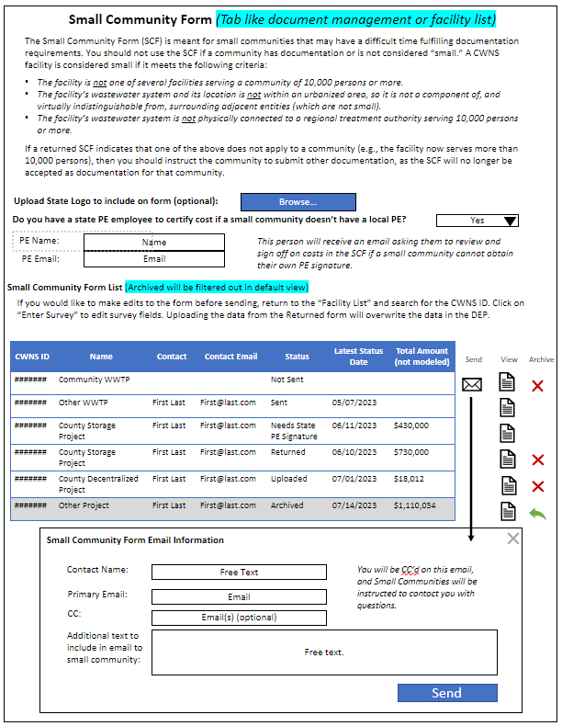

**State view, “returned” small community form and upload data to DEP:**

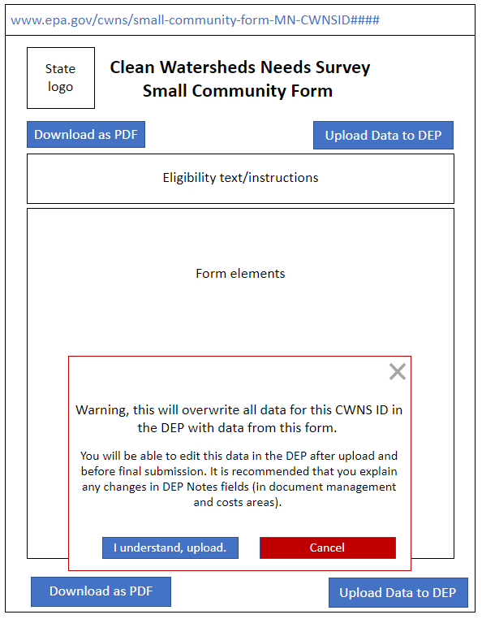

**Public view, small community form:**

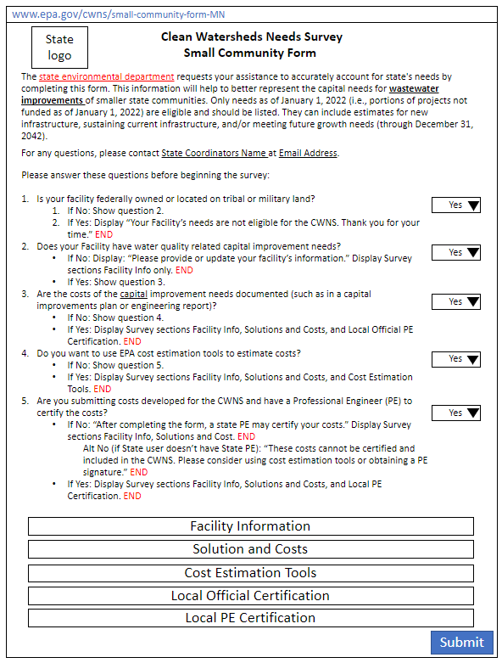

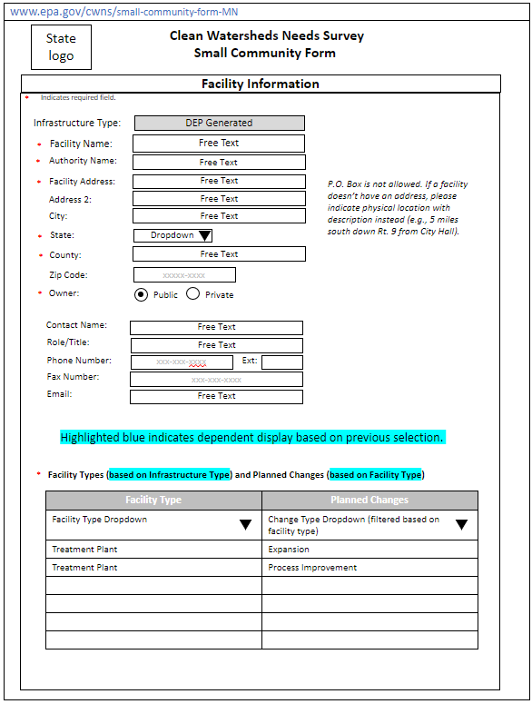

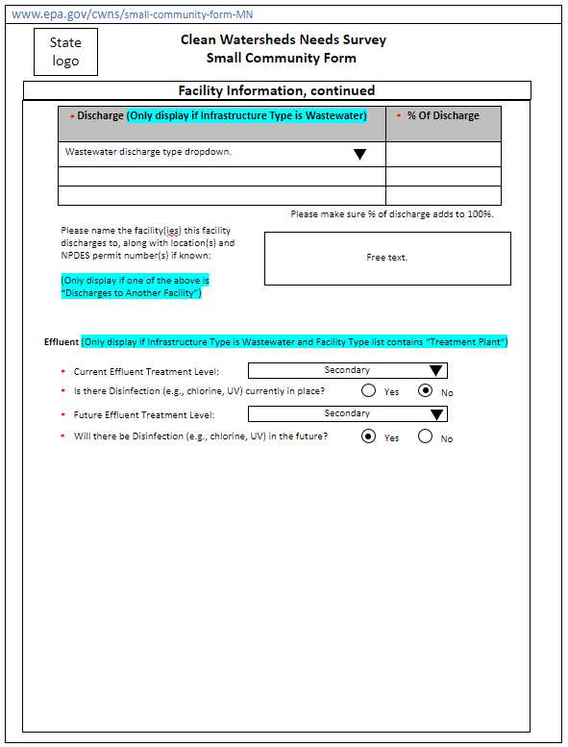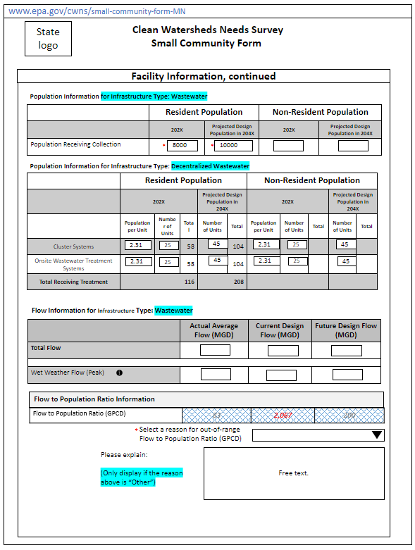

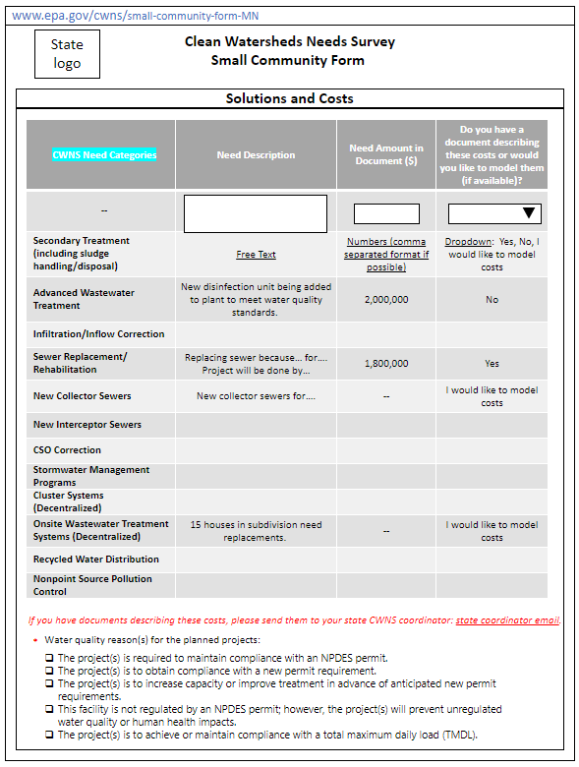

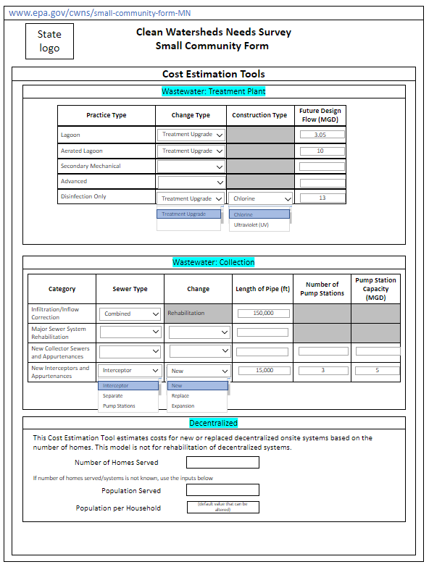

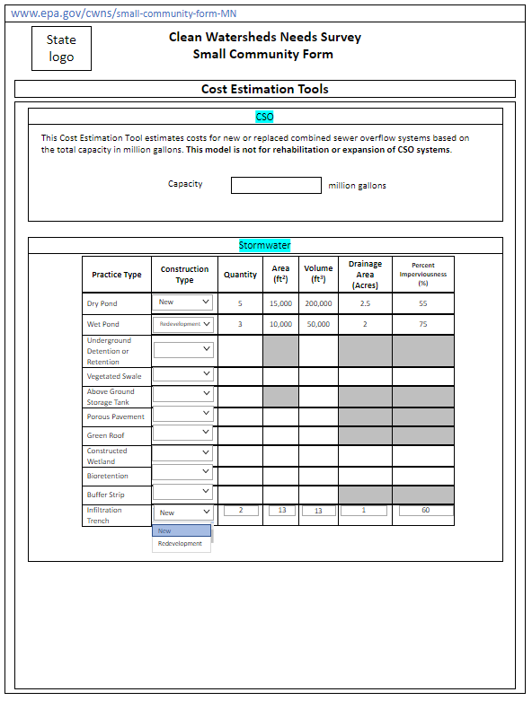

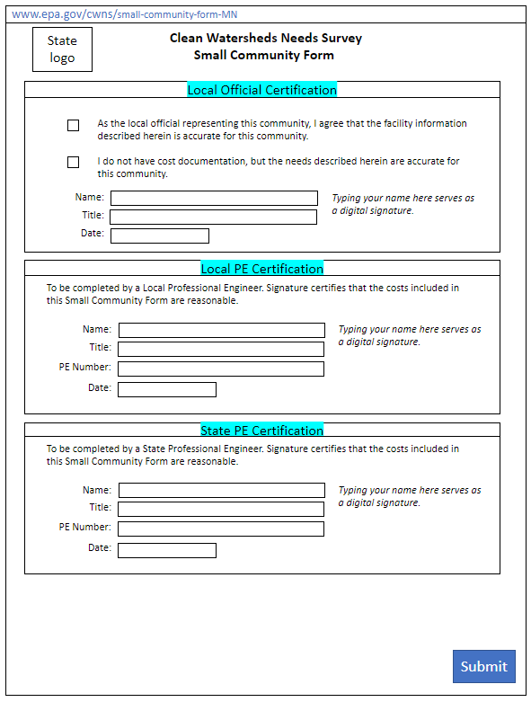

Data Areas and Data Elements Tables

Not all data areas and elements are required for or applicable to all facilities reported in the CWNS. Table I-1 indicates which data areas are required (R), optional (O), and not applicable (n/a) for each facility type. Required areas are shown in red, optional in yellow, and n/a in gray (these will not be accessible in the DEP). Table F-2 provides the full list of data elements in the DEP.

As an example of how to use this table, consider a CWNS ID with a “collection: interceptor sewers” facility type. For this CWNS ID, the required elements are facility information, point of contact, location, areas related to need, needs by document, and capital costs. Optional areas in yellow are permits, discharge, unit processes, asset management, and CETs. Fields in gray that do not apply are population, flow, and effluent treatment. Fields that do not apply will not appear in the DEP for this CWNS ID.

Table I-1. Data Areas by Infrastructure Type

| **Infrastructure Type** | **Facility Type** | **Data Area** | | | | | | | | | | | | | |
| --- | --- | --- | --- | --- | --- | --- | --- | --- | --- | --- | --- | --- | --- | --- | --- |
| **Technical Data** | | | | | | | | | | | **Needs Data1** | | |
| **Facility Information** | **Permits** | **Point of Contact** | **Location** | **Areas Related to Needs** | **Population** | **Flow** | **Discharge** | **Effluent Treatment** | **Unit Process** | **Asset Management** | **Needs by Document** | **Capital Costs** | **CETs** |
| Wastewater | Treatment plant | R | O | R | R | R | R | R | R | R | O | O | R | R | O |
| Collection: separate sewers | R | O | R | R | R | R | n/a | R | n/a | O | O | R | R | O |
| Collection: combined sewers | R | O | R | R | R | R | n/a | R | n/a | O | O | R | R | O |
| Collection: interceptor sewers | R | O | R | R | R | n/a | n/a | O | n/a | O | O | R | R | O |
| Water reuse | R | O | R | R | R | n/a | n/a | O | n/a | O | O | R | R | n/a |
| Biosolids handling | R | O | R | R | R | n/a | n/a | O | n/a | O | O | R | R | n/a |
| Honey bucket lagoon | R | O | R | R | R | n/a | O | O | O | O | O | R | R | n/a |
| Storage facility | R | O | R | R | R | n/a | O | O | O | O | O | R | R | O |
| Collection: pump stations | R | O | R | R | R | n/a | n/a | O | n/a | O | O | R | R | O |
| Desalination (wastewater infrastructure) | R | O | R | R | R | n/a | R | O | n/a | O | O | R | R | n/a |
| Stormwater | Phase I MS4 | R | O | R | R | R | n/a | n/a | O | n/a | O | O | R | R | O |
| Phase II MS4 | R | O | R | R | R | n/a | n/a | O | n/a | O | O | R | R | O |
| Non-traditional MS4 | R | O | R | R | R | n/a | n/a | O | n/a | O | O | R | R | O |
| Unregulated community | R | O | R | R | R | n/a | n/a | O | n/a | O | O | R | R | O |
| Decentralized Wastewater | OWTS | R | O | R | R | R | R | n/a | O | n/a | O | O | R | R | O |
| Clustered system | R | O | R | R | R | R | n/a | O | n/a | O | O | R | R | O |
| NPS Pollution | Agriculture—cropland | R | O | R | R | R | n/a | n/a | n/a | n/a | O | n/a | R | R | n/a |
| Agriculture—animals | R | O | R | R | R | n/a | n/a | n/a | n/a | O | n/a | R | R | n/a |
| Silviculture | R | O | R | R | R | n/a | n/a | n/a | n/a | O | n/a | R | R | n/a |
| Marinas | R | O | R | R | R | n/a | n/a | n/a | n/a | O | n/a | R | R | n/a |
| Resource extraction | R | O | R | R | R | n/a | n/a | n/a | n/a | O | n/a | R | R | n/a |
| Brownfields/Superfund | R | O | R | R | R | n/a | n/a | n/a | n/a | O | n/a | R | R | n/a |
| Storage tanks | R | O | R | R | R | n/a | n/a | n/a | n/a | O | n/a | R | R | n/a |
| Sanitary landfills | R | O | R | R | R | n/a | n/a | n/a | n/a | O | n/a | R | R | n/a |
| Groundwater**—**unknown source | R | O | R | R | R | n/a | n/a | n/a | n/a | O | n/a | R | R | n/a |
| Hydromodification | R | O | R | R | R | n/a | n/a | n/a | n/a | O | n/a | R | R | n/a |
| Estuary management | R | O | R | R | R | n/a | n/a | n/a | n/a | O | n/a | R | R | n/a |
| Desalination (NPS control infrastructure) | R | O | R | R | R | n/a | O | n/a | n/a | O | n/a | R | R | n/a |

1Not required if change type is “no change.”

Table I-2. Data elements table

301(h) Ocean Discharge Waivers

Secondary treatment is the minimum level of treatment required for discharges from all municipal wastewater treatment facilities by the CWA. Facilities granted ocean discharge waivers under Section 301(h) are exempt from this requirement. Table J-1 lists facilities with 301(h) waivers that may report less than secondary treatment effluent level in the DEP.

Table J-1. Facilities with 301(h) Waivers

| **301 (h) Waiver Recipients** | **State** | **2012 CWNS ID** | **Facility Name in 2012 CWNS** | |
| --- | --- | --- | --- | --- |
| Skagway | | Alaska | 02000122001 | SKAGKWAY WWTP |
| Haines | | Alaska | 02000120001 | HAINES WWTP |
| Ketchikan | | Alaska | 02000108001 | KETCHIKAN STP |
| Petersburg | | Alaska | 02000112001 | Petersburg WWTP |
| Wrangell | | Alaska | 02000118001 | WRANGELL |
| Sitka | | Alaska | 02000105001 | SITKA WASTEWATER FACIL |
| Anchorage | | Alaska | 02000106001 | POINT WORONZOF, JOHN ASPLUND WWTP |
| Whittier | | Alaska | 02000300001 | WHITTIER STP |
| Pelican | | Alaska | 02000279001 | PELICAN STP |
| Tafuna (Pago Pago) | | American Samoa | 60000001002 | TAFUNA WWTF |
| Utulei | | American Samoa | 60000001001 | UTULEI WWTF |
| San Diego | | California | 06009031001 | Point Loma WWTF |
| Bayville | | Maine | 23000164001 | BAYVILLE WWTF |
| Eastport | | Maine | 23000097001 | EASTPORT WWTF |
| Eastport/Quoddy | | Maine | 23000097002 | QUODDY VILLAGE WWTF |
| Lubec | | Maine | 23000129001 | LUBEC WWTP |
| North Haven | | Maine | 23000134001 | NORTH HAVEN, WWTF |
| Northport Village (Belfast) | | Maine | 23000094001 | Northport Village Corp.(akaBAYSIDE) |
| Searsport | | Maine | 23000103001 | SEARSPORT WWTF |
| Stonington | | Maine | 23000146001 | STONINGTON WPCF |

Unit Process Lists

Table K-1. List of Wastewater Unit Processes

| Treatment Stage | Unit Process |
| --- | --- |
| Preliminary treatment | Screening |
| Flow Equalization |
| Primary treatment | Flotation |
| Primary Clarification or Sedimentation |
| Secondary treatment | Attached Growth, Aerobic |
| Attached Growth, Anaerobic |
| Biological Treatment, Other |
| Lagoon, Aerobic |
| Lagoon, Anaerobic |
| Lagoon, Facultative |
| Suspended Growth, Aerobic |
| Suspended Growth, Anaerobic |
| Sludge Blanket, Anaerobic |
| Advanced treatment | Chemical Addition, Alum |
| Chemical Addition, Ferric Chloride |
| Chemical Addition, Polymer |
| Chemical N Removal |
| Chemical P Removal |
| Constructed Wetland |
| Filtration, Granular-Medium |
| Filtration, Other |
| Flocculation |
| Membrane Process |
| Sorption |
| Stripping, Not Specified |
| Disinfection | Dechlorination |
| Disinfection, Chemical |
| Disinfection, Thermal |
| Disinfection, UV |
| Solids handling | Biosolids Aerobic Digestion |
| Biosolids Anaerobic Digestion with Energy Recovery |
| Biosolids Anaerobic Digestion without Energy Recovery |
| Biosolids Chemical Addition |
| Biosolids Drying |
| Biosolids Incineration |
| Biosolids Mechanical Dewatering |
| Biosolids Thickening |

Table K-2. List of Stormwater Unit Processes

| Treatment Stage | Unit Process |
| --- | --- |
| Gray infrastructure | Gray stormwater conveyance |
| Manufactured devices |
| Underground storage |
| Real-time controls for CSO management |
| Green infrastructure | Wet pond |
| Dry pond |
| Bioretention |
| Constructed wetlands |
| Permeable pavement |
| Green roof |
| Cistern |
| Infiltration trench |
| Rain barrel |
| Vegetated swale |
| Buffer strip |
| Urban riparian restoration |

Table K-3. List of Decentralized Unit Processes

| Treatment Stage | Unit Process |
| --- | --- |
| Decentralized | Aeration |
| Evapotranspiration bed |
| Filter |
| Grinder pump—low-pressure sewer |
| Holding tank |
| Lagoon |
| Leach field |
| Mound system |
| Other non-centralized treatment |
| Septic tank |
| Trickling filter (unspecified media) |
| Wetland |

Table K-4. List of Nonpoint Source Unit Processes

| Treatment Stage | Unit Process |
| --- | --- |
|  |  |

1. <https://www3.epa.gov/npdes/pubs/cwatxt.txt#:~:text=SEC.%20212%20%5B33%20U.S.C.%201292%5D%20Definitions>
2. <https://www.epa.gov/cwsrf/sewer-overflow-and-stormwater-reuse-municipal-grants-program>
3. Note that Categories VIII, IX, XI, and XIII are no longer collected.