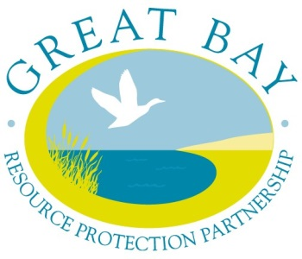
CONTACT: Dea Brickner-Wood, Great Bay Coordinator, GBRPP
(603) 868-6112
info@greatbaypartnership.org

FOR IMMEDIATE RELEASE
July 11, 2017

GRANTS AVAILABLE FOR LAND CONSERVATION TRANSACTION COSTS in the COASTAL WATERSHED
The Great Bay Resource Protection Partnership announces $38,000 in grant funds available
for conservation land transaction costs.

Durham, NH – The Great Bay Resource Protection Partnership (GBRPP) has announced grant applications are available for the Fall 2017 Land Protection Transaction Grant Program. A total of $38,000 is available for the fall grant round.

Applications must be postmarked by October 6, 2017. The grant instructions and application form are available on the GBRPP website http://www.greatbaypartnership.org

Qualified nonprofit tax-exempt 501(c)(3) conservation organizations or units of government may apply for a grant.
The matching grants program assists with the costs for permanent land protection projects (donation and/or acquisition of full fee and conservation easements) within the coastal watershed including coastal New Hampshire and part of southern Maine.

Conserving a network of undeveloped natural lands in the coastal watershed is critical to maintain clean water, protect significant habitats and ecosystems, support healthy wildlife populations, protect agricultural and forestry resources, and provide quality recreational opportunities. The purchase or donation of land or conservation easements often requires funding for transaction expenses (e.g. appraisals, land surveys, recording fees). The Land Protection Transaction Grant Program assists with the costs of conserving the most significant lands in the coastal watershed.

For questions about this grant opportunity contact:
Dea Brickner-Wood
GBRPP, Great Bay Coordinator
603-868-6112
info@greatbaypartnership.org

About the Great Bay Resource Protection Partnership:
The Great Bay Resource Protection Partnership is a collaboration of conservation organizations in the coastal region that promotes landscape-scale land conservation and stewardship. Funding for the Land Protection Transaction Grant program is provided by the New Hampshire Charitable Foundation. The Nature Conservancy serves as the fiscal agent for the GBRPP grants program. http://www.greatbaypartnership.org
###

