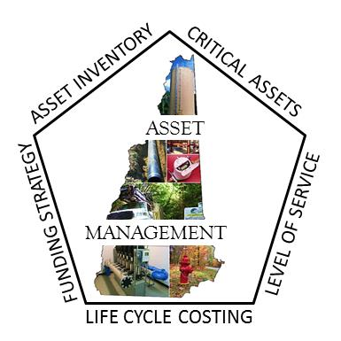
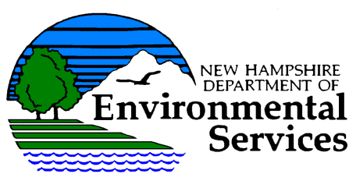
ASSET MANAGEMENT
“BRIDGING THE GAP”
WORKSHOP
THURSDAY, DECEMBER 1, 2016

Workshop Goal: To provide New Hampshire drinking water, stormwater and wastewater system operators and managers with an overview of asset management best practices. Most importantly, this workshop will provide all participants with means and methods on how to leverage your asset management programs to maximize interactions within the entire organization. This workshop will not only provide testimonial presentations from your peers, great panel discussions, and the facilitated breakout sessions will allow various opportunities for networking and small group learning and sharing of experiences.

Time: 8:00 a.m. - 3:30 p.m. (Registration begins at 7:30 a.m.)

Workshop Location:
NH Department of Environmental Services
29 Hazen Drive
Concord, NH 03302
Who Should Attend: Drinking Water, Stormwater and Wastewater facility managers and operations staff, Public Work Directors town fiscal managers, Commissioners, Selectmen

Contact Hours: 6 technical contact hours for drinking water and wastewater operators

For Workshop Questions: Luis Adorno, luis.adorno@des.nh.gov or 603-271-2472
Cost: $35.00 (Please note that the registration fee includes lunch. Lunch includes soup or salad, spinach stuffed chicken, baked stuffed haddock, eggplant parmigianino, rice or potatoes, vegetables, rolls, and coffee). Gluten-free option available upon request.
Space is limited so register early

Registration Deadline: November 21rd, 2016

REGISTRATION FORM

Registrations must be postmarked by November 21, 2016 and must include a registration fee of $35. Registration fees are due upon registration and are non-refundable. Mail registration and registration fee (checks payable to Treasure State of New Hampshire) to: Luis Adorno
Drinking Water and Groundwater Bureau
NH Department of Environmental Services
29 Hazen Drive
Concord, NH 03302

NAME:______________________
JOB TITLE: _________________________
FACILITY NAME:___________________________________________________________
ADDRESS: _________________________________________________________________________
PHONE #: (____) ________________ FAX #: (____) _________________________
email: _________________________________________________________________________
Lunch Preference: ___ Chicken ___ Seafood ___ Vegetarian ___ Gluten-free Option
RA: 402090 # I

Thursday, December 1, 2016
AGENDA- “Bridging the Gap”

Time | Topic | Presenter | Location
7:30 – 8:00am | Registration |  | Lobby
8:00 – 8:10am | Welcome Introduction | Sharon Rivard, P.E.  NHDES Waste Water Engineering Bureau- Design Review | Auditorium
8:10 – 9:10am | “Bridging the Gap”  Past, Present, and Future | Kevin Campanella, P.E.  Utilities Planning Leader  Burgess & Niple, Inc. | Auditorium
9:10 – 10:20am | “Tools you need to bridge the gap” | Group Discussions | Conf. Rms.
10:20 – 10:30am | Break (coffee/pastries) |  | Anteroom
10:30 – 11:10am | “Bridging the Infrastructure Gap” | Nicholas Alexander  NHDOT- Asset Management, Performance, and Strategies Administrator | Auditorium
11:10 – 11:30am | “Assessing Stream Crossings in New Hampshire to Reduce Flood Risks” | Shane Csiki, Ph.D., CFM  NHDES Flood Hazards Program Administrator | Auditorium
11:30 – 12:30pm | Lunch (provided) |  | Conf. Rms.
12:30 – 1:50pm | “Asset Management is the foundation of your infrastructure” | Sara Siskavich, GISP  (Nashua Regional Planning Commission)  Rodney Bartlett, Town Administrator  (Town of Peterborough)  Kathleen Meyers, Asset Management Administrator, (City of Dover)  Kevin Campanella, P.E.  (Burgess & Niple, Inc.) | Auditorium
1:50 – 2:00pm | Break
2:00 – 3:15pm | “Technology Transformation”  Narrowing the Gap/Software Choices | Mike Bergeron, Water Superintendent  (Town of Wilton)  Jan Wrona  (Town of Derry)  Sharon McMillan, Ph.D., Administrator  (NHDES- Franklin Wastewater Treatment Facility)  David Fredrickson, Distribution Foreman  (Merrimack Village District) | Auditorium
3:15 – 3:30pm | Closing Remarks | Clark Friese  NHDES Assistant Commissioner | Auditorium
3:30 pm | Certificates and Adjourn

“BRIDGING THE GAP”
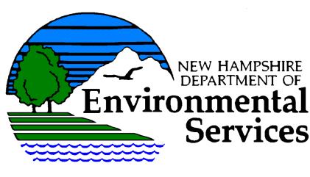
Drinking Water and Groundwater Bureau
Luis Adorno
NH Department of Environmental Services
29 Hazen Drive
Concord, NH 03302

