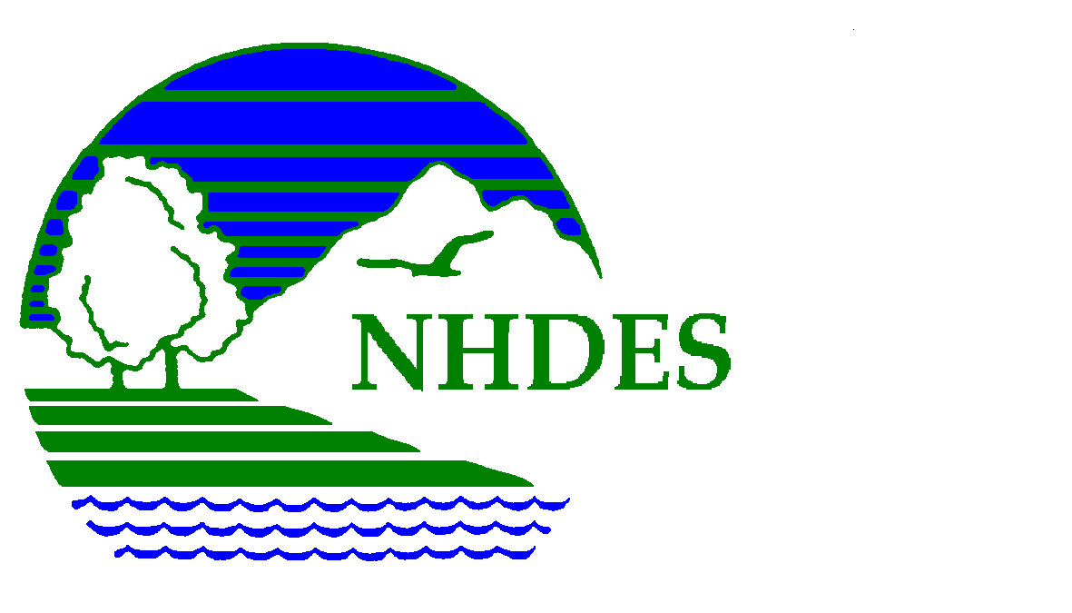

Social Media Workshop for 319 Grantees and Friends
- Agenda -
Thursday, June 4th

Location: Grappone Toyota Dealership, 594 New Hampshire 3A, Bow, NH
Hosted by: The Department of Environmental Services Watershed Assistance Section

- 8:45 – 9:00: Sign-in and refreshments

- 9:00 – 10:30: Beyond Messages, Missions, and Visions – Christine Halvorson, Halvorson New Media, LLC will provide an overview of how social media platforms work for your organization to help: increase visibility, build capacity, change behavior, and raise funds. Topics will include: how to plan your social media marketing strategy, which method is more appropriate, how to package your message, how to address different audience types, and how much is enough.

- 10:30 a.m – 10:45: Break

- 10:45 – 11:15: Halvorson New Media continued: Wrap-up and questions and answers.

- 11:15 – 11:45: How to Get “them” to Listen: using Facebook and Twitter to break through the funny cat videos and get your message heard – Jill Farrell, Community Impact Program Manager, Piscataqua Region Estuaries Partnership (PREP) will provide an overview of lessons learned using Twitter and Facebook and what platforms to use and what not to use for each audience.

- 11:45 – 12:15: A Lake Association’s Goals and Results with Social Media. – Andrea LaMoreaux, Vice President, NH LAKES Association, will discuss what NH LAKES Association works to accomplish with social media, some of their challenges and successes, and how knowing your audience can help.

Biographies
Social Media Workshop for 319 Grantees and Friends

Christine Halvorson, Halvorson New Media, LLC, HalvorsonNewMedia.com

Christine Halvorson founded Halvorson New Media, LLC in 2006 to provide businesses and nonprofits with training, strategic consultation and content development in the rapidly exploding world of social media.
Christine began her social media career in 2004, as the Chief Blogger for Stonyfield Farm, the national organic yogurt company based in Londonderry, New Hampshire. There she pioneered the use of corporate blogging by writing and managing five company blogs. After 2 years, Christine turned her Stonyfield experience into her own consulting firm that now employs others and keeps her busy 24/7. Her mission is to teach businesses and nonprofits not just how to use social media, but to be strategic about it, and she has been a guest speaker in front of hundreds of business groups across New England and the country.
Her current clients include the New Hampshire Small Business Development Center; Monadnock Community Hospital and its Bond Wellness Center; and Customer Perspectives, a New Hampshire-based customer service consulting firm. She also provides social media consultation and content to the clients of Louis Karno & Company Communications, LLC of Concord, New Hampshire. She has served as an adjunct professor at Southern New Hampshire University and the University of New Hampshire-Manchester, teaching social media to Communications undergrads.
Christine is the author of 5 e-courses: Social Media for Small Business; Advanced Social Media Tools & Tactics for Small Business; Sites that Sell: Creating Your E-commerce Website; Pinterest for Business: An Introduction; Instagram for Business; and Mobile Marketing, all available at NHSBDC.org.

Jill Farrell, Piscataqua Region Estuaries Partnership (PREP), Community Impact Program Manager
E-mail: jill.farrell@unh.edu

Jill Farrell is the Community Impact Program Manager for PREP. Jill is responsible for PREP''s outreach, communications, data sharing, community engagement and stakeholder communications. Jill is also PREP’s social media maven on Twitter (@PREPCommunity) and Facebook (/PREPCommunity). Jill started with PREP in 2008 as a program assistant and prior to that she was a journalist working on Cape Cod and in Southern Florida. Jill received her Masters of Science in Natural Resources & Policy from UNH and her BS in Communications from Loyola University New Orleans. Jill lives on board a 43-foot ketch rigged sailboat in the Piscataqua River year-round.

Andrea LaMoreaux, Vice President, NH LAKES Association

Andrea is the Vice President of the New Hampshire Lakes Association, a statewide nonprofit 501(c)(3) organization founded in 1992 dedicated to protecting New Hampshire’s lakes through education and advocacy. Andrea has been with NH LAKES since 2007 and is responsible for managing the organization’s education and outreach programs.
In a manner of ‘trial by fire’ she has also become the organization’s social media meister.
Andrea brings a comprehensive understanding of how to effectively work and communicate with volunteers, the ecology and health of the state’s lakes, and what can be to be done to protect and improve lake quality in the state, having coordinated the New Hampshire Department of Environmental Services Volunteer Lake Assessment Program for six years before joining NH LAKES.

